

New Residence Hall Capital Program
Information Sheet
September 2013

1 - Brief Historical Overview
- The Residence Hall Capital Program (“Program”) has always been self-sustaining, relying on the rents, fees, and charges related to the operations of the facilities to pay for all operations and debt service.
- The Program’s debt was part of the State debt cap because of the general obligation pledge it received from SUNY and the appropriation of its funds.
- Due to pressure on the State debt cap, the Program did not receive any additional bonding appropriation in the 2012-13 State Budget.
- Immediately, SUNY began work with DASNY, DoB, underwriters, and bond counsel (the “Working Group”) to develop legislation for a self supported Program, one removed from the State debt cap and the need for future capital appropriation.
- The 2013-14 Enacted State Budget enacted language restructuring the Program, with future debt issuances removed from the State bond cap, eliminating the need for future capital bonded appropriations. A program bond cap of $944.0M was established for the Program over the next five years.

2 - Legal Agreements for the New Program
- The Working Group amended existing documents and created new ones in support of this new Program.
- Some of the critical documents are:
  - The existing “Lease and Agreement” between SUNY and DASNY was amended to address concerns related to outstanding debt.
  - “Assignment” of all revenues associated with the Program to DASNY to be held in Tax and Finance accounts, outside of the State Treasury.
  - The “Financing and Development Agreement” which outlines the handling of all operating and procedural issues for the new program (akin to the “Lease and Agreement” for the old debt).
  - The “Dormitory Facilities Revenue Fund Administration Agreement” between SUNY, Tax & Finance, and DASNY establishes procedures for all transactions related to the newly created Tax and Finance accounts.

3 - Program Comparison

4 - Establishing the New Bonding Mechanism (“Credit”)
  - As a new Credit, the Wall Street community sought information related to every detail of how the Program would operate going forward and what security there will be for existing and potential future bond holders. It became clear that several steps were necessary to help establish the new credit.
  - Toward this end, the Working Group participated in the following events:
  - One-on-one presentations to each of the major rating agencies (Moody’s, Standard & Poor’s, and Fitch), allowing for in depth Q & A sessions that eventually helped establish new credit ratings. (No general obligation pledge caused each to notch one spot AA3, A+, A+)
  - Creation of an internet “Road Show”, a recording made by the working group, which was made available to any investor seeking information related to the new Credit.
  - Just prior to pricing, the Working Group hosted one-on-one calls with nine investment firms, answering any and all questions related to the Program and new credit.

5 - 2013 Bond Sale Results
- The 2013 sale priced the week of August 19th, receiving rave reviews both in pre-sale press from Bloomberg and the day after the pricing from the “Bond Buyer” quoted below:
  - “The Dormitory Authority of the State of New York was the focus of the municipal bond market Wednesday as traders said the $443 million sale was attractively priced, allowing the issuer to accelerate the institutional sale and cut yields.”
- The bond sale ($440M) included new money ($175M) and a refunding component ($265M), which produced a savings of $3.8M for the Program.
- The aggregate All-in TIC (True Interest Cost) was 4.386% (4.248% for refunding and 4.565% for new money)
- This bond sale will support the progress of over 100 projects, supplying cash flow into the Fall of 2014.

6 - 2013 Bond Sale Details
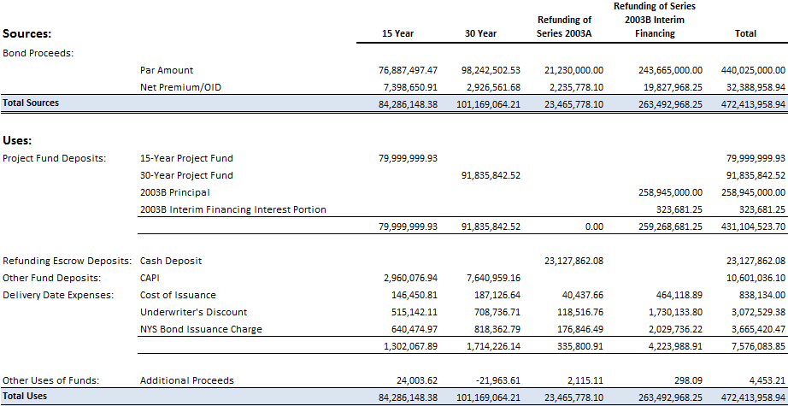

7 - Going Forward
- Each campus will continue to develop ten year capital plans on an annual basis, providing the necessary data to allow the Office for Capital Facilities to properly analyze the Program and determine future bonding capacity.
- The Program expects to bond each Fall, enough for roughly one year’s worth of project disbursements.
- The Program will continue to be a part of the overall annual SUNY Budget Submission process.
  - The Program will seek incremental increases to the $944M cap.
  - The Program will still seek Pay as you Go (Hard Dollar) capital appropriation to allow campuses to perform small maintenance and repair projects using Repair and Rehabilitation Reserves (R&R)
  - The Program will also still receive operating appropriations.
- The Program requires annual reporting to the Governor, the Director of the Budget, and various members and committees of the Senate and Assembly.

8 – Bonded Project Initiation Process – History and Current
2007 and before – Bond by Project
- Projects or phases of projects were bonded in their entirety
- Campuses owned a portion of bonds and related debt service in perpetuity
- If a project “missed” a bond sale, it had to wait until the next year’s sale
2008 to 2012 – Cash Flow Bonds controlled by State Appropriation and Debt Cap statute
- Bonds were sold to fund the Program for 12-15 months, based on projected payments by campus and project
- Once all proceeds are disbursed, campus debt service is adjusted based on actual use
- Additional or Ad-Hoc projects could be added and started at anytime during the year, assuming that they would not cause cash flow problems for the Program and as long as there was available bonded appropriation
2013 forward – Dormitory Facilities Revenue Bonds
- The Program will no longer be limited by the annual capital appropriation
- $944M cap will be increased every couple of years as needed
- Projects will initially be submitted as part of the annual capital plan process and receive final approval through a new project approval process to be coordinated with DASNY.
- Additional or Ad-Hoc projects can be added with submission of revised capital plan

9 – FAQs
Q: Who owns the residence halls and when does that status change?
A: DASNY still owns all buildings in the program until all outstanding debt is paid. Since debt will continue to be issued under this program, there will in effect always be outstanding debt.
Q: What mechanisms are in place to achieve the total SUNY requirement at T&F when some campuses haven't filled their requirement, so that other campuses can get their operating cash?
A: Program reserves from the revolving loan fund currently held at System Administration will be filling an unallocated account at T&F. The cash in this account will count toward the total SUNY requirement, covering those campuses that have not yet filled, allowing others to start flowing funds back to the campus.
Q: What was the cost to establish this Program?
A: Cost ≈ $530K for the 1½ year long process
Q: What will the incremental ongoing costs be to run this Program?
A: Tax and Finance is the only measurable annual expense, ≈ $125K

