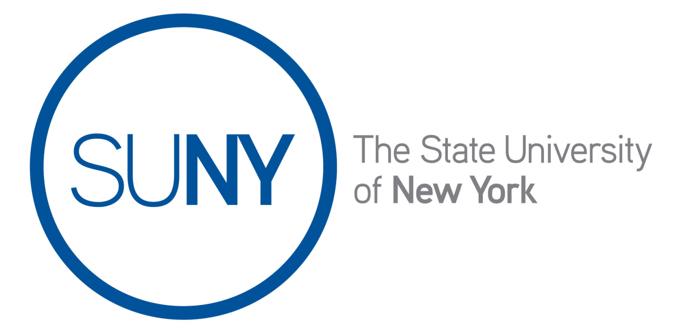

Office for Capital Facilities

Guidance Document

RES-1
April 2023
Residence Hall Projects Funded by Campus Funds (DASNY Voucher Contracts)
A reference guide for the submittal of DASNY voucher contracts for approval.
Contents | Attachments
- Process | - Draft Memo – Residence Hall Projects Funded by Campus Funds
- Approvals | - Residence Hall Program Capital Project Budget Request Form
 | - MOU between DASNY and SUNY, October 1997

Summary

Per section 3.02 of the Financing and Development Agreement (FDA) between the Dormitory Authority of the State of New York (“DASNY”) and State University of New York (“SUNY”), DASNY is responsible for the design, acquisition, construction, reconstruction, rehabilitation, improvement, and equipping of dormitory facilities, referred to as the Residence Hall Capital Program. Capital contracts within the Residence Hall Program let by DASNY are primarily funded with bond proceeds. However, in some cases, SUNY provides funding to DASNY to support a project using campus cash or revolving loan funds. To transfer funding to DASNY, a campus is required to establish a SUNY contract in the State Financial System (SFS). These contracts are often referred to as “DASNY Voucher Contracts”.

The campus is not entering into a contract for goods or services with vendors. DASNY is the contracting entity procuring and letting contracts with vendors for this project in accordance with all applicable rules, regulations and laws. The contract issued by SUNY to DASNY is a mechanism to make payment to DASNY to provide funding. The contract issued by SUNY to DASNY is used to periodically voucher money to DASNY in accordance with the agreed upon payment schedule.

This process is established by the attached MOU between DASNY and SUNY, dated October 3, 1997. All SUNY contracts valued at $75,000 or more (or $150,000 or more for healthcare facilities), for construction, construction-related services, commodities, computer equipment (inclusive of software and hardware), printing, and non-construction related services that are awarded on or after March 17, 2023 shall be subject to the OAG and then the OSC for review and approval.

Process
SUNY’s Office for Capital Facilities has worked with OSC to develop a process that allows these contracts to obtain approval using a modified process.

To obtain approval for a DASNY Voucher contract, the campus will take the following steps:

- The campus submits a Capital Project Budget Request Form to the Office for Capital Facilities (OCF) for approval. Once the request is approved by the OCF it will be forwarded to DASNY for approval.
- The campus enters the contract into SFS using existing allocation, or if no allocation is available the campus can request additional allocation from the OCF at this time.
- For contracts of $75,000 or more (or $150,000 or more for healthcare facilities), the campus submits the required documentation to OSC for approval (details outlined below).
- Upon notification of approval by OSC, the campus provides the contract number to DASNY to commence work on the project.

Approvals
Contracts of $75,000 or more (or $150,000 or more for healthcare facilities) require review and approval by the Office of the State Comptroller. Approval by the Attorney General is not required. Each DASNY Voucher Contracts submitted to the Office of the State Comptroller for approval should include the following documentation.

  - A memo to OSC summarizing the process and program (a draft memo is provided as an attachment to this Guidance Document).
  - A fully approved copy of the Residence Hall Program Capital Project Budget Request Form
  - A copy of the 1997 MOU between DASNY and SUNY (a copy is provided as an attachment to this Guidance Document)

Attachments

- Draft Memo – Residence Hall Projects Funded by Campus Funds
- Residence Hall Program Capital Project Budget Request Form
- MOU between DASNY and SUNY, October 1997

