2026 Supportive Measures in Response to Reports of Violence

1. Introduction:Duty to Offer

1.1 Title Slide
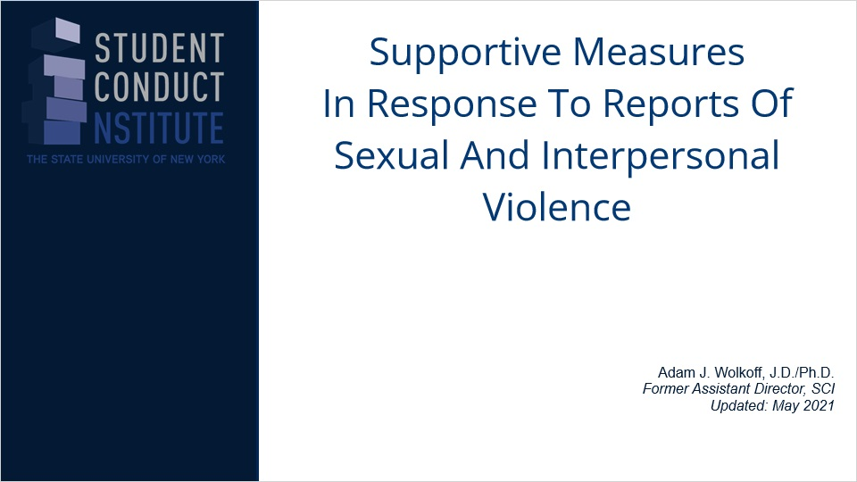
Notes:

1.2 Disclaimer
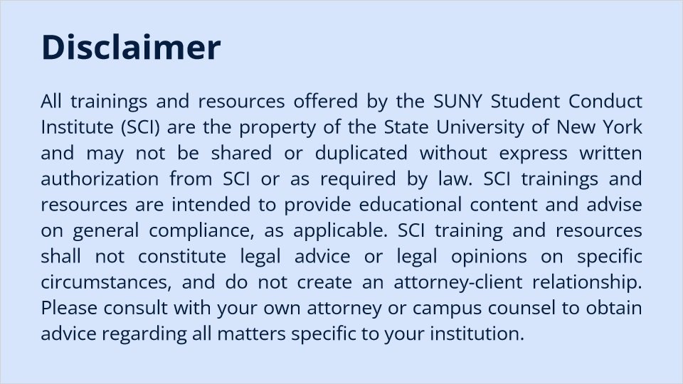
Notes:
Conduct Institute (SCI) are the property of the State University of New York and may not be shared or duplicated without express written authorization from SCI or as required by law. SCI trainings and resources are intended to provide educational content and advise on general compliance, as applicable. SCI training and resources shall not constitute legal advice or legal opinions on specific circumstances, and do not create an attorney-client relationship. Please consult with your own attorney or campus counsel to obtain advice regarding all matters specific to your institution.

1.3 Overview
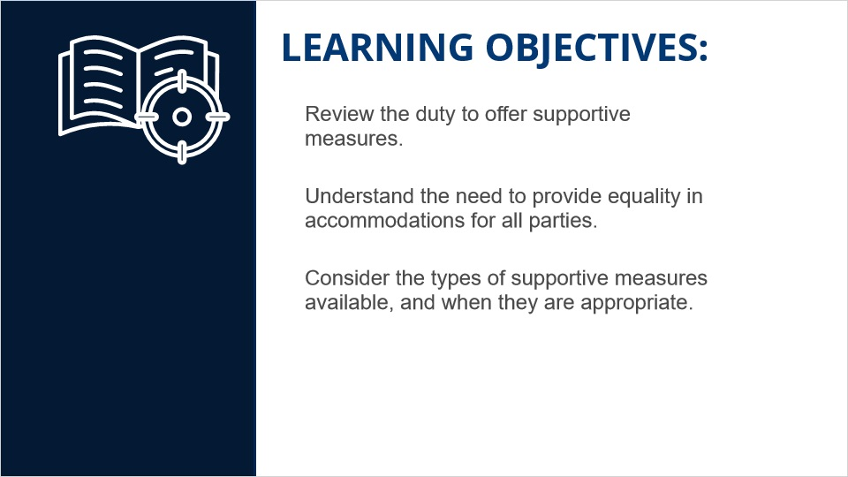
Notes:

1.4 Introduction
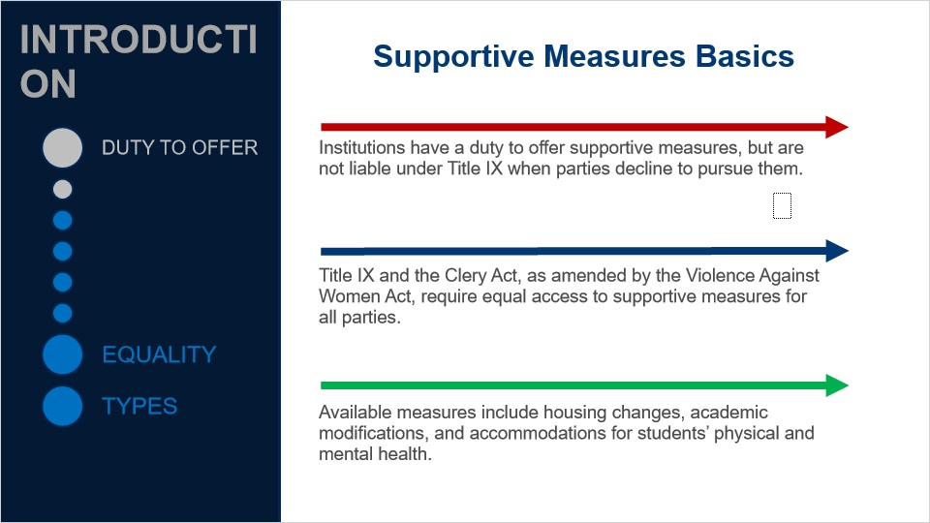

1.5 clery/vawa I
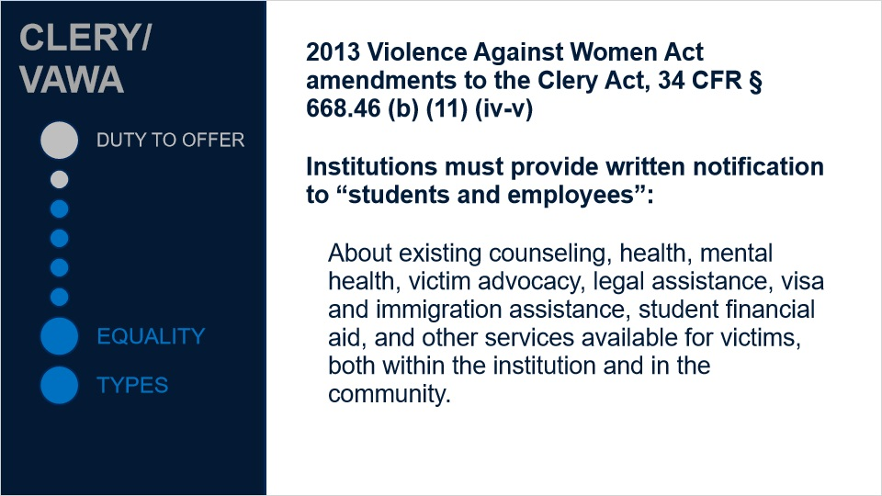

1.6 clery/vawa ii
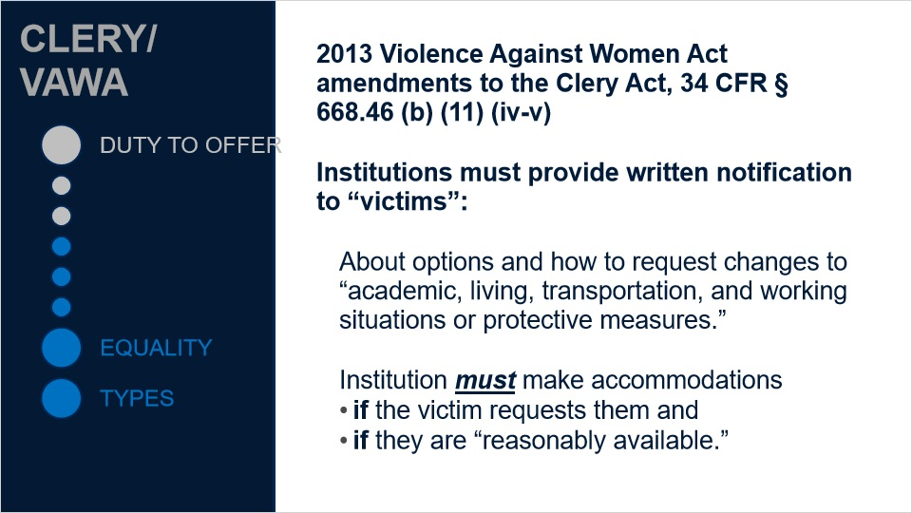

1.7 clery/vawa prot comm
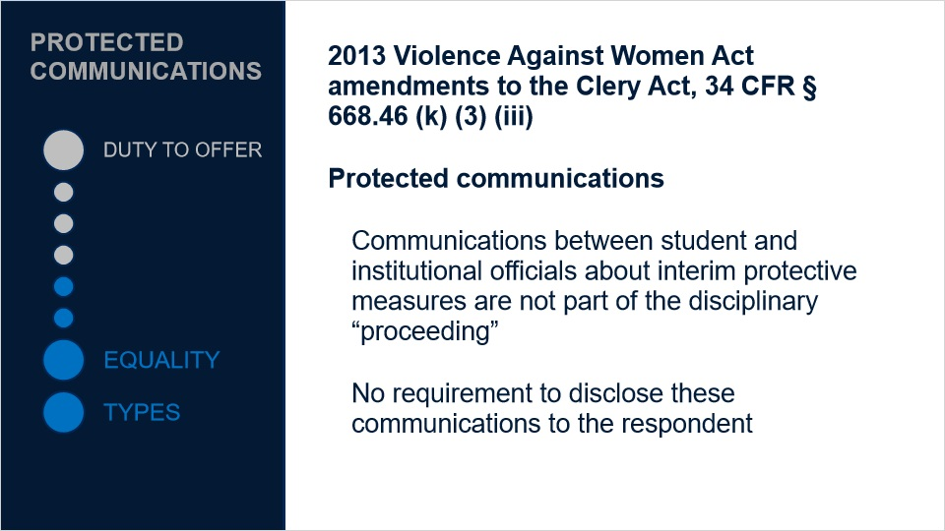

1.8 TIX duty I
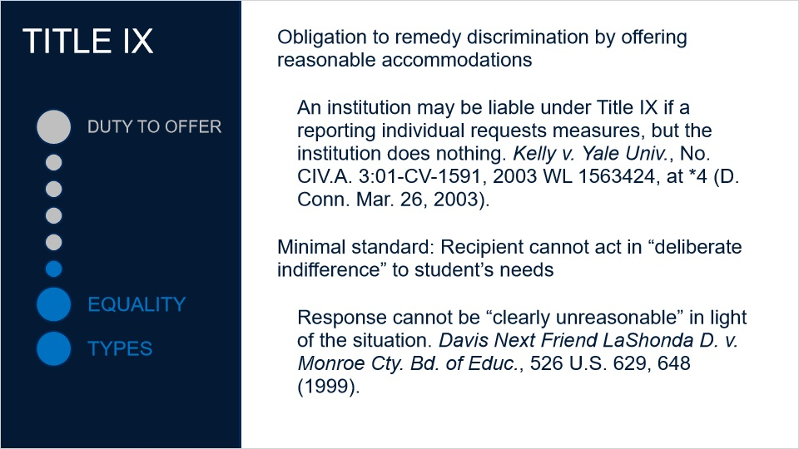

1.9 TIX duty II
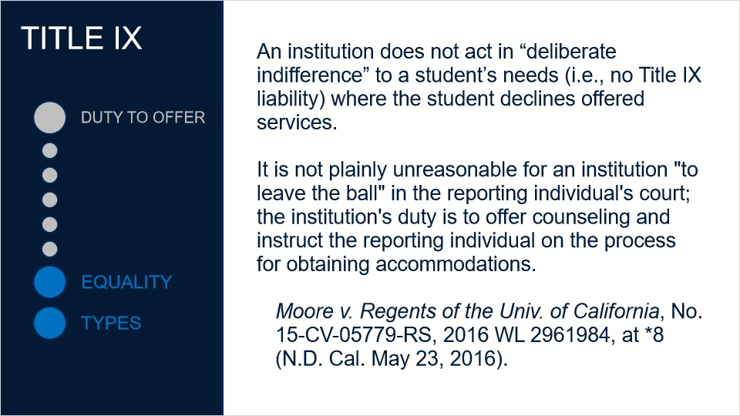

1.10 TIX duty III
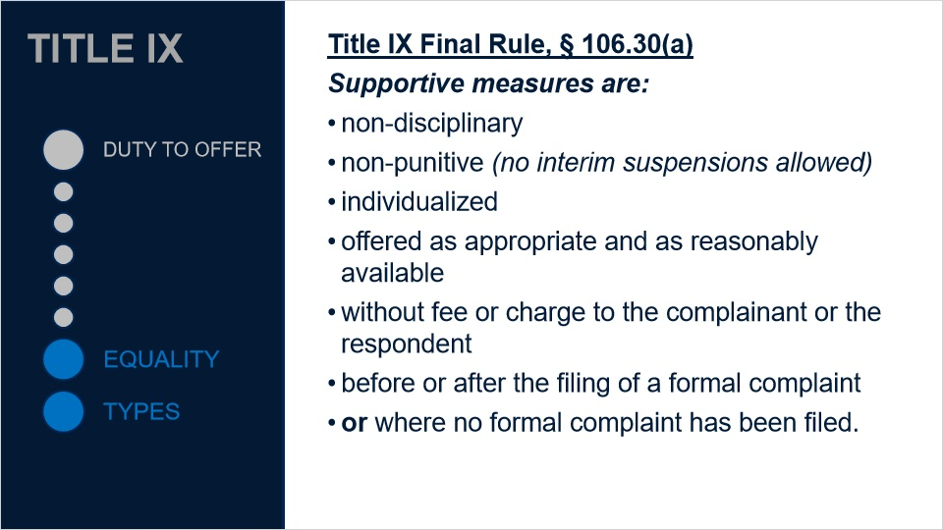

1.11 TIX duty IV
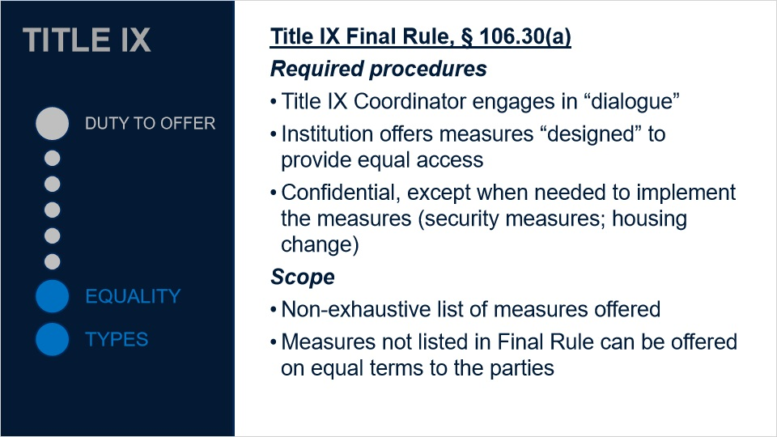

2. Equality

2.1 Equality in providing supportive measures
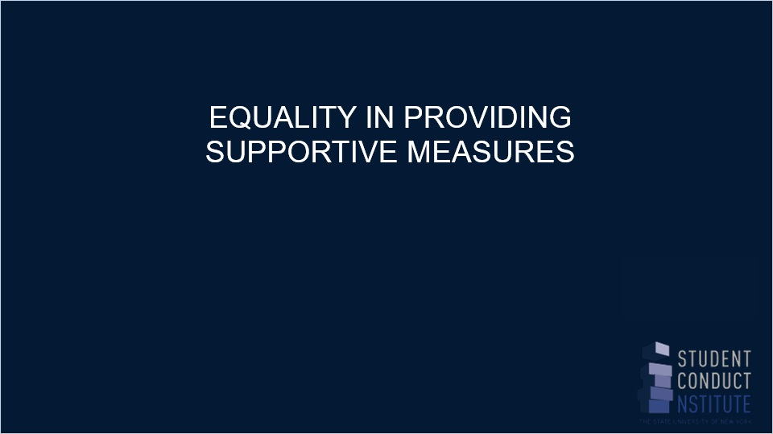
Notes:
Joe to review

2.2 student services
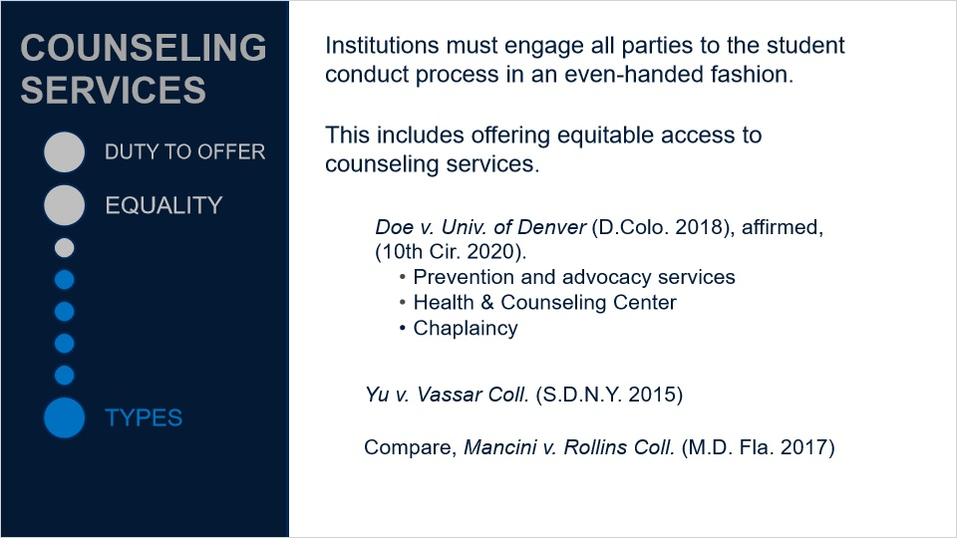

2.3 disability
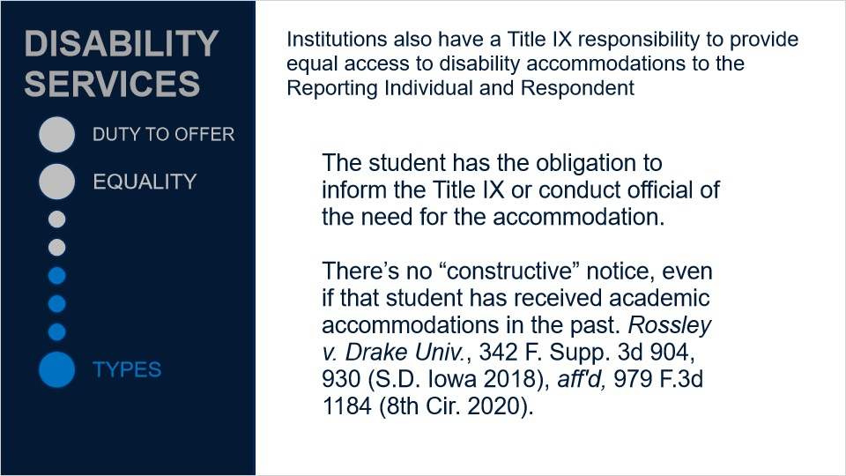
Notes:

2.4 doe v quinnipiac
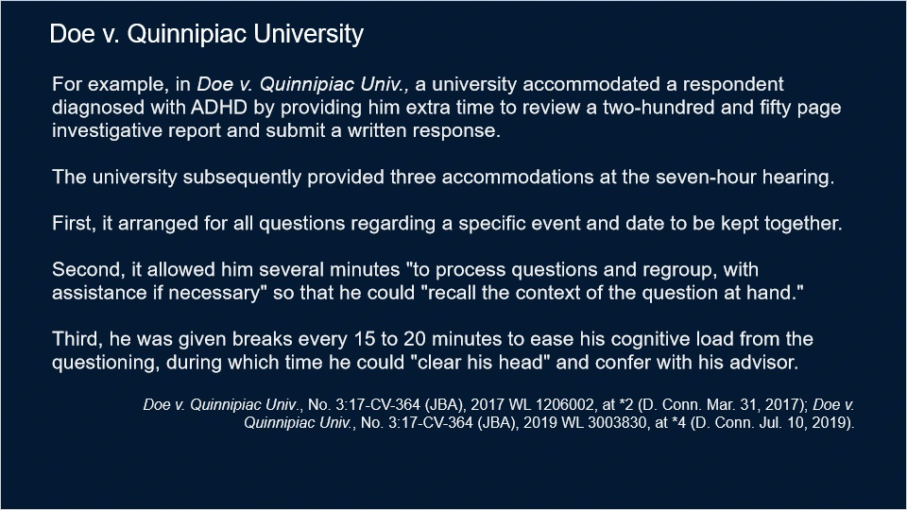
Notes:

2.5 quiz: moving violations
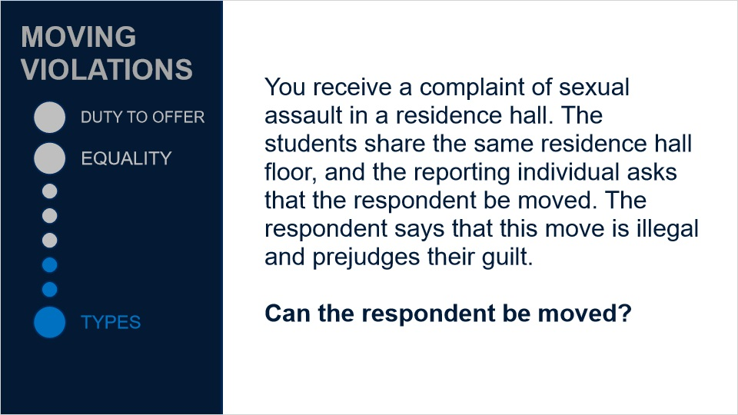

2.6 min burdens I
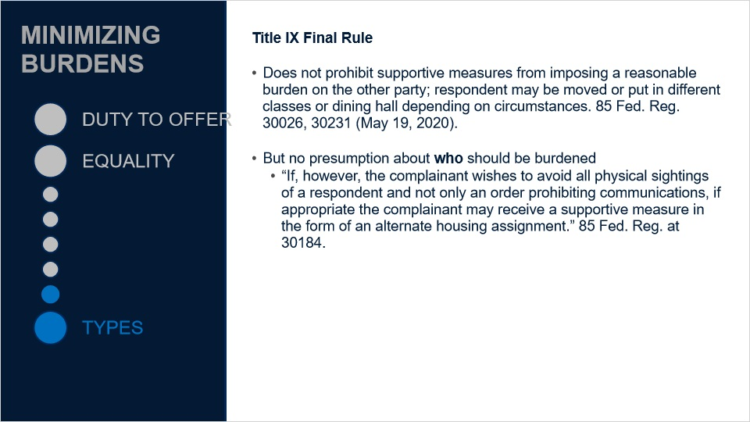

2.7 min burdens II
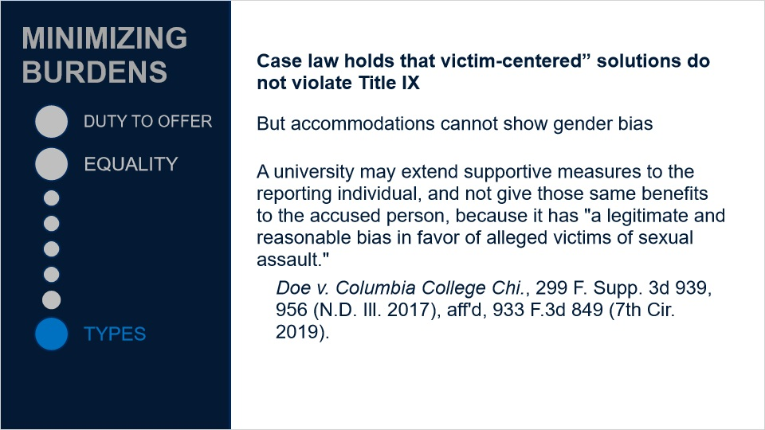

3. Types

3.1 Types of supportive measures
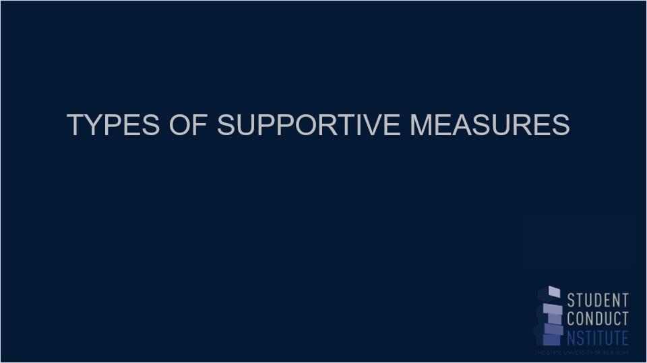
Notes:
Joe to review

3.2 housing
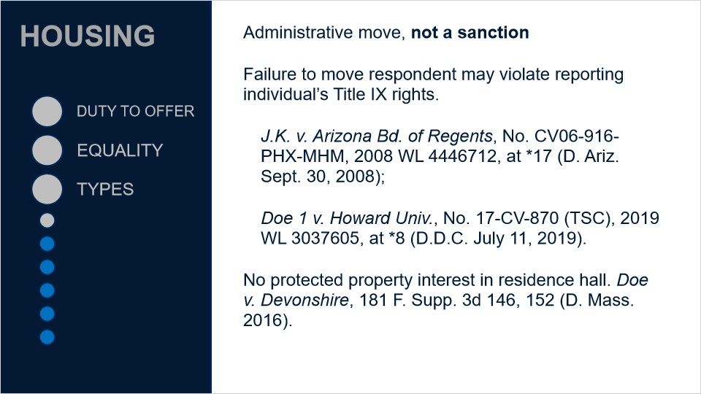

3.3 housing ii
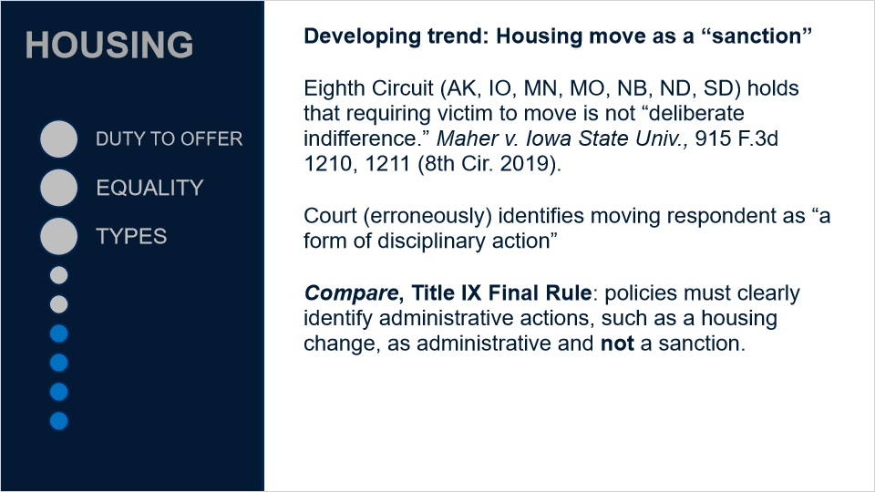

3.4 academic I
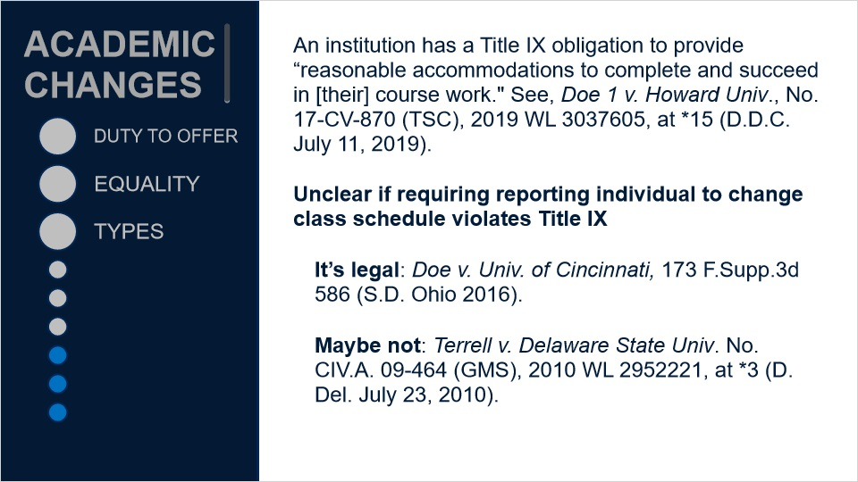
Notes:
- Proposed rule: the recipient must apply either the preponderance of the evidence standard or the clear and convincing evidence standard. The recipient may, however, employ the preponderance of the evidence standard only if the recipient uses that standard for conduct code violations that do not involve sexual harassment but carry the same maximum disciplinary sanction.

- You should use the same standard of proof for all cases of violence, not just sexual violence; the distinction should be, if any, between violent and non-violent violations

- An institution would be able to reserve the clear and convincing evidence standard for SIV cases, but then use the lesser standard for other types of misconduct

- The recipient must also apply the same standard of evidence for complaints against students as it does for complaints against employees, including faculty.

3.5 academic II
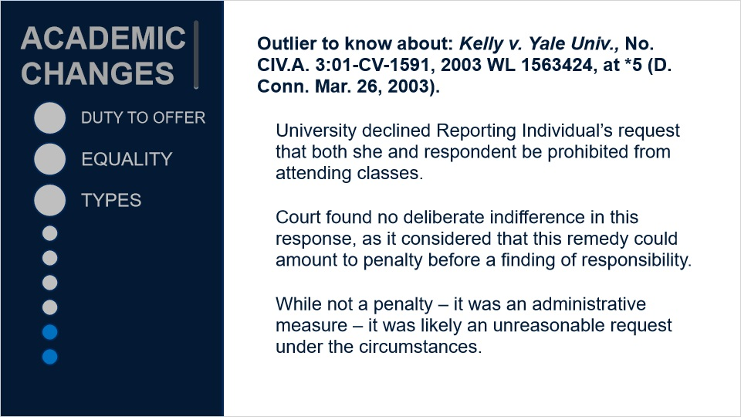
Notes:

3.6 health I
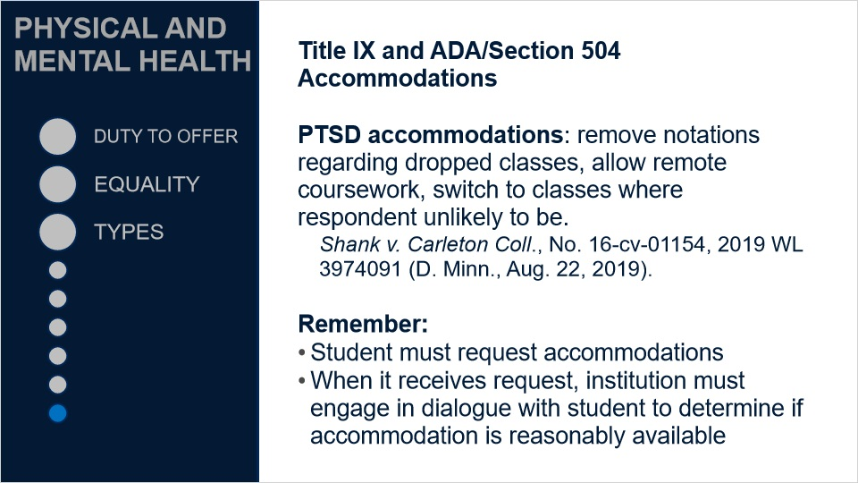

3.7 health II
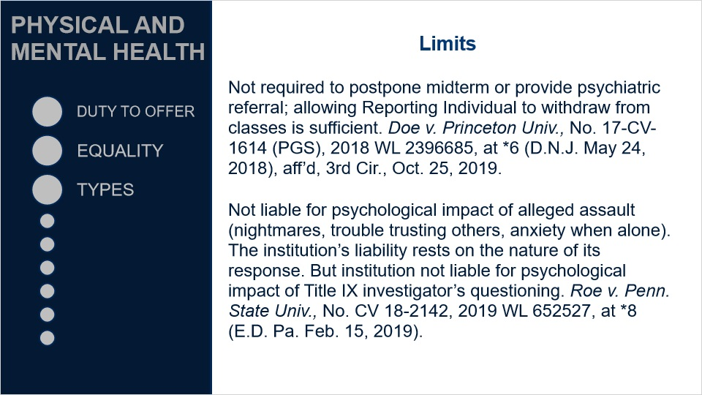

3.8 Summary
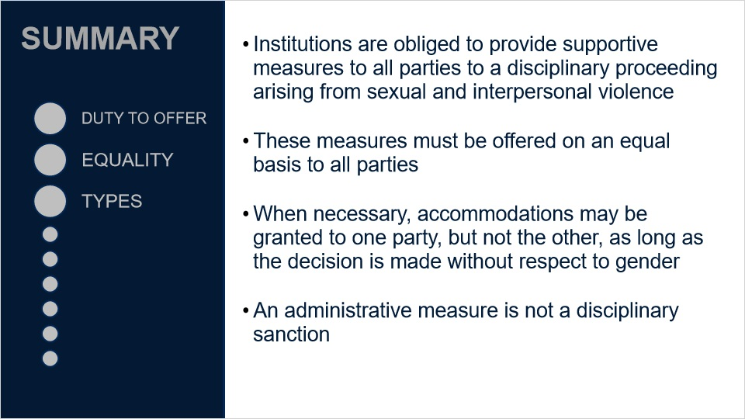
Notes:

4. Exit Questions

4.1 Attest
(True/False, 100 points, 1 attempt permitted)
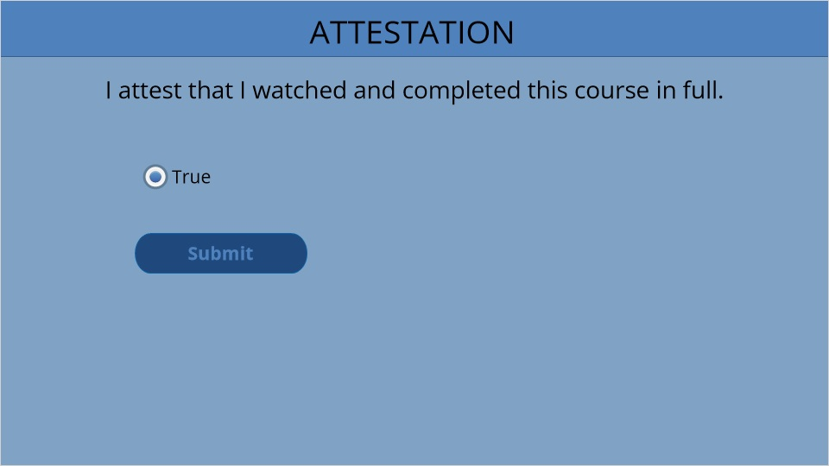
Correct | Choice
X | True

4.2 Results Slide
(Results Slide, 0 points, 1 attempt permitted)
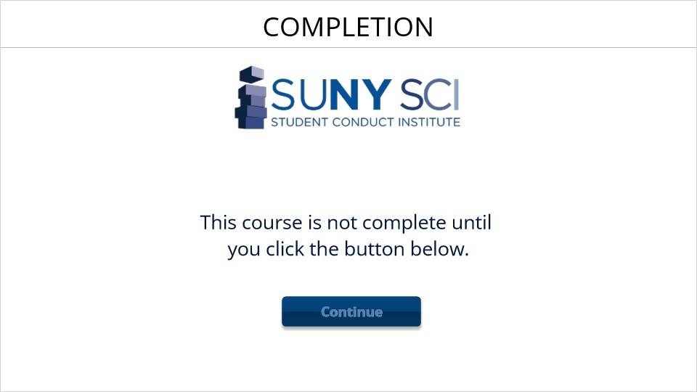

Results for
4.1 Attest

Result slide properties | Passing Score
80%

Success (Slide Layer)

Failure (Slide Layer)

4.3 End Course
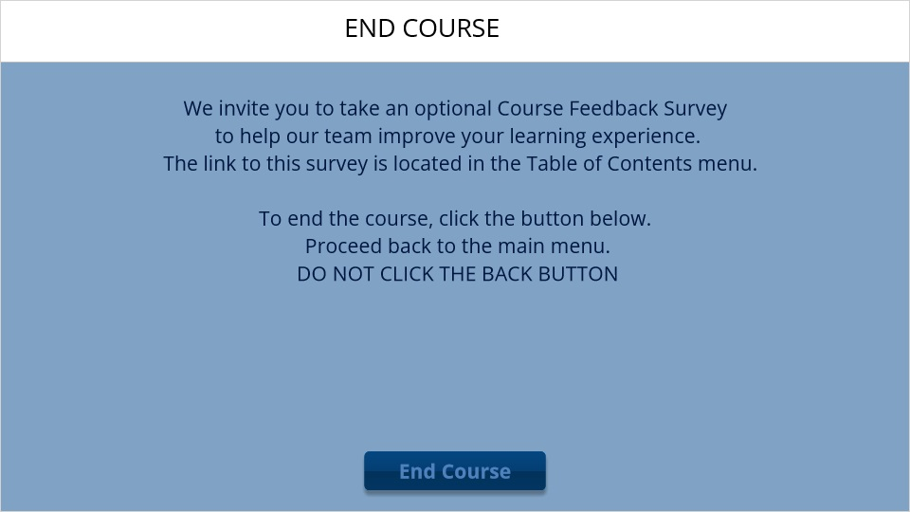
Notes:

