26-27 Due Process Part One Theory and History

1. Introduction to Theory and History

1.1 SCI Welcome & legal disclaimer
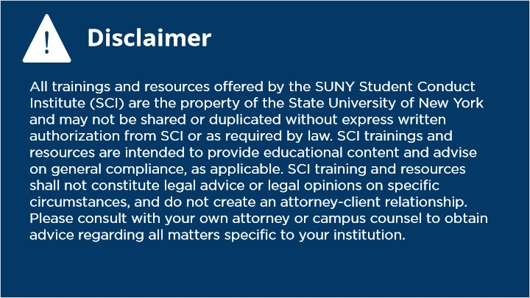
Notes:

1.2 Title Slide
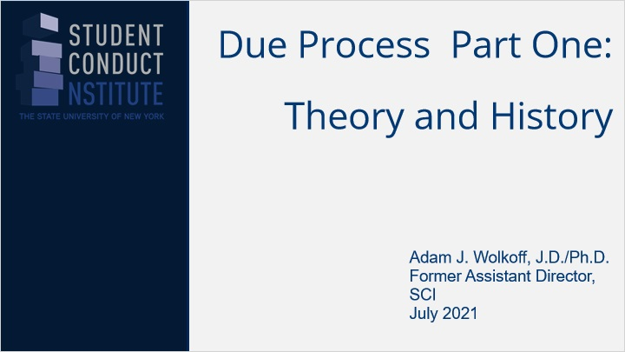
Notes:

1.3 Overview
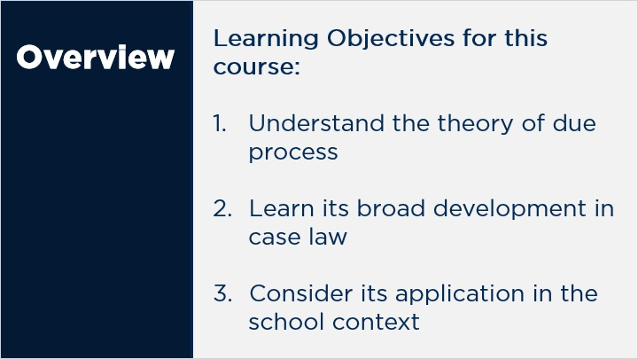
Notes:

1.4 Introduction
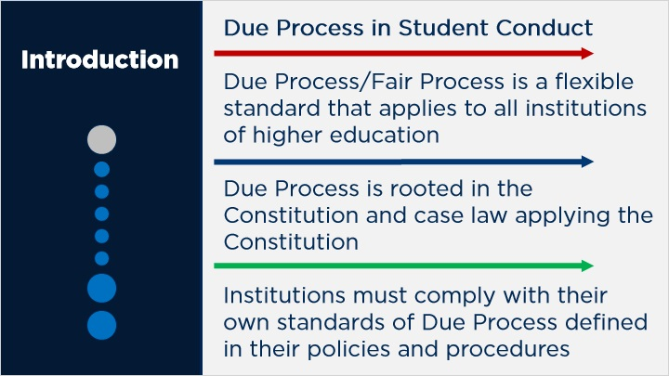
Notes:

1.5 Types of DP
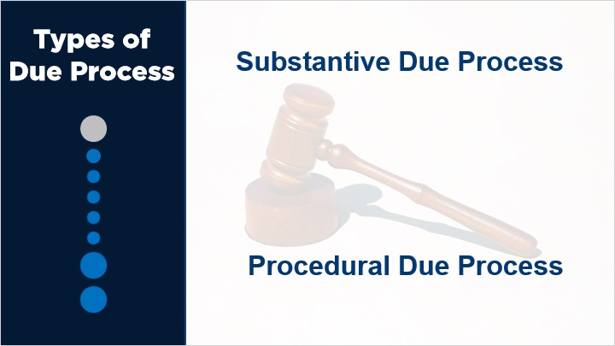

1.6 Substantive Due Process
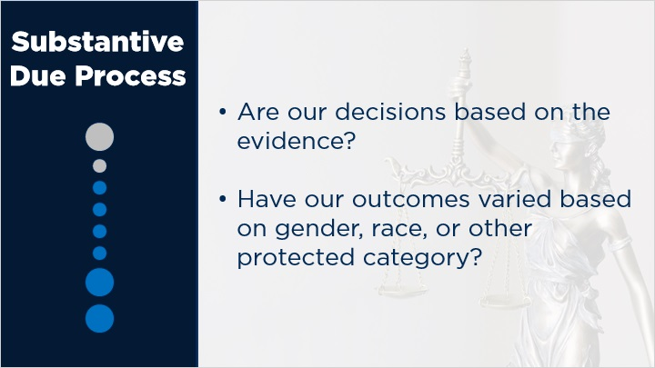

1.7 Procedural Due Process
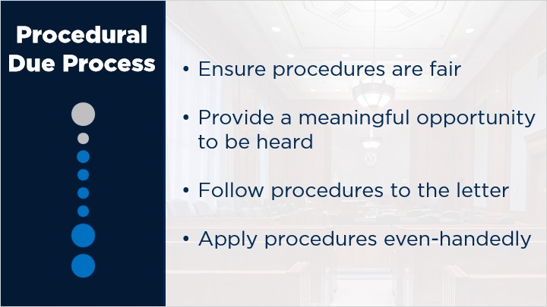

1.8 Sources of due process
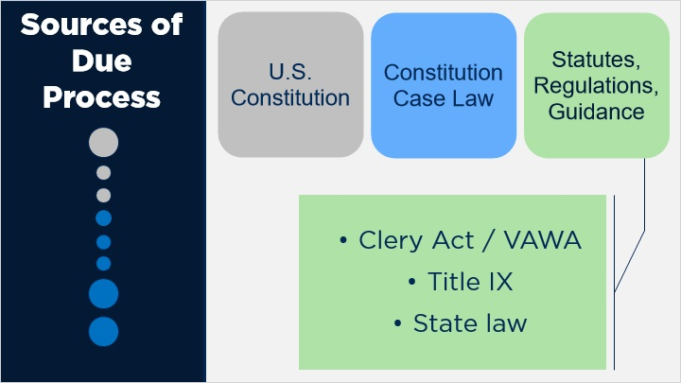

1.9 Public v Private Process
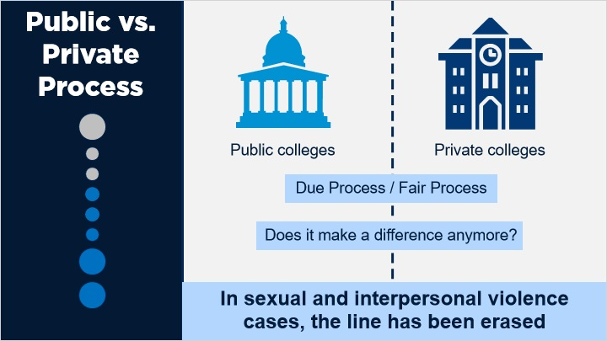

1.10 Flexibility Intro
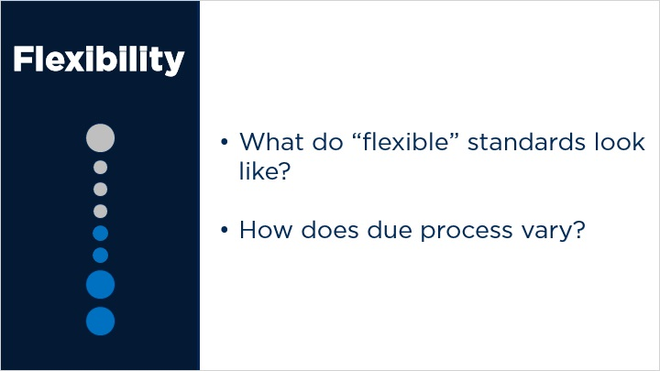

1.11 Public v Private
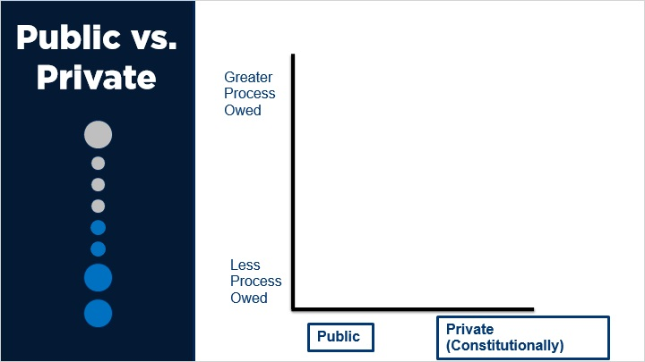

1.12 P v P w Contract and Laws
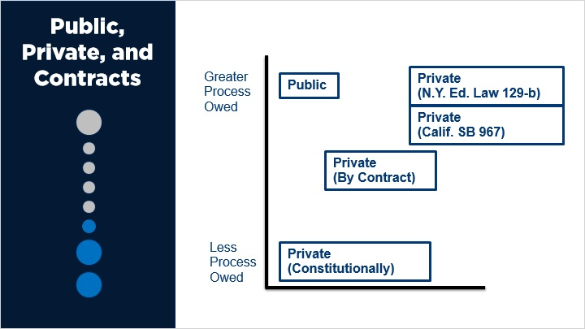

1.13 Type of charge
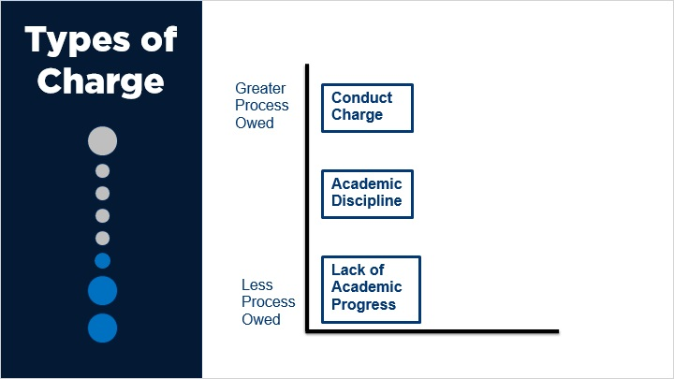

1.14 Deprivation
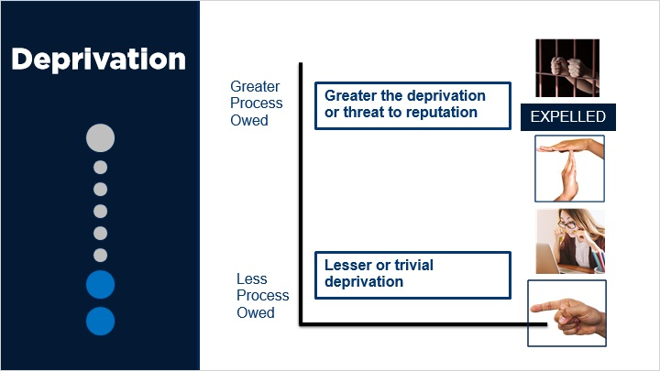

1.15 Academic status
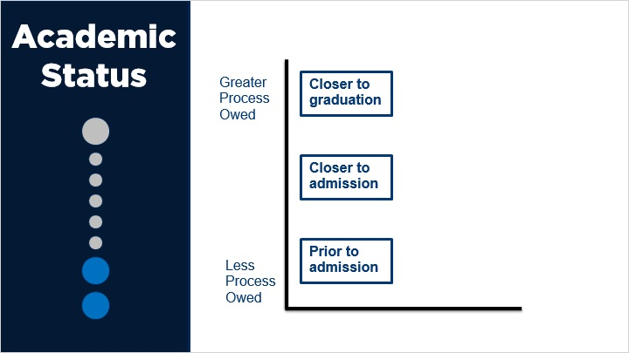

2. Major Cases

2.1 The 5th Amendment
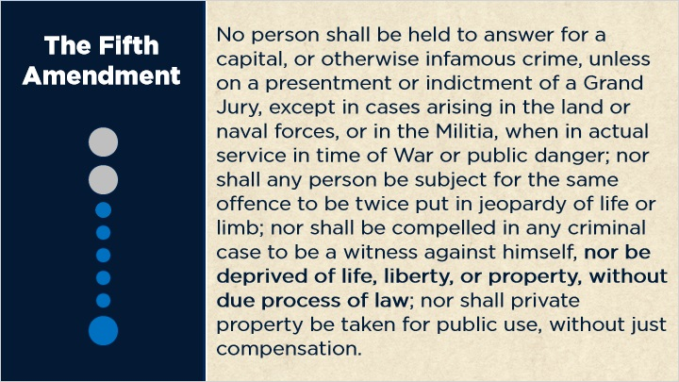

2.2 14th Amendment
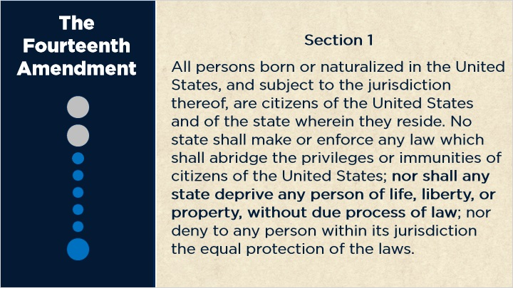

2.3 Big Picture Theory
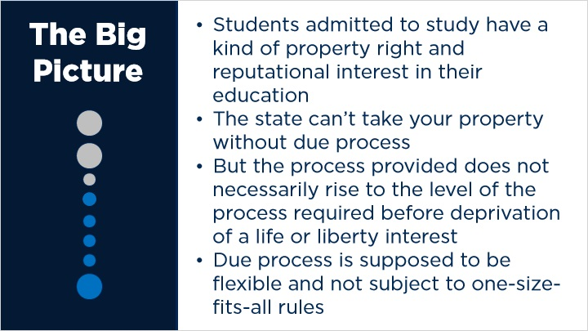

2.4 Goldberg v. Kelly
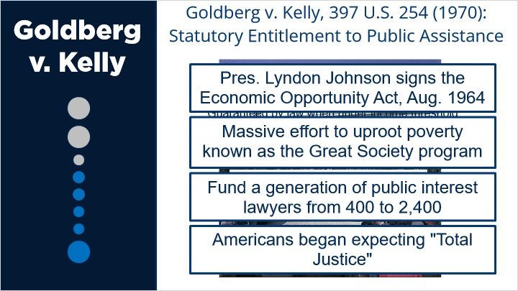
Notes:
- Where there is a statutory entitlement, individual set to lose benefits is entitled to timely and adequate notice of the potential deprivation, an oral hearing before impartial decision-maker, the right to present evidence at such a hearing, the right to confront/cross examine witnesses, and right to written decision stating the decision, evidence relied upon and legal basis (need not be a formal judicial opinion).

- No right to a formal trial.

- The Government (in general) need not provide the individual with an attorney but must allow them to bring their own attorney.

- The decision-maker can have had prior involvement in the case, but should not have participated in making the decision that is the subject of the hearing

2.5 Goldberg v. Kelly and Due Process
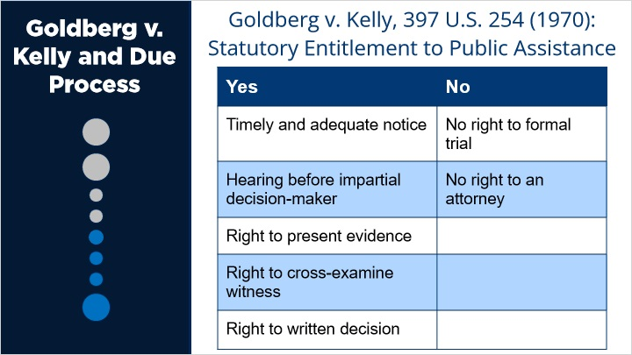
Notes:

2.6 Mathews v. Eldridge
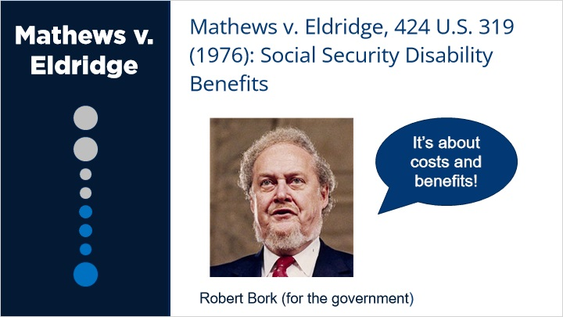
Notes:
We are in effect dealing with a cost benefit judgment and so view the question becomes really how many -- the decision of this case will have a heavy impact upon the decision of how many decisional processes of government must be conform to a judicial model rather than to an administrative model.
I think that is important and I think clearly there has to be stopping point somewhere to the imposition of judicial models upon the governmental decision making because it is very expensive and in some circumstances which I would contend, this is one, adds little or nothing to the alternative procedures provided.

2.7 Mathews v. Eldridge: Social Security Disability Benefits
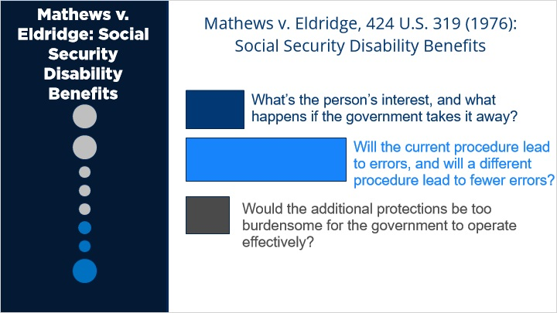

2.8 Mathews III
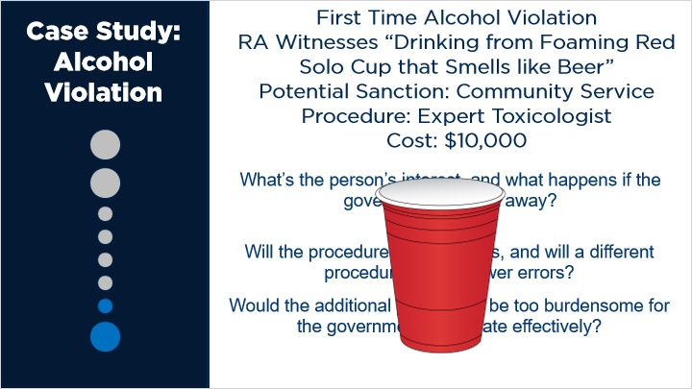

2.9 Constantineau
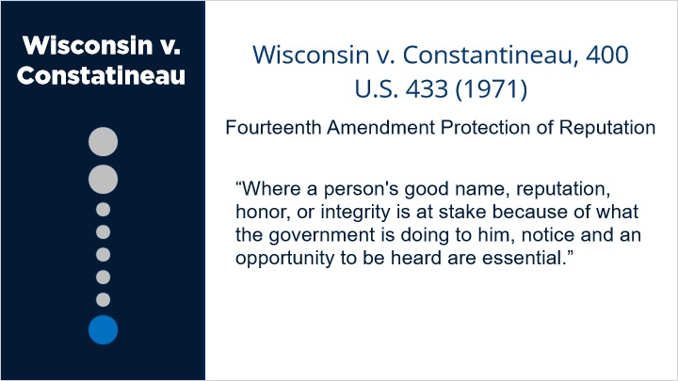
Notes:
MR. JUSTICE DOUGLAS delivered the opinion of the Court.
Appellee is an adult resident of Hartford, Wis. She brought suit in a federal district court in Wisconsin to have a Wisconsin statute declared unconstitutional....The Act...provides that designated persons may in writing forbid the sale or gift of intoxicating liquors to one who "by excessive drinking" produces described conditions or exhibits specified traits, such as exposing himself or family "to want" or becoming "dangerous to the peace" of the community.
The chief of police of Hartford, without notice or hearing to appellee, caused to be posted a notice in all retail liquor outlets in Hartford that sales or gifts of liquors to appellee were forbidden for one year. Thereupon this suit was brought against the chief of police claiming damages and asking for injunctive relief....
We have no doubt as to the power of a State to deal with the evils described in the Act. The police power of the States over intoxicating liquors was extremely broad even prior to the Twenty-first Amendment. The only issue present here is whether the label or characterization given a person by "posting," though a mark of serious illness to some, is to others such a stigma or badge of disgrace that procedural due process requires notice and an opportunity to be heard. We agree with the District Court that the private interest is such that those requirements of procedural due process must be met.
It is significant that most of the provisions of the Bill of Rights are procedural, for it is procedure that marks much of the difference between rule by law and rule by fiat.
Generalizations are hazardous as some state and federal administrative procedures are summary by reason of necessity or history. Yet certainly where the State attaches "a badge of infamy" to the citizen, due process comes into play. "[T]he right to be heard before being condemned to suffer grievous loss of any kind, even though it may not involve the stigma and hardships of a criminal conviction, is a principle basic to our society."
Where a person's good name, reputation, honor, or integrity is at stake because of what the government is doing to him, notice and an opportunity to be heard are essential. "Posting" under the Wisconsin Act may to some be merely the mark of illness, to others it is a stigma, an official branding of a person. The label is a degrading one. Under the Wisconsin Act, a resident of Hartford is given no process at all. This appellee was not afforded a chance to defend herself. She may have been the victim of an official's caprice. Only when the whole proceedings leading to the pinning of an unsavory label on a person are aired can oppressive results be prevented....
In the present case the Wisconsin Act does not contain any provision whatsoever for notice and hearing. There is no ambiguity in the state statute. There are no provisions which could fairly be taken to mean that notice and hearing might be given under some circumstances or under some construction but not under others. The Act on its face gives the chief of police the power to do what he did to the appellee. Hence the naked question, uncomplicated by an unresolved state law, is whether that Act on its face is unconstitutional....

3. School Law

3.1 Dixon
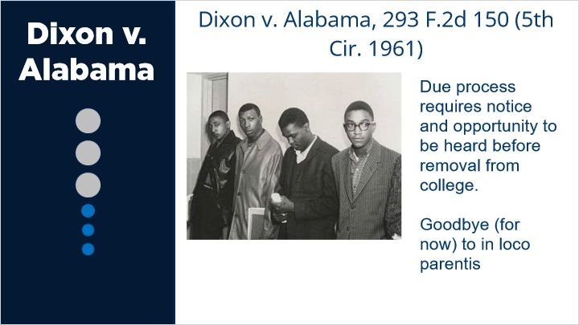
Notes:

3.2 Goss v. Lopez
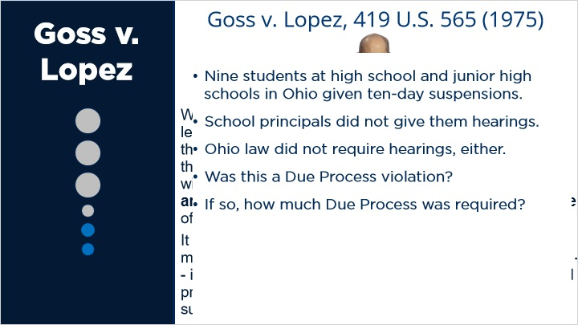

3.3 Goss v. Lopez: Conducting Hearing
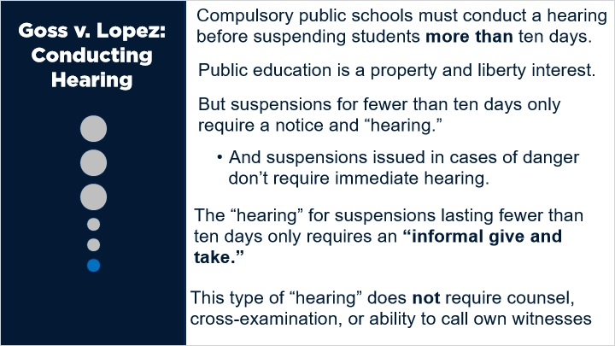

3.4 Review
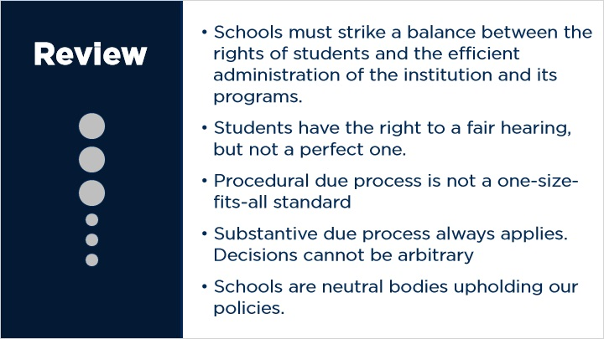

4. Conclusion

4.1 Next Steps
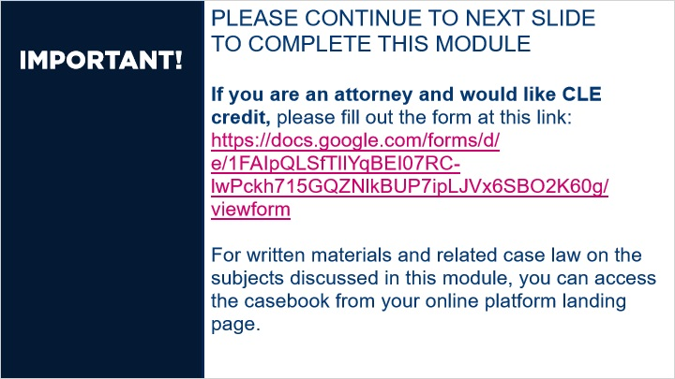
Notes:

5. Exit Questions

5.1 Attest
(True/False, 100 points, 1 attempt permitted)
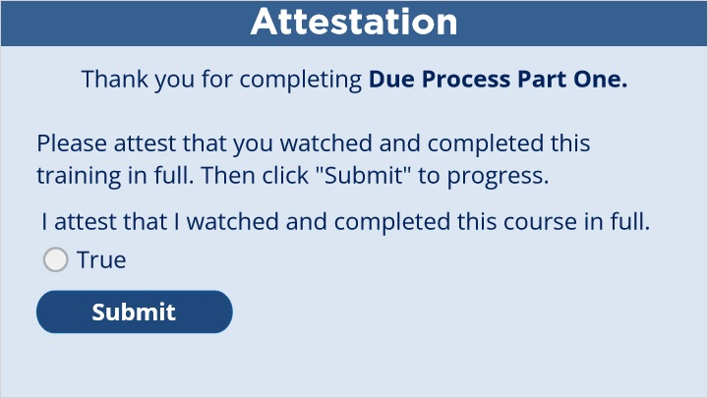
Correct | Choice
 | True

Notes:

5.2 Continue
(Results Slide, 0 points, 1 attempt permitted)


Results for
5.1 Attest

Result slide properties | Passing Score
80%

Success (Slide Layer)

Failure (Slide Layer)

5.3 End Course


