26-27 Due Process Part Two: Practical Applications

1. Introduction

1.1 SCI Welcome & legal disclaimer
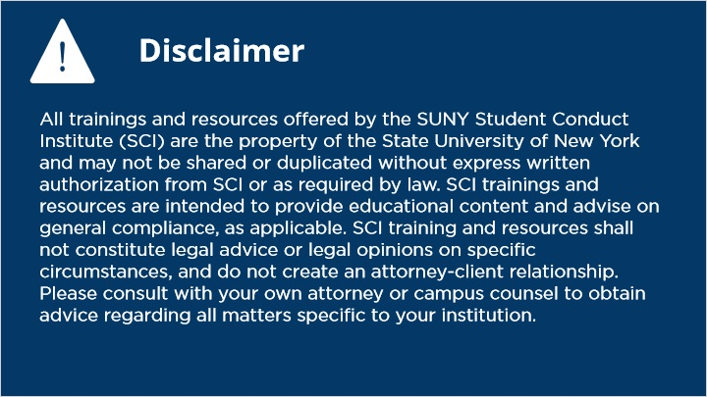
Notes:

1.2 Title Slide
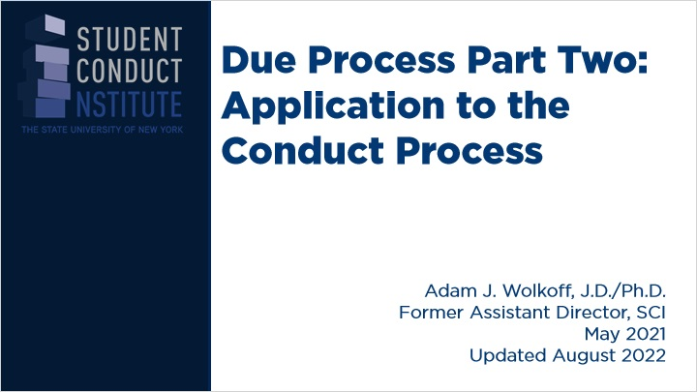
Notes:

1.3 Major concepts
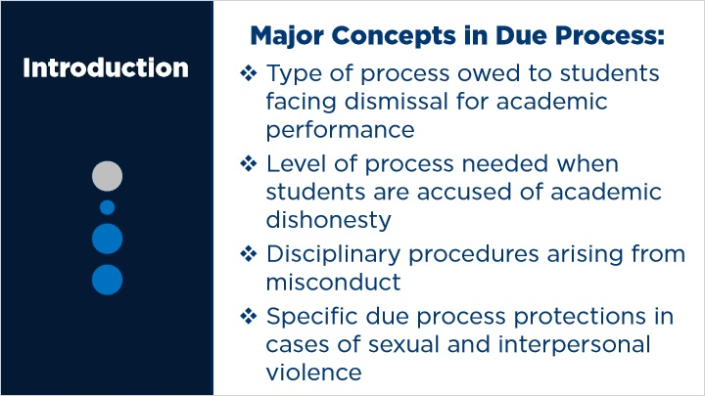
Notes:

1.4 Theory review
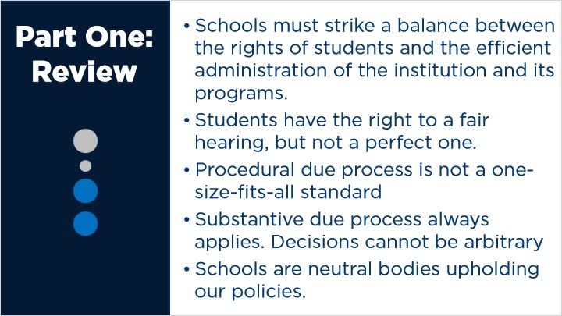
Notes:

2. General Rules

2.1 General Rules Intro
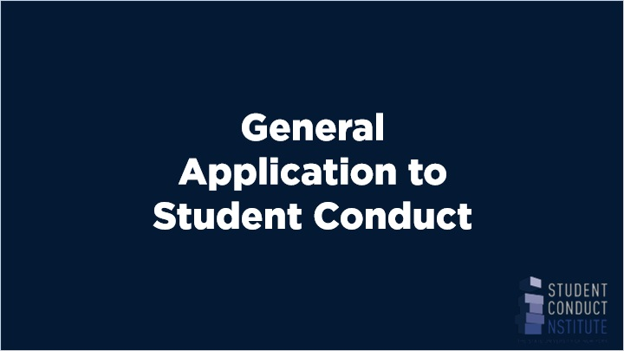
Notes:
Joe to review

2.2 Types of charges
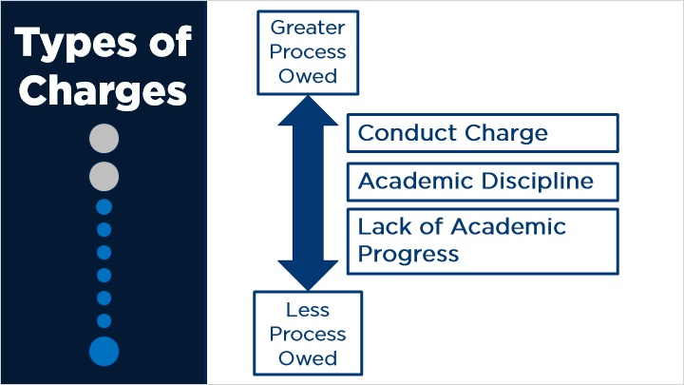

2.3 Academic dissatisfaction: Frankfurter
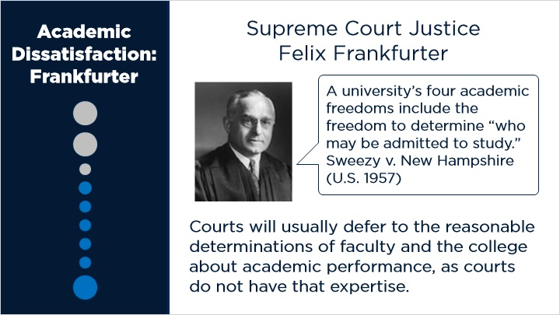

2.4 Academic dissatisfaction: Rehnquist
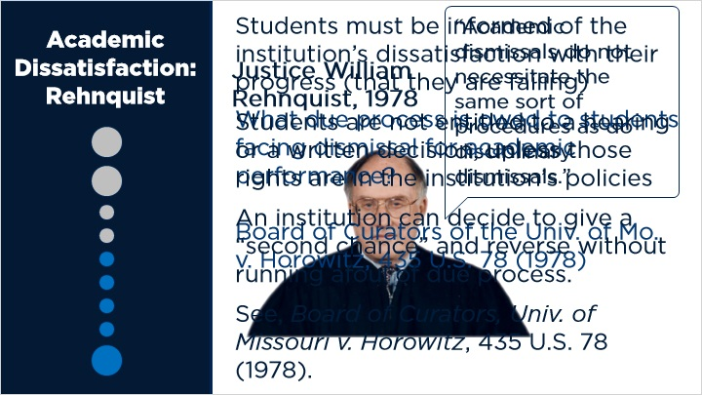

2.5 Substantive Due Process
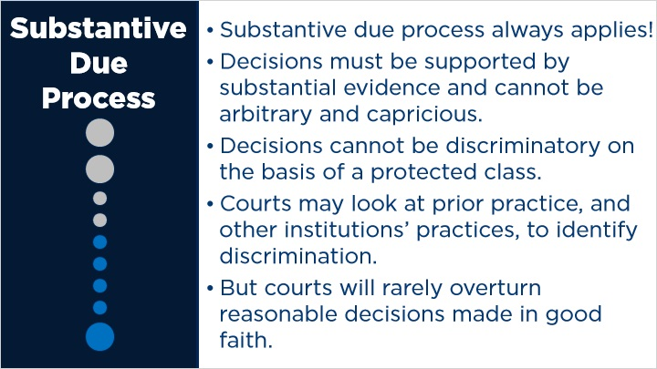

2.6 Academic dishonesty
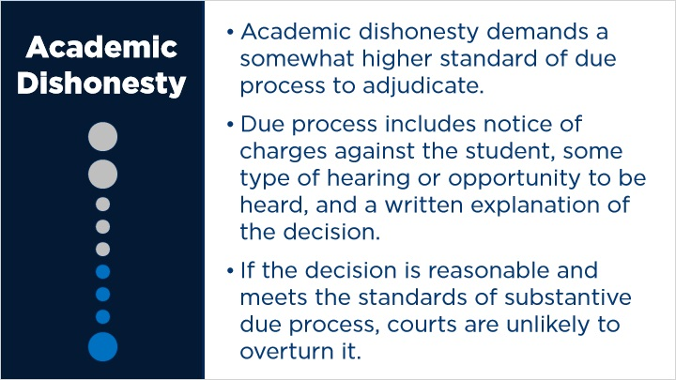

2.7 Conduct Discipline
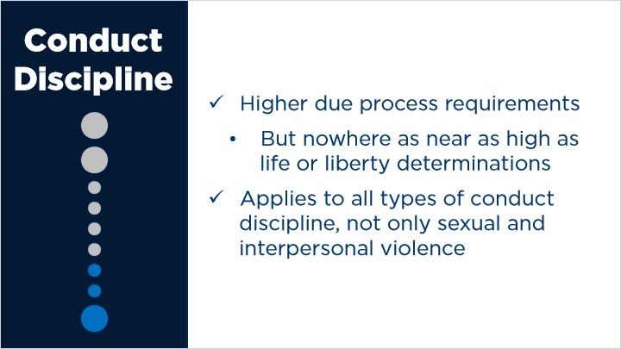

2.8 Notice of Charges
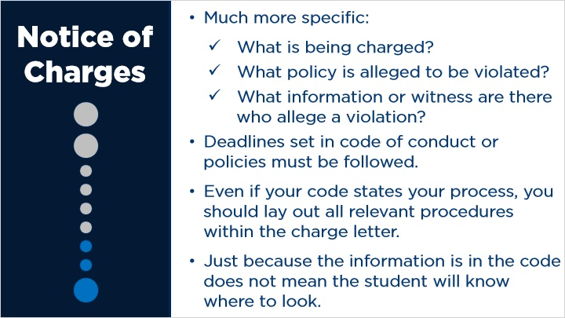

2.9 Scheduling
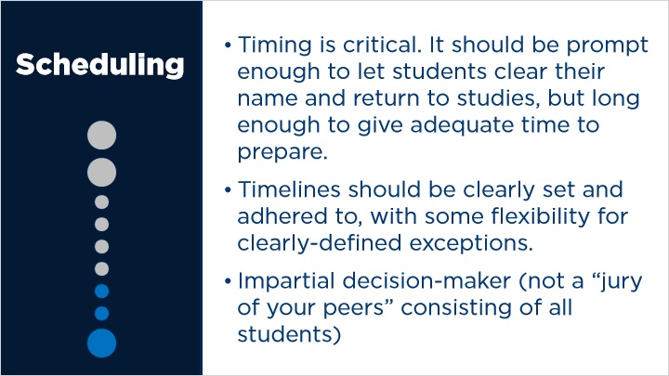

2.10 General hearing rules
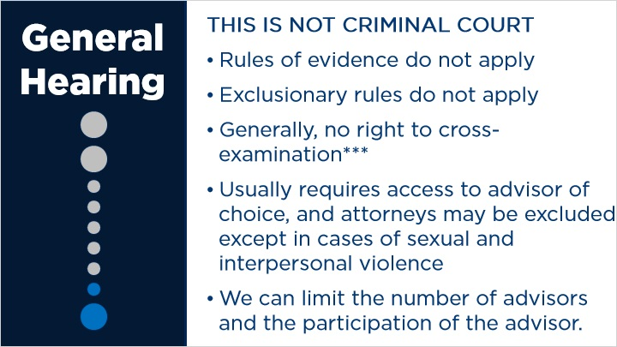

2.11 General hearing rules II
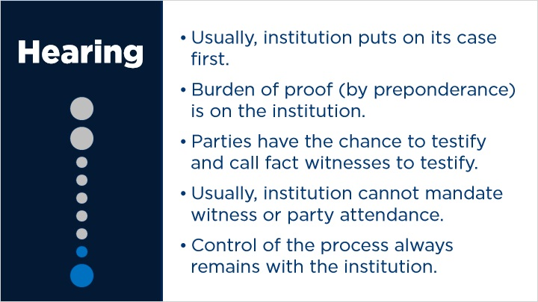

2.12 Decisions in Writing
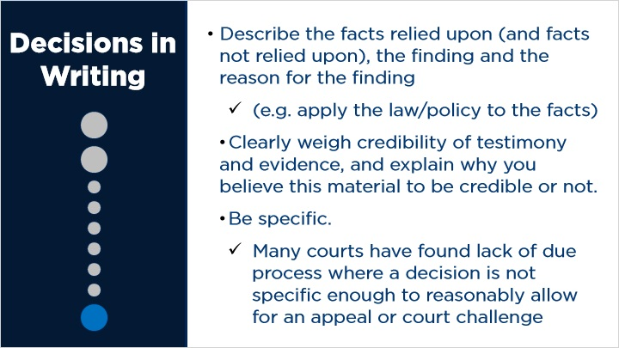

3. Specific Rules

3.1 Specific rules intro
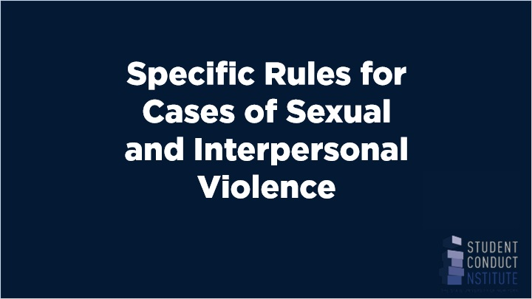
Notes:
Joe to review

3.2 Sources of due process
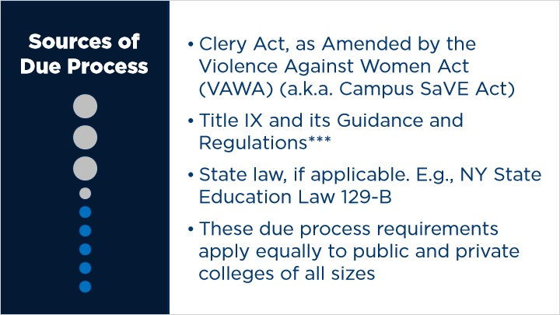

3.3 Equity
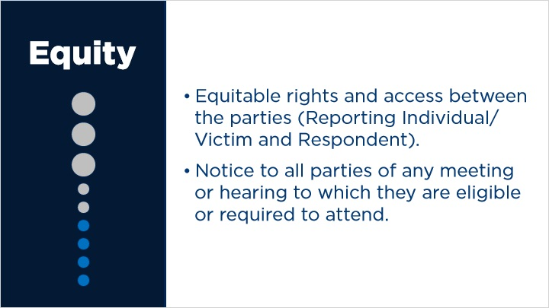

3.4 Advisor
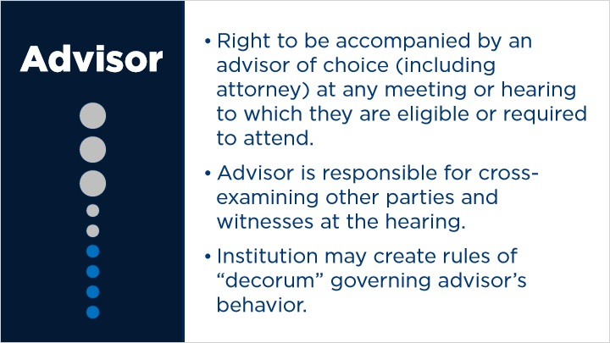

3.5 Standard of evidence
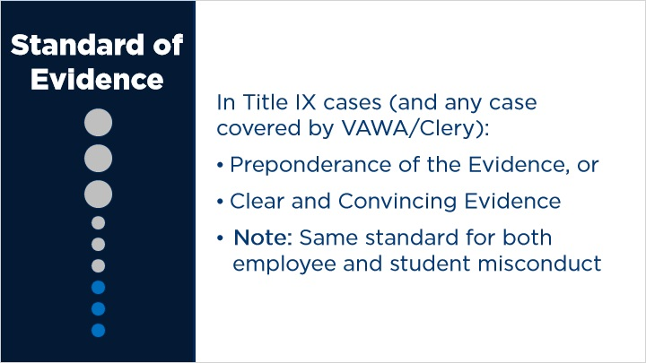
Notes:
- Proposed rule: the recipient must apply either the preponderance of the evidence standard or the clear and convincing evidence standard. The recipient may, however, employ the preponderance of the evidence standard only if the recipient uses that standard for conduct code violations that do not involve sexual harassment but carry the same maximum disciplinary sanction.

- You should use the same standard of proof for all cases of violence, not just sexual violence; the distinction should be, if any, between violent and non-violent violations

- An institution would be able to reserve the clear and convincing evidence standard for SIV cases, but then use the lesser standard for other types of misconduct

- The recipient must also apply the same standard of evidence for complaints against students as it does for complaints against employees, including faculty.

3.6 Notification
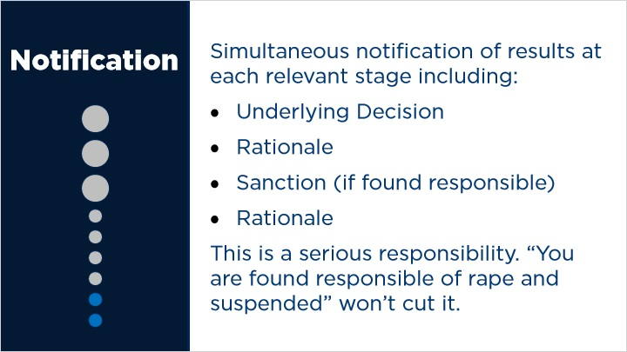

3.7 Sanctions
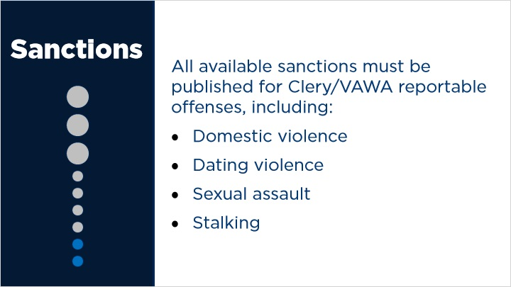

3.8 Appeals
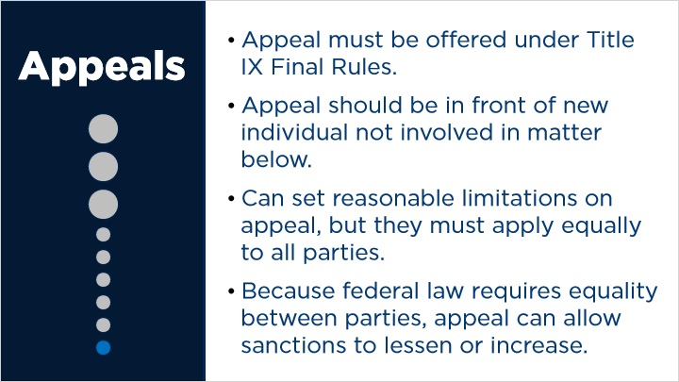

3.9 Substantive due process
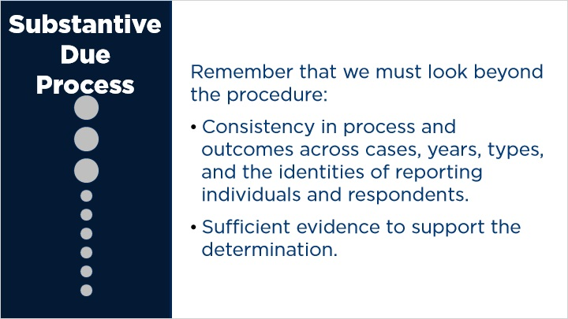

3.10 Litigation
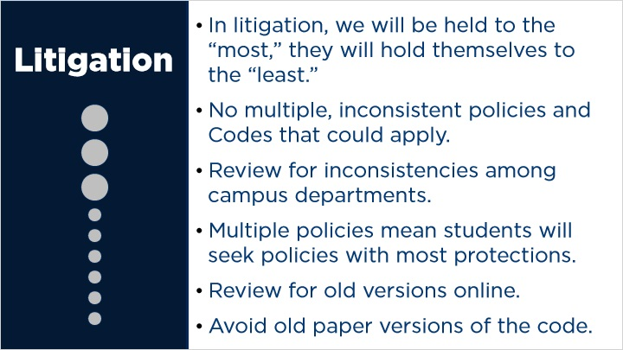

4. Exit Questions

4.1 Attest
(True/False, 100 points, 1 attempt permitted)
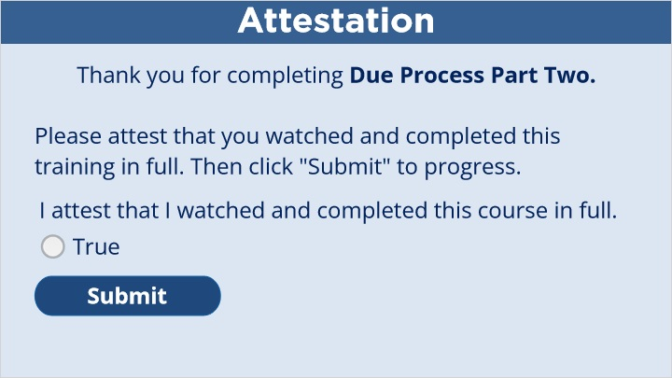
Correct | Choice
 | True

Notes:

4.2 Continue
(Results Slide, 0 points, 1 attempt permitted)
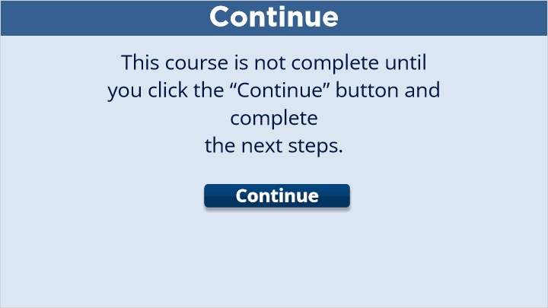

Results for
4.1 Attest

Result slide properties | Passing Score
80%

Success (Slide Layer)

Failure (Slide Layer)

4.3 End Course
