Cultural Awareness

1. Draft

1.1 Title
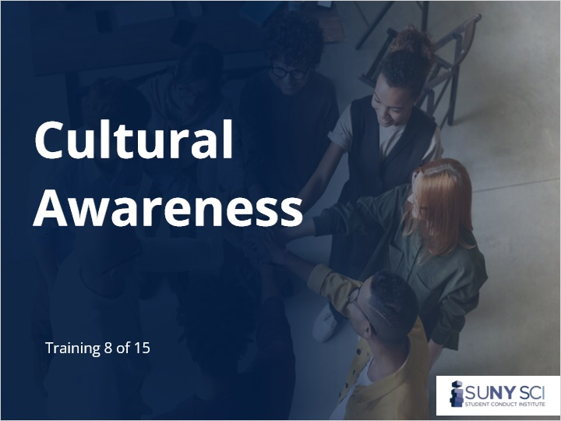
Notes:

1.2 Disclaimer
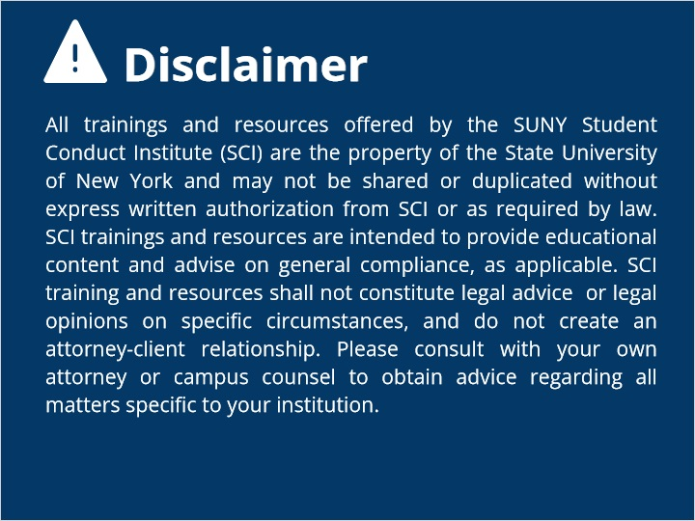
Notes:

1.3 Overview
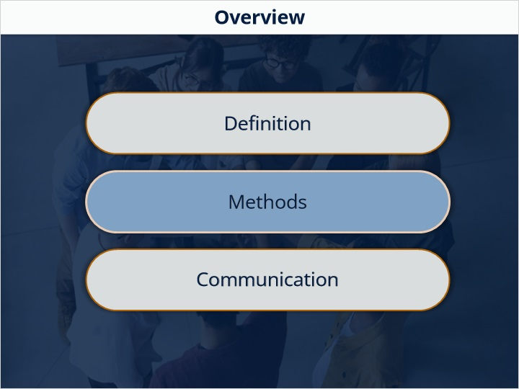

1.4 Cultural Bias
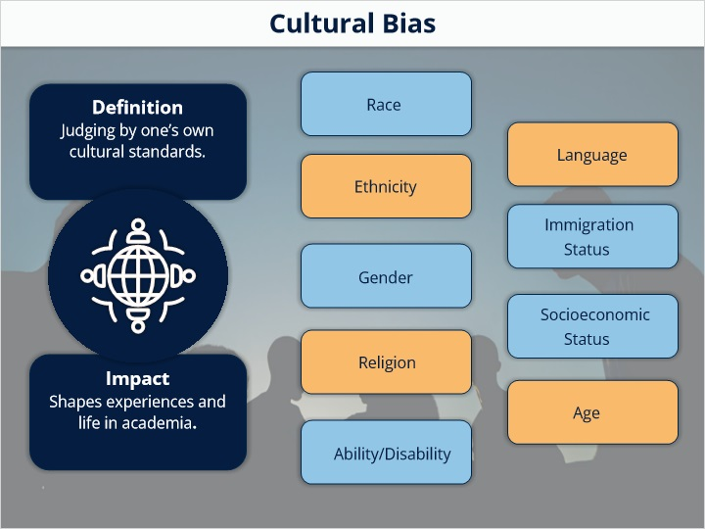

1.5 Understanding Cultural Bias in Title IX
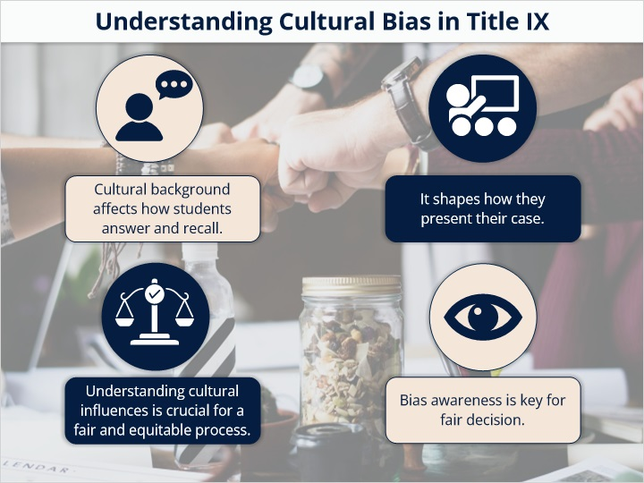

1.6 Cultural Humility
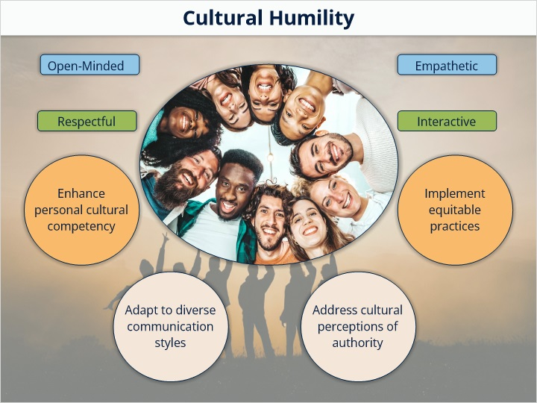

1.7 Enhancing Cultural Competency
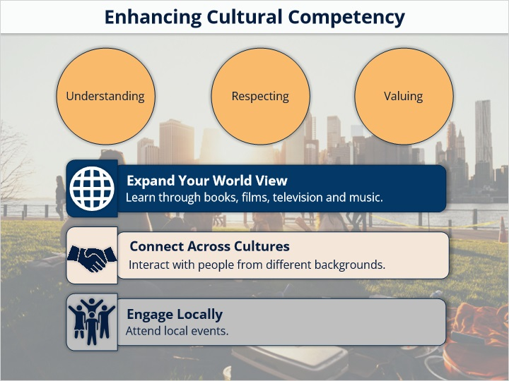

1.8 Adapting to Diverse Communication Styles
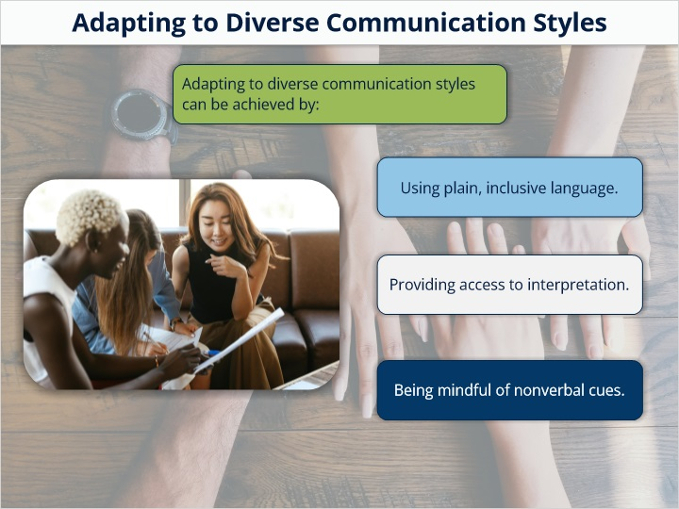
Notes:

1.9 Cultural Humility
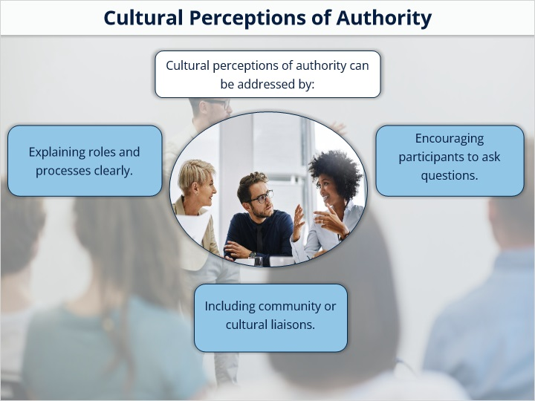

1.10 Implementation of Equitable Practices
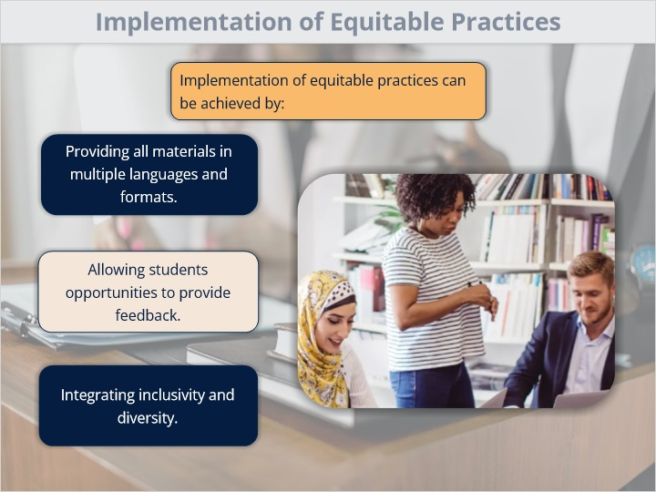

1.11 Knowledge Check
(Multiple Response, 10 points, 1 attempt permitted)
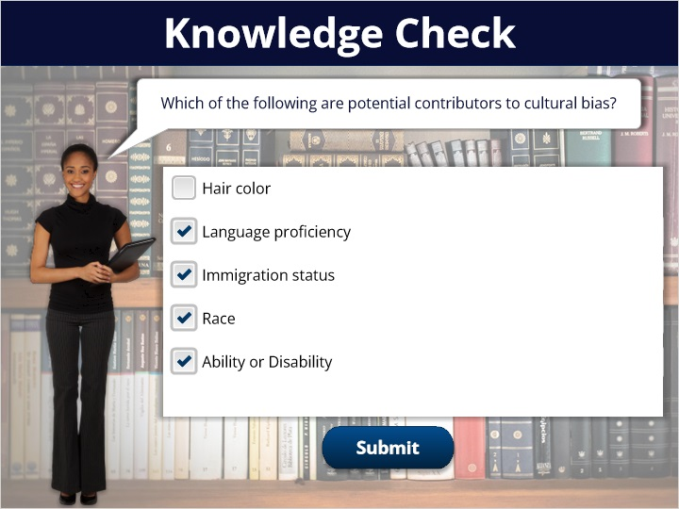
Correct | Choice
 | Hair color
X | Language proficiency
X | Immigration status
X | Race
X | Ability or Disability

Feedback when correct:
Great work!
Feedback when incorrect:
Not quite. Review the guidelines and think about what supports fairness and legality.

1.12 Cultural Bias
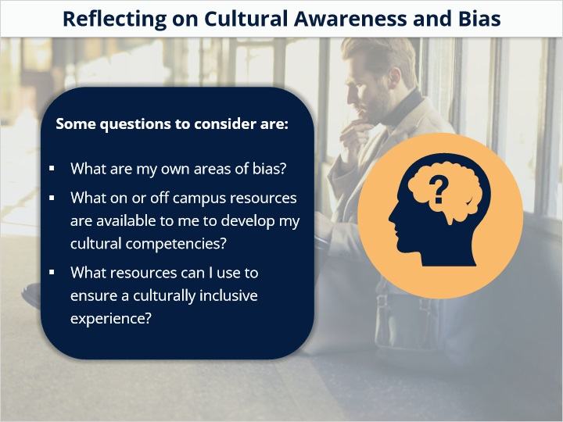

1.13 Conclusion
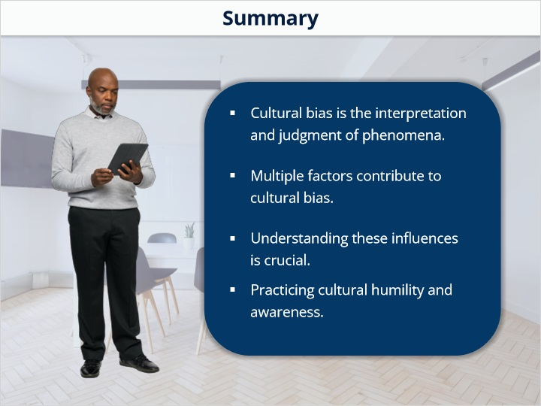

1.14 Next
