Cultural Relevance and Inclusiveness & Responding to Sexual Violence

1. Introduction

1.1 SCI Welcome & Legal disclaimer
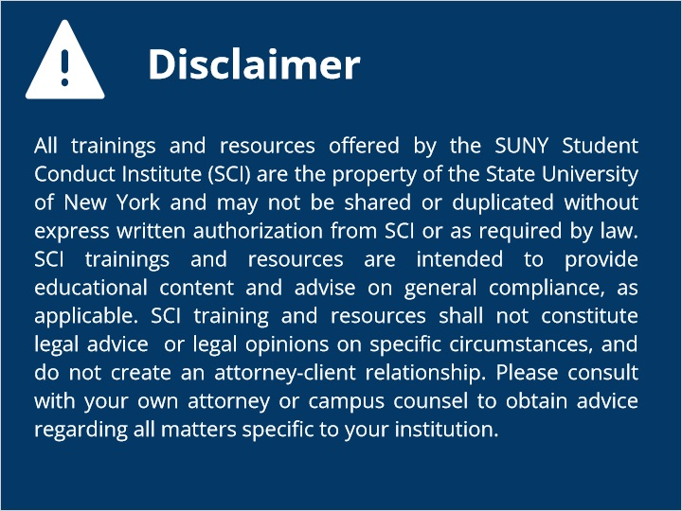
Notes:

1.2 Title Slide
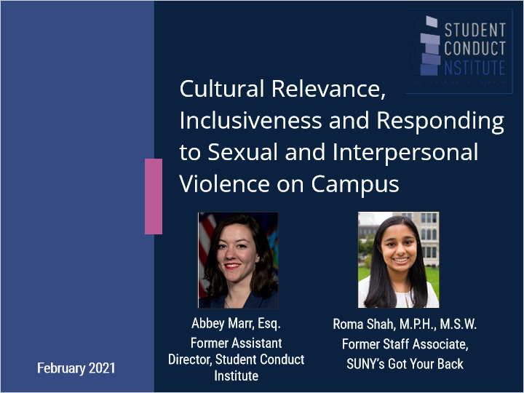
Notes:

1.3 Overview
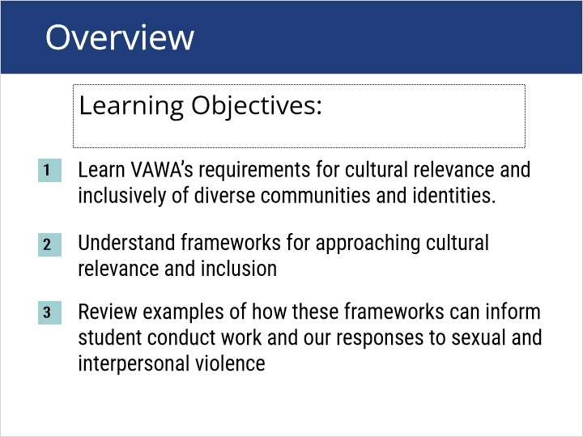
Notes:

1.4 VAWA's Requirements
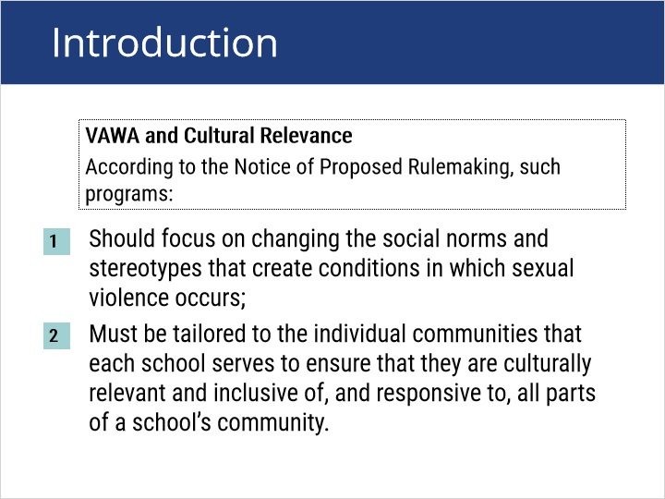

1.5 Demographics: students
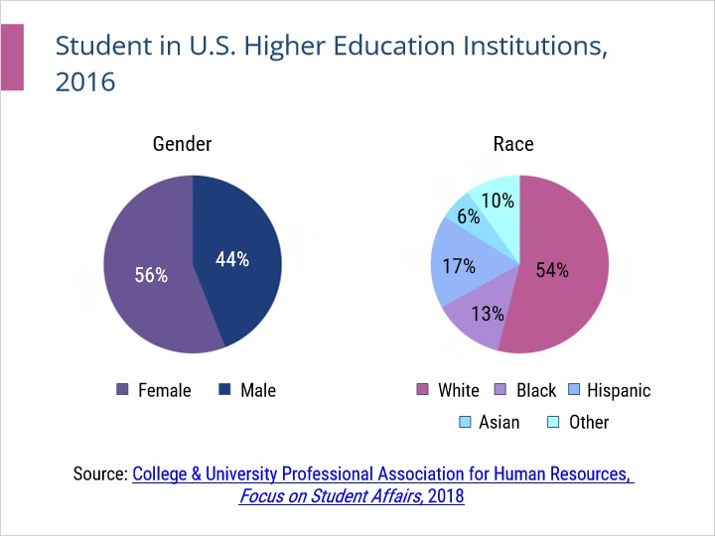

1.6 Demographics: Professionals
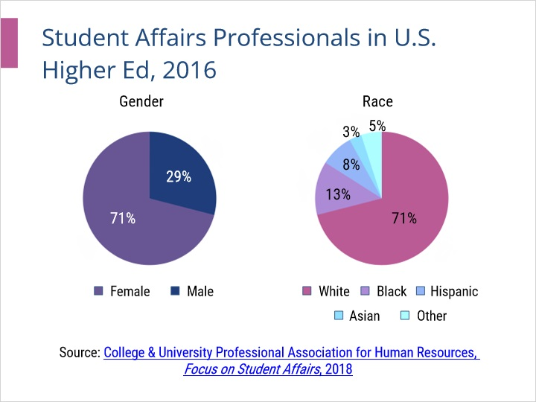

1.7 VAWA and Cultural Relevance
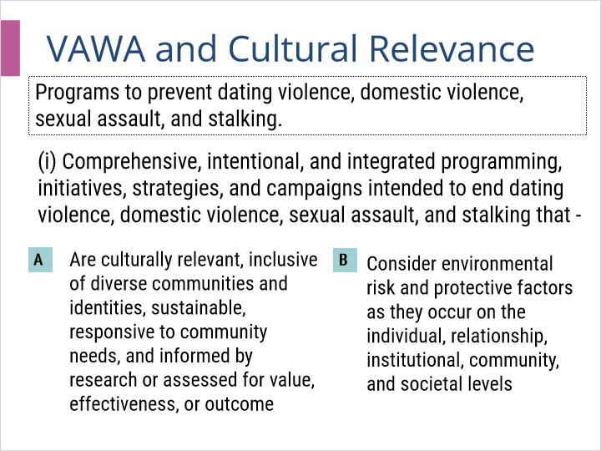

2. Key Concepts

2.1 Key Concepts

Notes:
Joe to review

2.2 Terminology
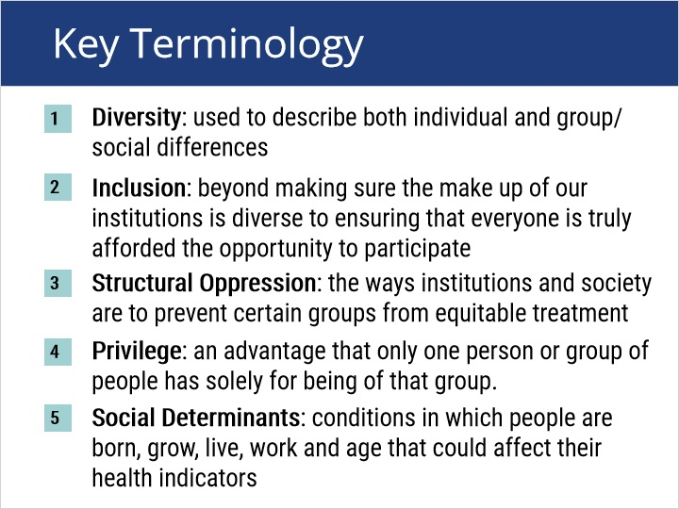

2.3 Key Concepts: Bias
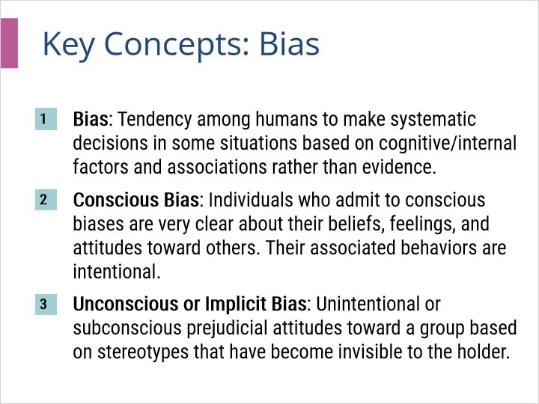

2.4 Cultural Competency
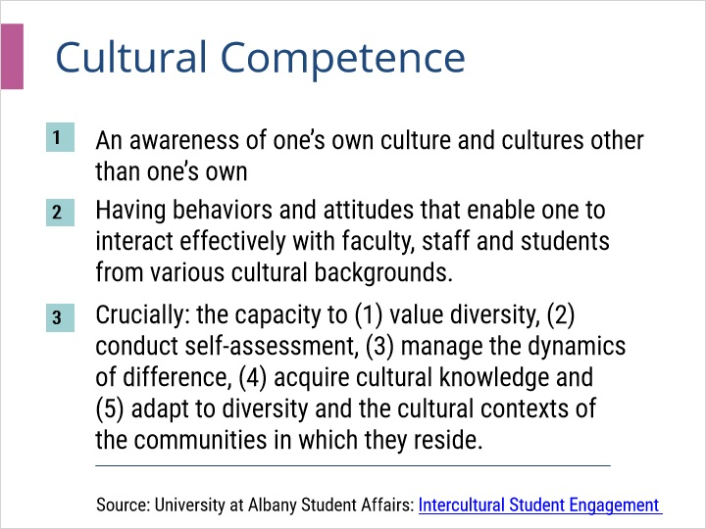

2.5 Cultural Humility
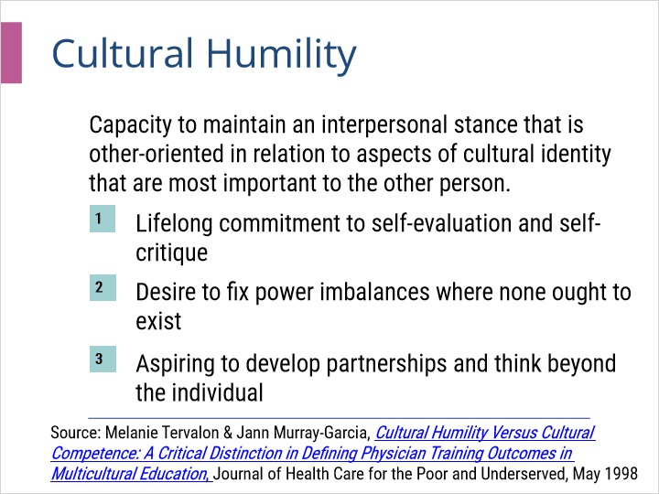

2.6 Intersectionality
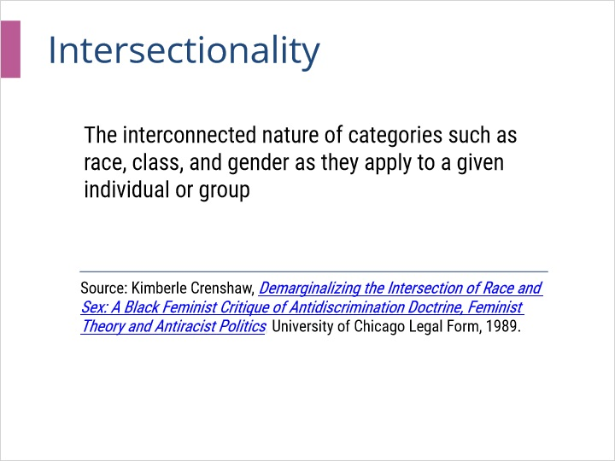

3. Case Studies

3.1 Consider
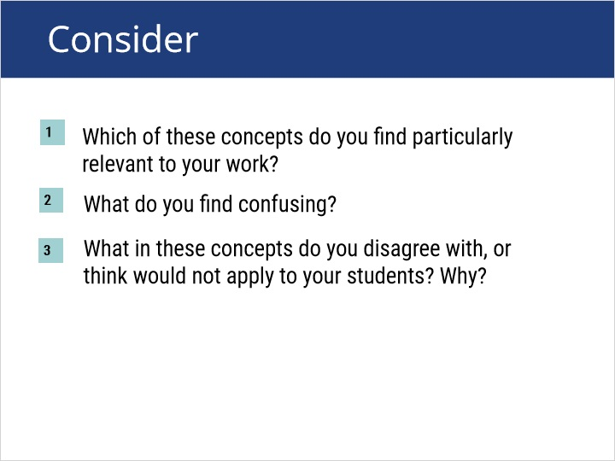
Notes:
Joe to review

3.2 Case Studies
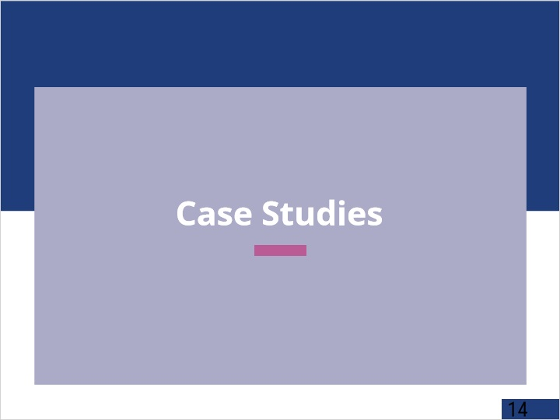
Notes:
Joe to review

3.3 Case Study: 1
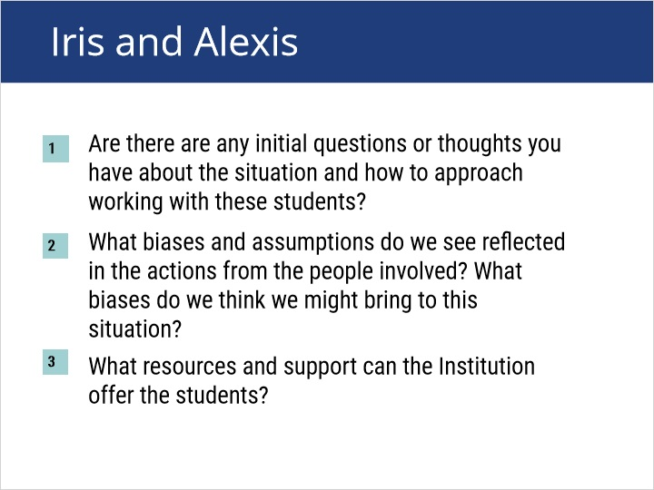

3.4 Case Study: 2
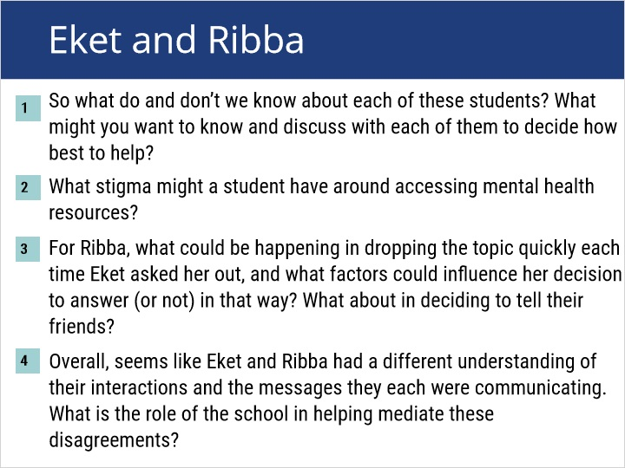
Notes:
University may have acted in deliberate indifference of reporting individual's Title IX rights where it permitted an appeal to the university's NCAA representative. That individual was not indicated as part of the appeal process in the code of conduct, and the reporting individual was not notified that the respondent had sought an appeal through this representative. Doe v. Univ. of Alabama in Huntsville, 177 F. Supp. 3d 1380, 1386 (N.D. Ala. 2016)

Where a university brings charges against a respondent based on violations of a code of conduct, it is obliged to provide all procedural rights described in that code, including any appeal rights. Thus, a university violated a respondent's due process rights where it charged him under a 2013-2014 code, which gave the right to an appeal by committee, but then applied a conduct procedure that did not offer the same appeal process: the appeal was conducted by the Title IX coordinator, who had previously issued the sanction. The university compounded this error by sending the respondent various correspondence indicating that he was being charged under the 2014-2015 code, rather than the 2013-2014 code. Norris v. Univ. of Colorado, Boulder, No. 1:18-CV-02243-LTB, 2019 WL 764568, at *15 (D. Colo. Feb. 21, 2019).

4. Conclusion

4.1 Conclusion
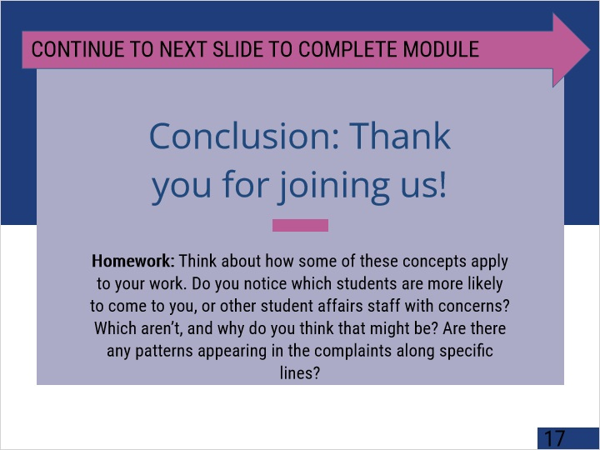
Notes:
University may have acted in deliberate indifference of reporting individual's Title IX rights where it permitted an appeal to the university's NCAA representative. That individual was not indicated as part of the appeal process in the code of conduct, and the reporting individual was not notified that the respondent had sought an appeal through this representative. Doe v. Univ. of Alabama in Huntsville, 177 F. Supp. 3d 1380, 1386 (N.D. Ala. 2016)

Where a university brings charges against a respondent based on violations of a code of conduct, it is obliged to provide all procedural rights described in that code, including any appeal rights. Thus, a university violated a respondent's due process rights where it charged him under a 2013-2014 code, which gave the right to an appeal by committee, but then applied a conduct procedure that did not offer the same appeal process: the appeal was conducted by the Title IX coordinator, who had previously issued the sanction. The university compounded this error by sending the respondent various correspondence indicating that he was being charged under the 2014-2015 code, rather than the 2013-2014 code. Norris v. Univ. of Colorado, Boulder, No. 1:18-CV-02243-LTB, 2019 WL 764568, at *15 (D. Colo. Feb. 21, 2019).

4.2 SCI Exit slide
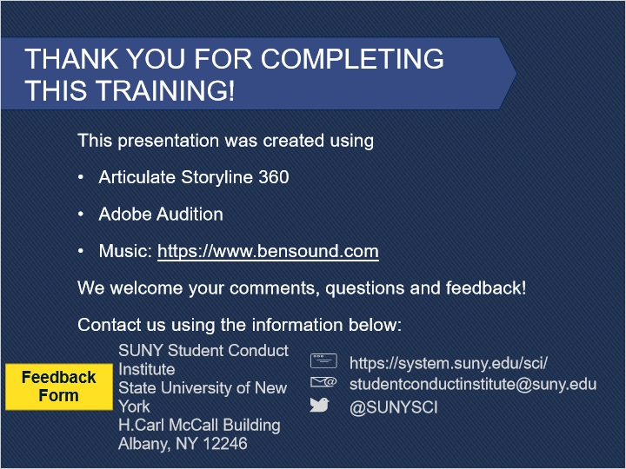
Notes:

5. Lightbox

5.1 Need Help?
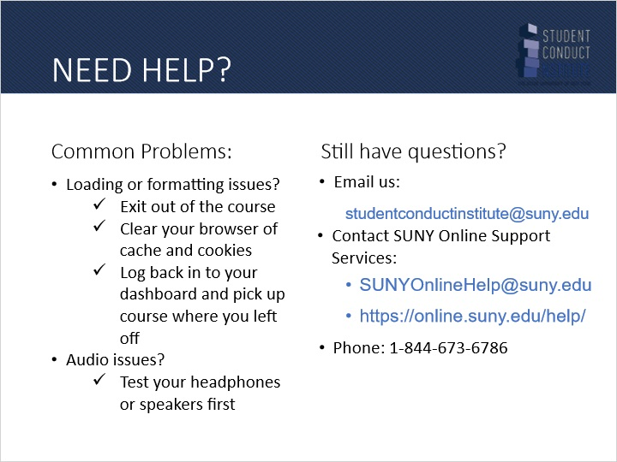
Notes:

