Due Process and Compliance_V2 Review

1. Due Process Draft

1.1 Title

Notes:

1.2 Disclaimer
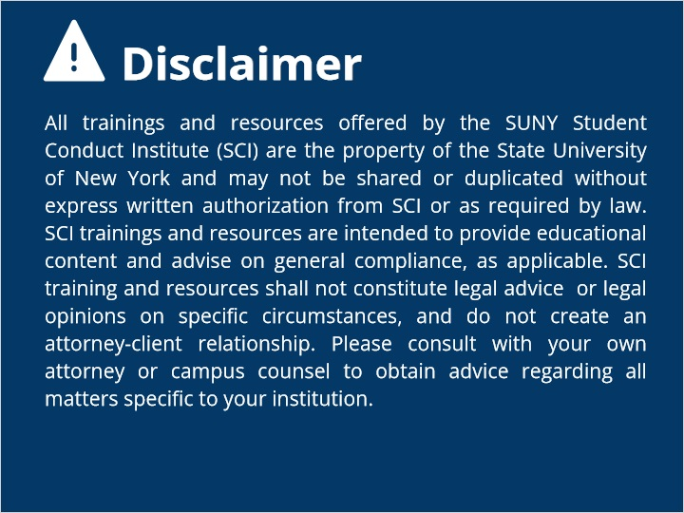
Notes:

1.3 Overview
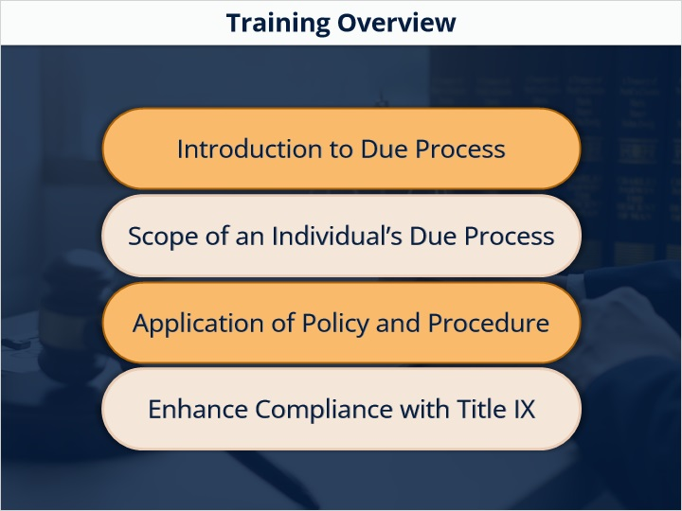

1.4 Intro to Due Process
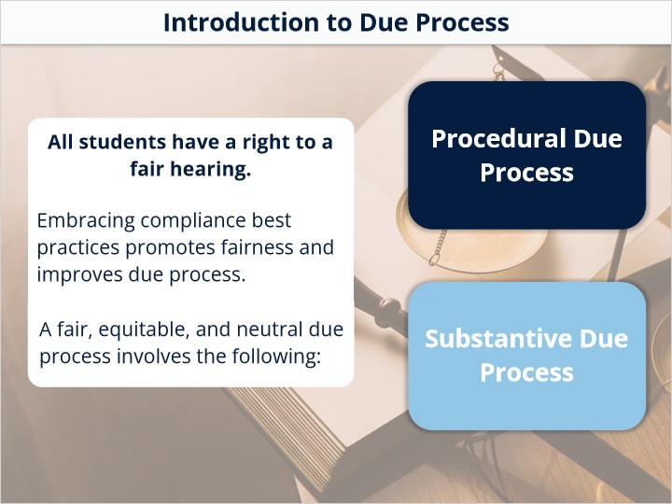

1.5 Kinds of Due Process
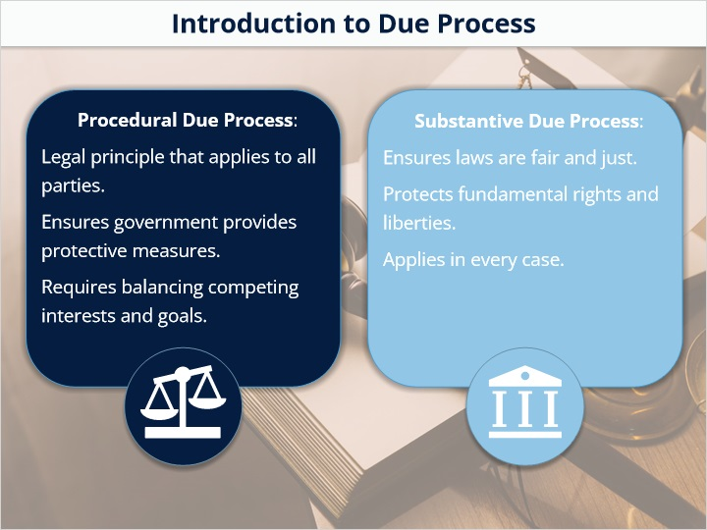

1.6 Due Process History
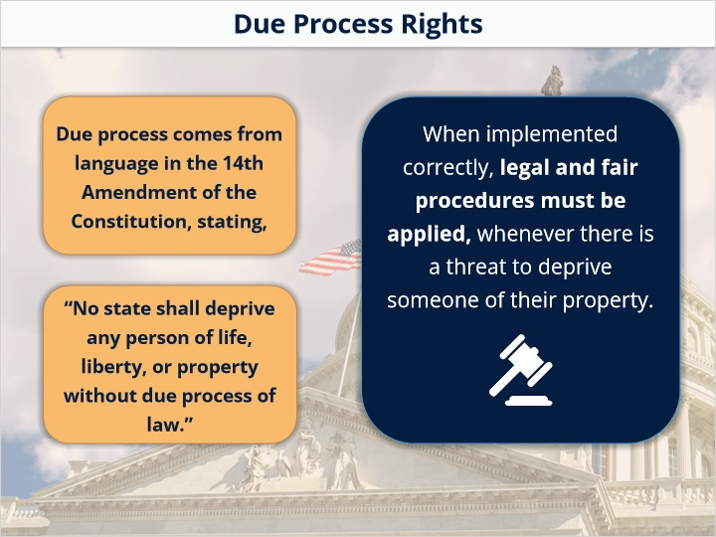

1.7 Education is Property
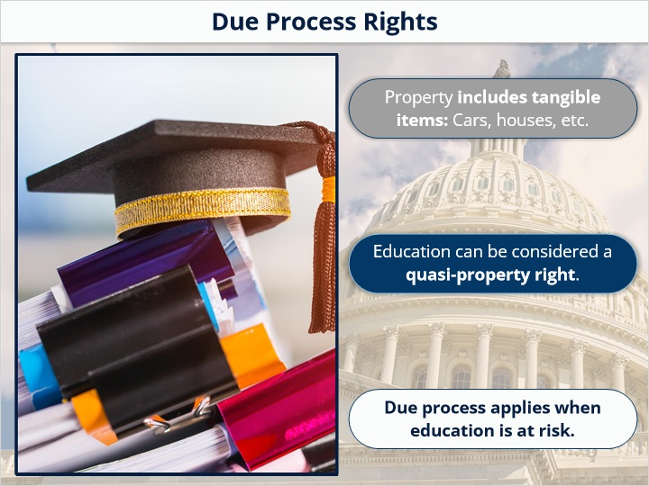

1.8 Guaranteed Title 9 Rights
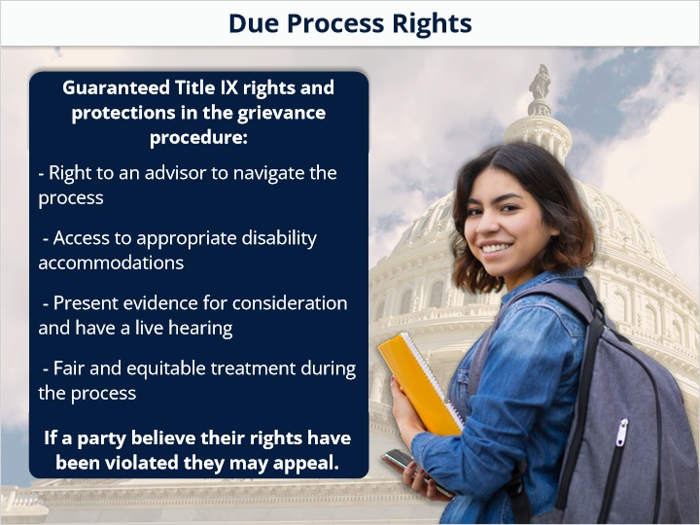

1.9 Levels of Due Process
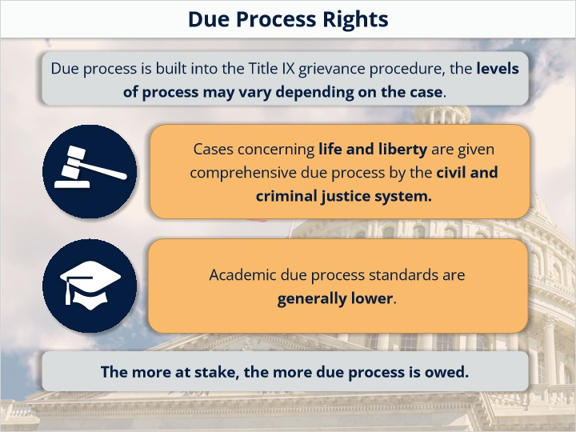

1.10 Amount of Due Process
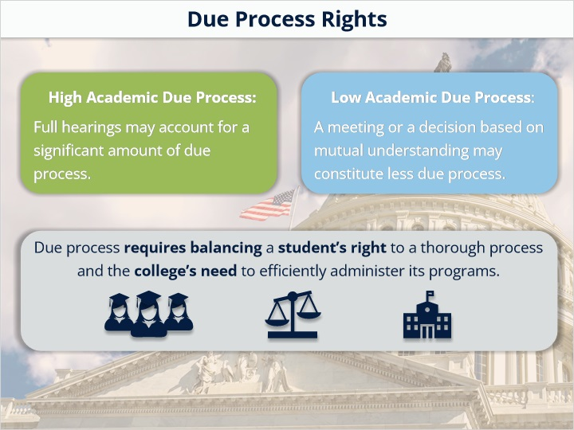

1.11 Fair and Equitable Process
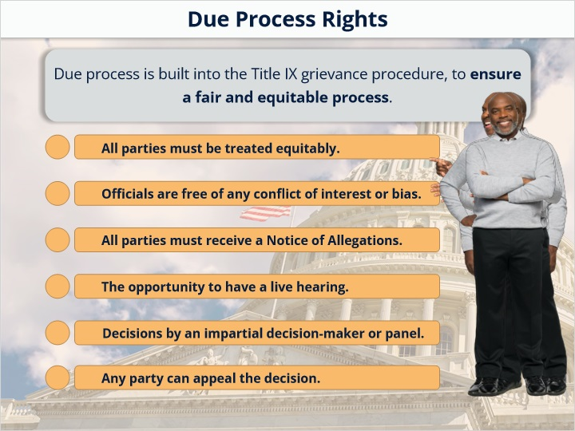

1.12 KC 1 - Due Process Rights
(Multiple Choice, 10 points, 1 attempt permitted)
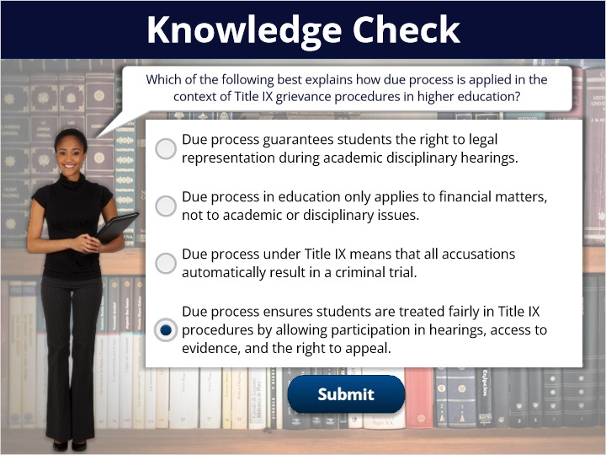
Correct | Choice
 | Due process guarantees students the right to legal representation during academic disciplinary hearings.
 | Due process in education only applies to financial matters, not to academic or disciplinary issues.
 | Due process under Title IX means that all accusations automatically result in a criminal trial.
X | Due process ensures students are treated fairly in Title IX procedures by allowing participation in hearings, access to evidence, and the right to appeal.

Feedback when correct:
Great work!
Feedback when incorrect:
Title IX involves equitable treatment, the opportunity to present evidence and be heard, access to advisors, and the ability to appeal.

1.13 Implementation
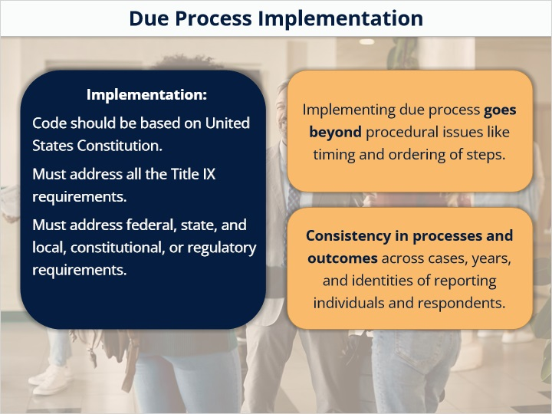

1.14 Review


1.15 Equal Treatment
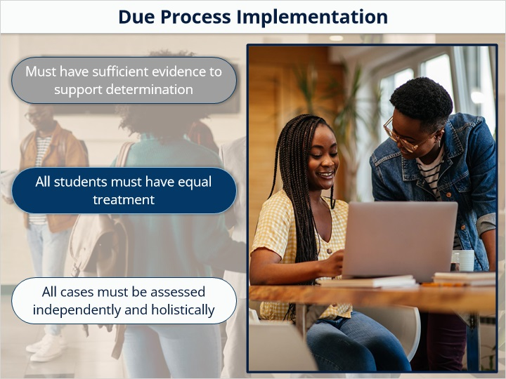

1.16 Understand Policy
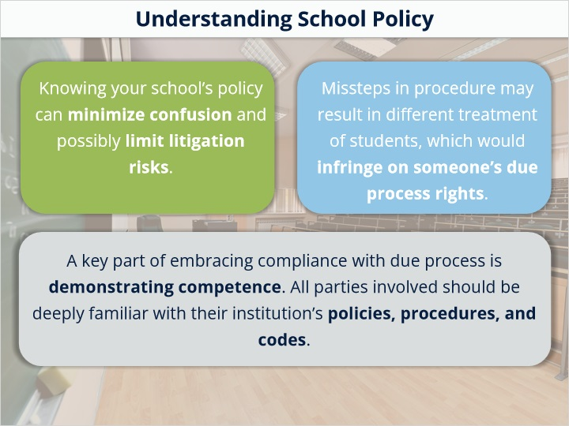

1.17 How to Understand
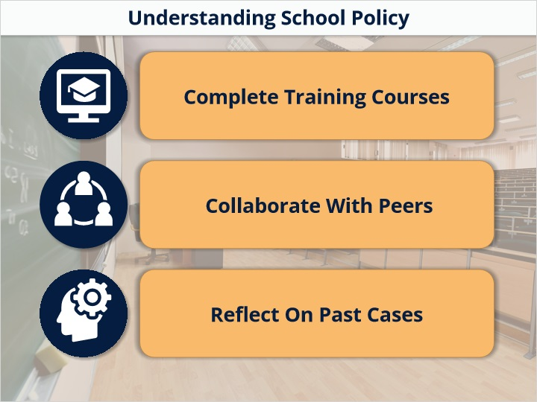

1.18 129-B
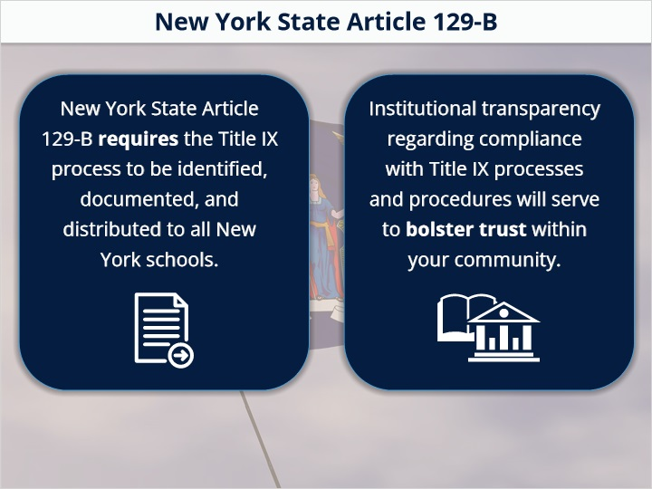
Notes:

1.19 End Slide
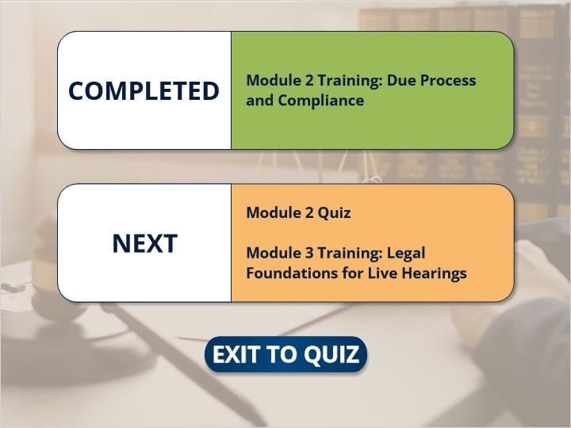
Notes:

