Appeals

1. Appeals

1.1 Title

Notes:

1.2 Disclaimer
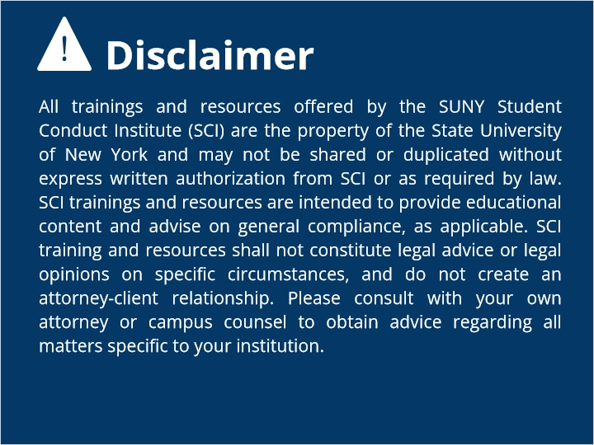

1.3 Overview
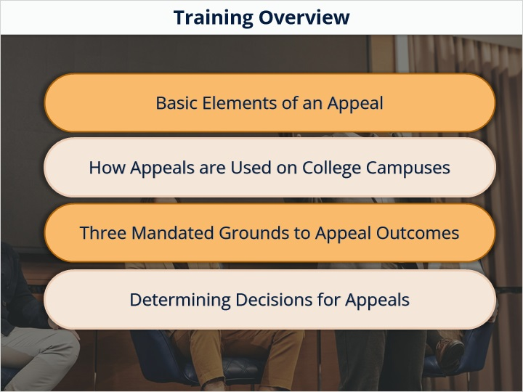

1.4 what is appeal
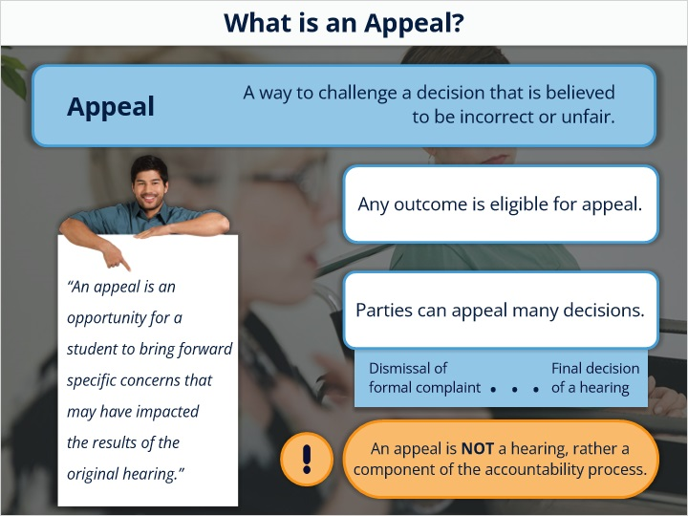

1.5 3 mandated grounds
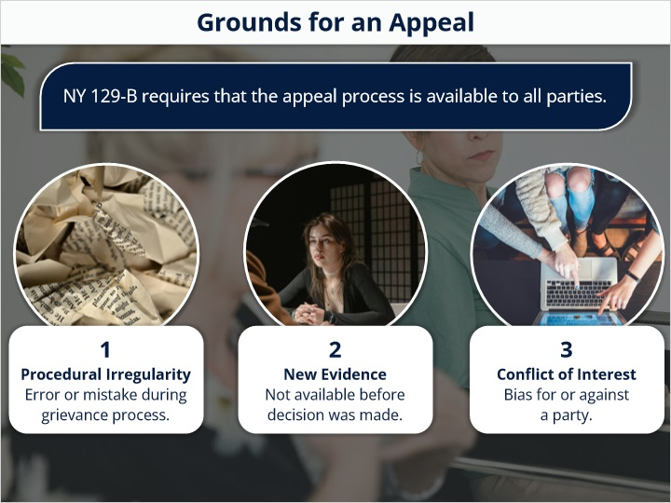

1.6 Changing Outcomes
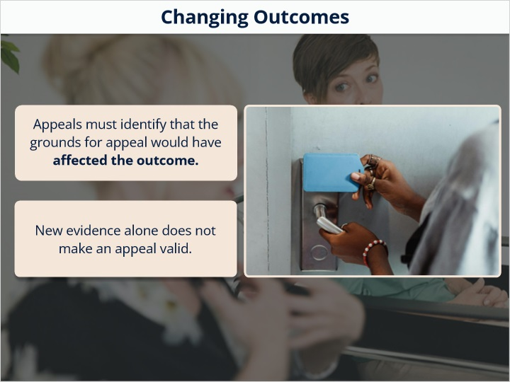

1.7 not an appeal
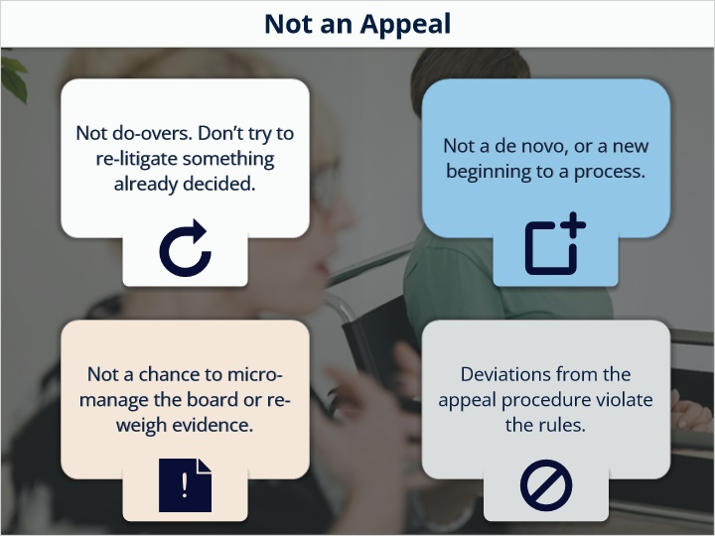

1.8 notice
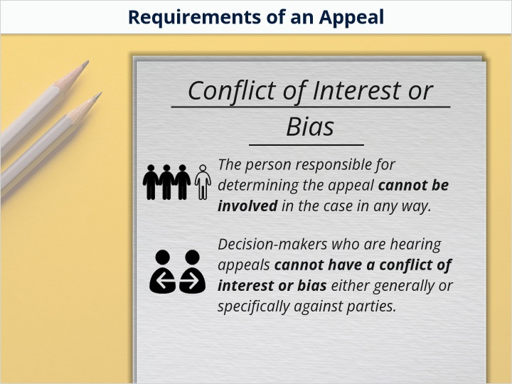

1.9 Multiple Response
(Multiple Response, 10 points, 1 attempt permitted)
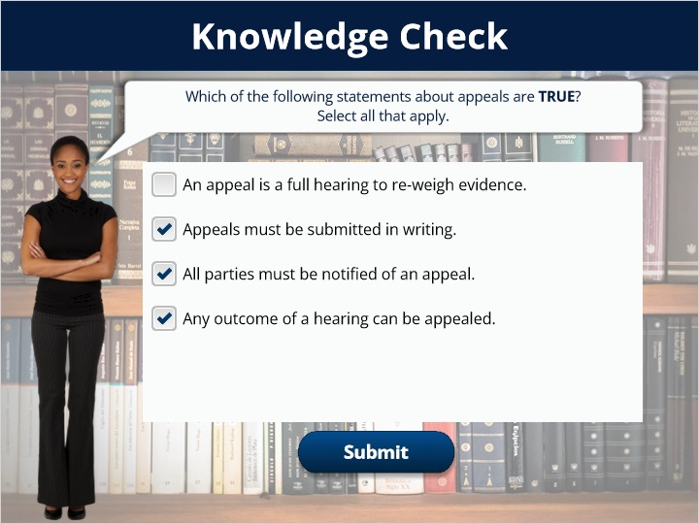
Correct | Choice
 | An appeal is a full hearing to re-weigh evidence.
X | Appeals must be submitted in writing.
X | All parties must be notified of an appeal.
X | Any outcome of a hearing can be appealed.

Feedback when correct:
Great work!
Feedback when incorrect:
An appeal is a single component of the accountability process. It is not a full hearing.

Correct (Slide Layer)
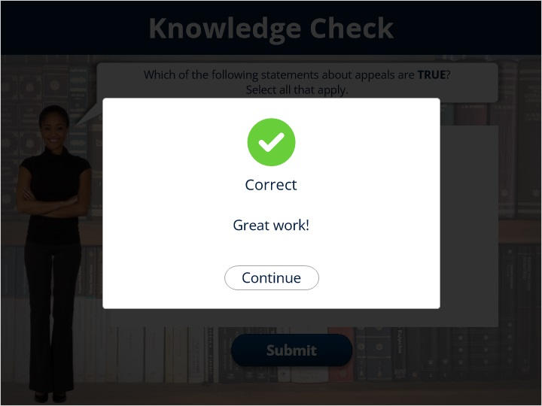

Incorrect (Slide Layer)
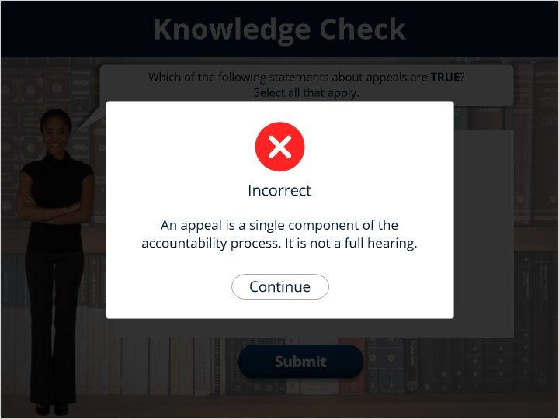

1.10 When Can Appeals
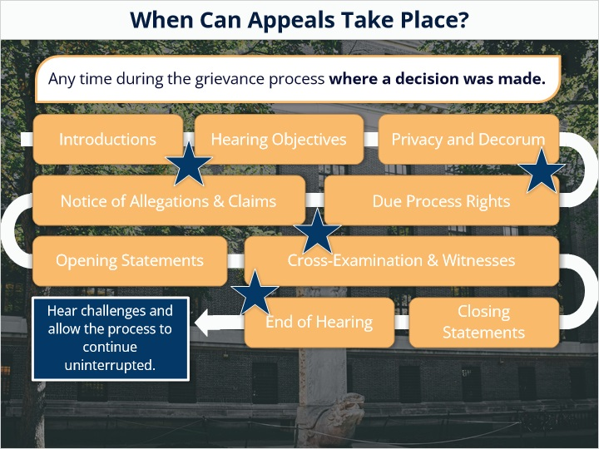

1.11 decisions
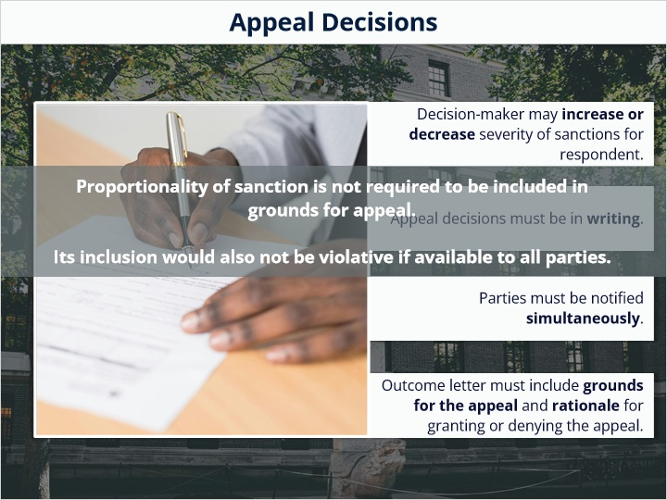

1.12 conclusion
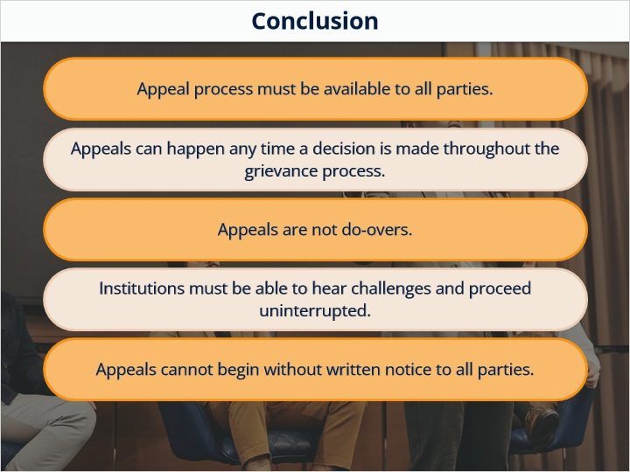

1.13 end
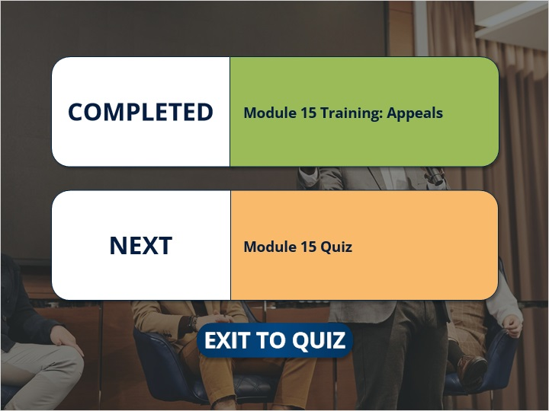
Notes:

