Intake

1. Intro Scene

1.1 Intake

Notes:
[Upbeat music]

1.2 Disclaimer
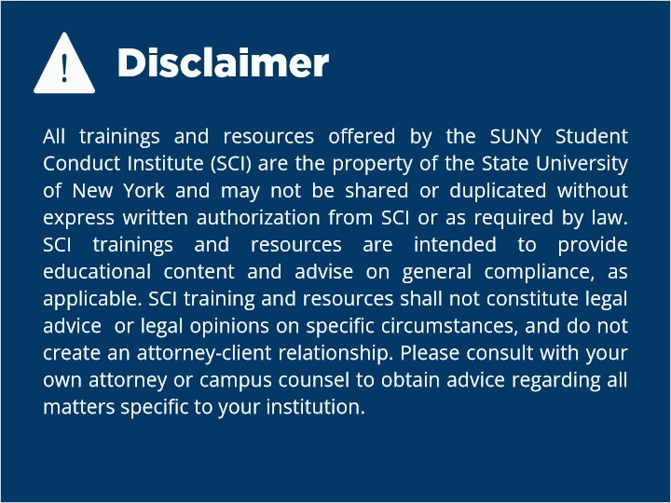
Notes:
All trainings and resources offered by the SUNY Student Conduct Institute (SCI) are the property of the State University of New York and may not be shared or duplicated without express written authorization from SCI or as required by law. SCI trainings and resources are intended to provide educational content and advise on general compliance, as applicable. SCI training and resources shall not constitute legal advice or legal opinions on specific circumstances, and do not create an attorney-client relationship. Please consult with your own attorney or campus counsel to obtain advice regarding all matters specific to your institution.

1.3 Overview
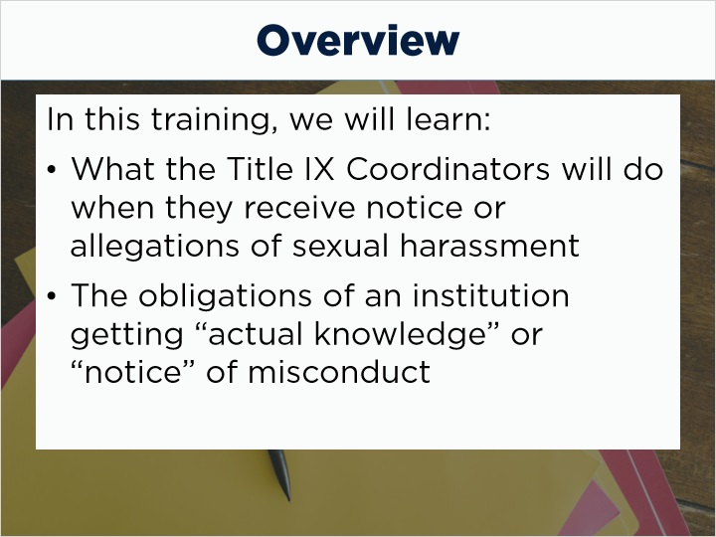
Notes:
Welcome to the Intake portion of the Title IX grievance process. We will discuss what the Title IX Coordinators will do when they receive reports of sexual harassment and the obligations of an institution once it gets “actual knowledge” or “notice” of this kind of misconduct.

1.4 Intake vs. Formal Complaint
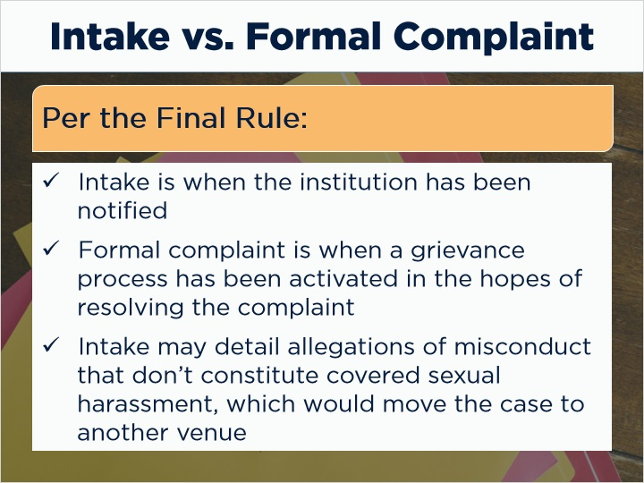
Notes:
It's important the complainant fully understands that the intake is different from the formal complaint. In the Final Rule, the intake is when the institution has been notified, but the formal complaint is when a grievance process has been activated in the hopes of resolving the complaint. The intake may not result in the pursuit of a disciplinary process, or a Title IX grievance process at all. In fact, the intake may detail allegations of misconduct that don’t constitute covered sexual harassment, which would move the case to another venue for resolution.

1.5 Complainant’s Intentions
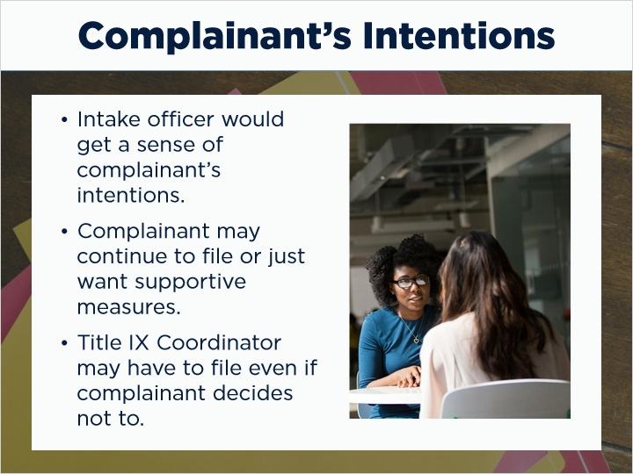
Notes:
During that time, the intake officer would get a sense of the complainant’s intentions. They may wish to continue with the grievance process and file a formal complaint, or they simply wish for some supportive measures. Either way, the intake officer can maintain the complainant’s autonomy and agency throughout this process. And remember, there are some situations where the Title IX Coordinator will decide they need to initiate a formal complaint, even if the complainant has not decided to file one.

1.6 Receiving a Report
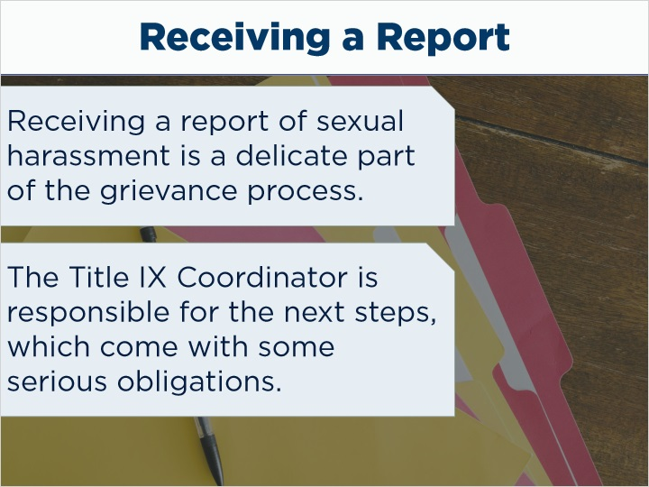
Notes:
Receiving a report of sexual harassment is a delicate part of the grievance process. An individual is coming to you and sharing something personal and intimate about their lives. The Title IX Coordinator who receives that information is responsible for the next steps, which come with some serious obligations.

1.7 Actual Notice or Knowledge
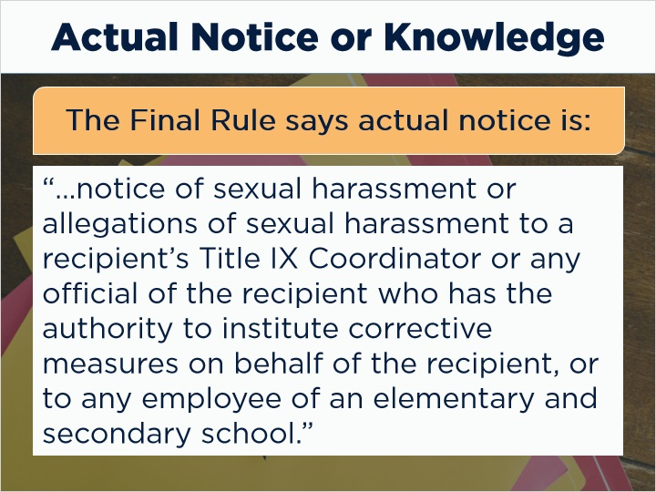
Notes:
Let’s look at what constitutes “actual knowledge” or “notice,” as that is what will trigger the next steps for the Title IX Coordinator. The Final Rule tells us that actual notice is:

“notice of sexual harassment or allegations of sexual harassment to a recipient’s Title IX Coordinator or any official of the recipient who has the authority to institute corrective measures on behalf of the recipient, or to any employee of an elementary and secondary school.”

1.8 Caveat for Postsecondary Institutions
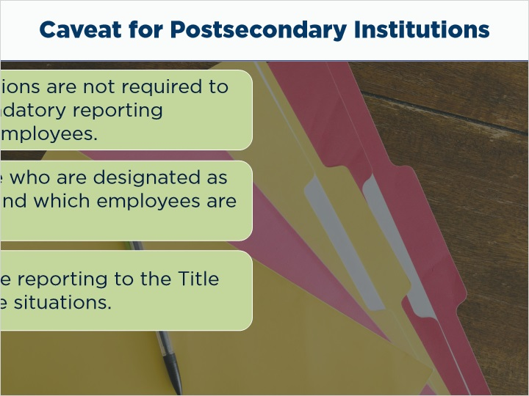
Notes:
There’s a caveat where postsecondary institutions are not required to impose “universal mandatory reporting obligations” upon all employees. That requirement is only for K to 12. Knowing this, institutions can decide for themselves who on their campuses are designated as mandatory reporters and who are not. This includes determining which employees are confidential resources. Additionally, your state law may mandate reporting to the Title IX Coordinator in some situations.

1.9 Why does “actual knowledge” matter to an institution?
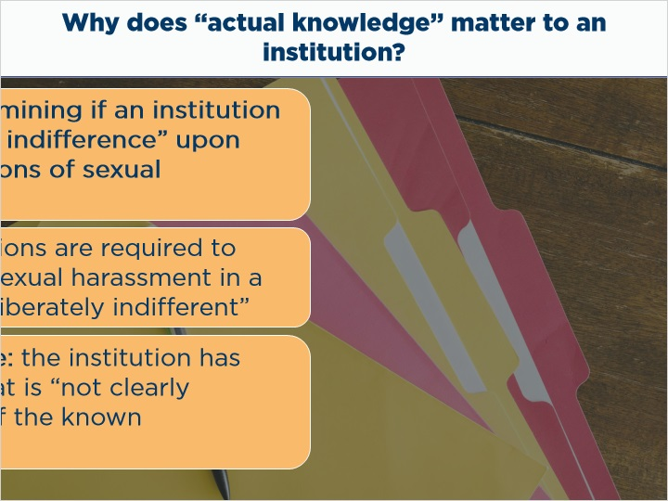
Notes:
Why does “actual knowledge” matter to an institution? It is an important factor when determining if an institution has acted with “deliberate indifference” upon hearing about allegations of sexual harassment.
The Final Rule informs us that institutions are required to respond to notices of sexual harassment in a manner that is not “deliberately indifferent.” This means that the institution has acted in such a way that is “not clearly unreasonable in light of the known circumstances.”

1.10 Deliberately Indifferent Response
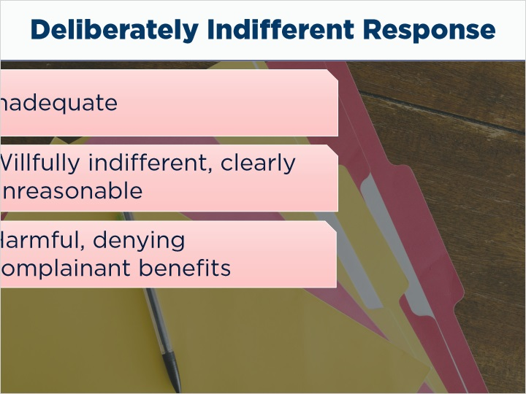
Notes:
What makes a response deliberately indifferent? The institution’s responses was:

- Inadequate

- Willfully indifferent, or clearly unreasonable; and

- Causes harm, or denies the complainant educational benefits they are entitled to.

1.11 Deliberate Indifference Examples
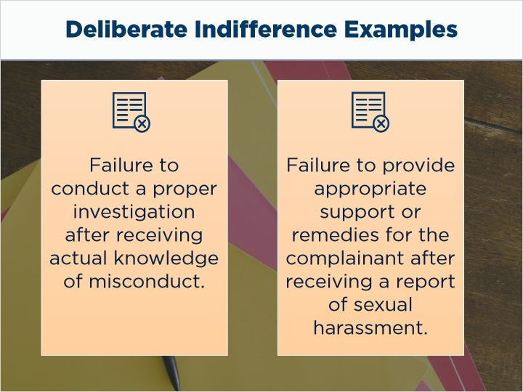
Notes:
Some examples of what would constitute “deliberate indifference” would be a failure to conduct a proper investigation after receiving actual knowledge of misconduct, or failing to provide appropriate support or remedies for the complainant after receiving a report of sexual harassment.

1.12 U.S. Department of Education Recommendations
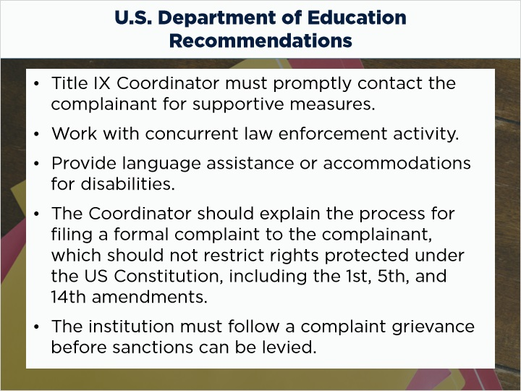
Notes:
The Department of Education has also given us some information about how they would like institutions to respond to complaints.
Upon receipt of a report, the Title IX Coordinator must promptly contact the complainant to discuss supportive measures, and consider the complainant’s wishes, and inform the complainant of the available of supportive measures with or without the filing of a formal complaint
The Coordinator should explain the process for filing a formal complaint to the complainant, which should not restrict rights protected under the US Constitution, including the 1st, 5th, and 14th amendments.
The institution must follow a compliant grievance before sanctions can be levied, which is discussed later in this compliance certificate.

1.13 Good Cause
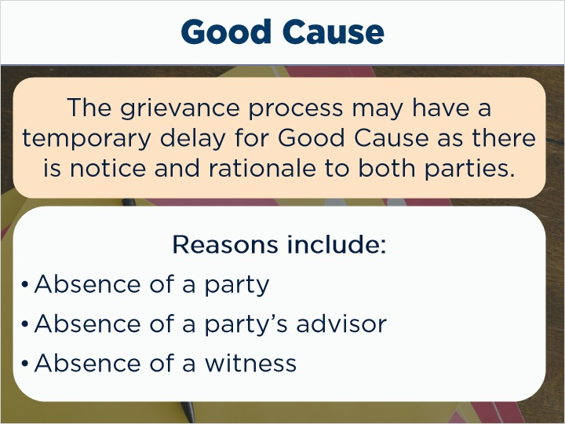
Notes:
The grievance process may have a temporary delay for good cause, so long as there is notice to both parties including the rationale for the delay. Good cause may include:

- Absence of a party, a party’s advisor, or witness;
Concurrent law enforcement activity; or
The need for language assistance or accommodation of disabilities.

1.14 Notice: NY-129B
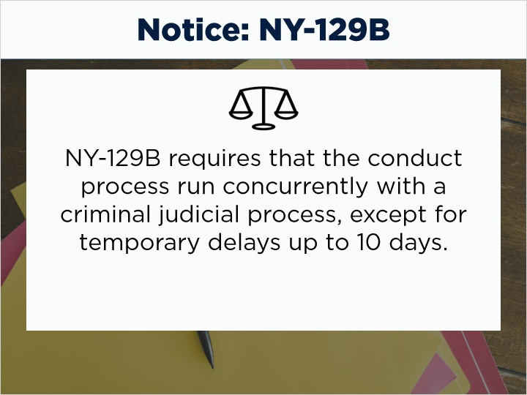
Notes:
NOTICE: NY-129B requires that the conduct process run concurrently with a criminal judicial process, except for temporary delays up to 10 days.

1.15 Reasonably Prompt
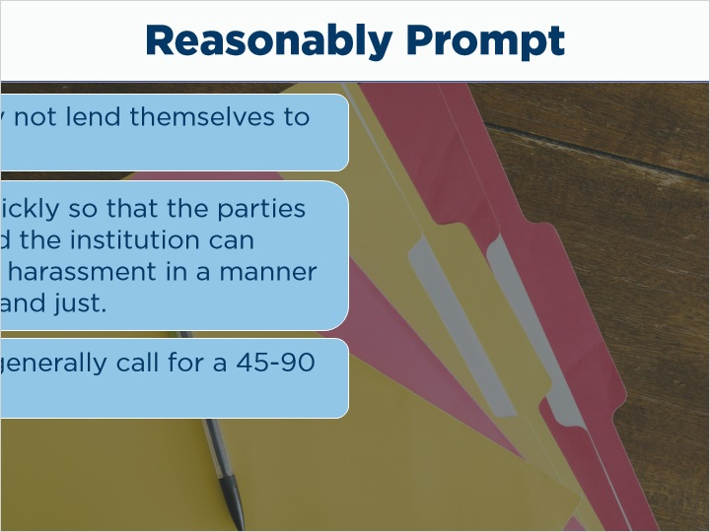
Notes:
So what does “reasonably prompt” mean? Ultimately, the Department of Education took the position that a flexible timeframe accounts for schools’ unique attributes (for example, their size, population, location, or mission), recognizes that complex matters may not lend themselves to set deadlines, and acknowledges that delays may sometimes be necessary, especially with a concurrent criminal investigation.
The call for reasonably prompt timeframes balances the priority of getting the matter resolved in a swift manner so that the parties can move forward and the institution can remedy and prevent any potential harassment while also recognizing the challenges of processing sometimes complex cases in a manner that is fair, equitable, and just.
To put succinctly, campus procedures generally call for a 45-90 day timeframe which would be considered reasonable in most cases.

1.16 Complainant Intake
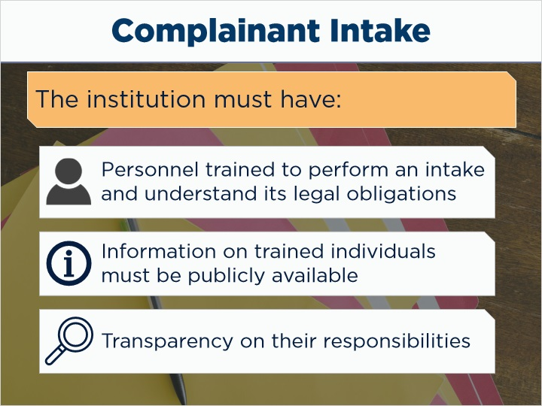
Notes:
The institution must have personnel who are trained to perform an intake, informed of how it should be completed and what their legal obligations may be. The institution should share the names, locations, job titles, and other important information for these intake resources publicly so that everyone knows who these individuals are. Transparency goes a long way to ensuring that complainants can trust this process. Similarly, consider publicizing who the responsible and confidential employees are on your campus. That way, if an individual decides to confide in an employee that is not confidential, that employee can be transparent about what their responsibilities are.

1.17 Intake Script
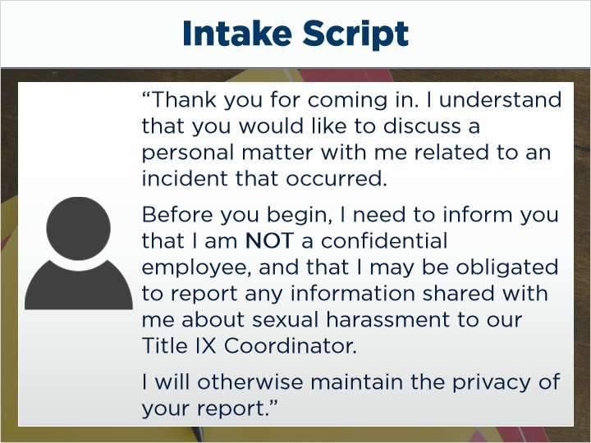
Notes:
Having some pre-scripted language can be helpful for training purposes. Something like:
“Thank you for coming in. I understand that you would like to discuss a personal matter with me related to an incident that occurred. Before you begin, I need to inform you that I am NOT a confidential employee, and that I may be obligated to report any information shared with me about sexual harassment to our Title IX Coordinator. I will otherwise maintain the privacy of your report.”
Take a moment to speak this phrase aloud to yourself before continuing.

1.18 Private Space

Notes:
An intake will be conducted in a private space that is comfortable and conducive to sharing personal information. That means that the space should be well-lit, with comfortable seating, and free from distractions as best as can be possible.

1.19 Accessible Resources
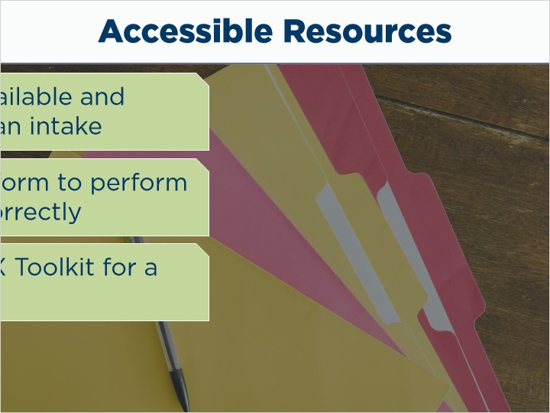
Notes:
Having resources available and accessible at this time is also encouraged. Things like an intake form the intake officer can consult and utilize in order to perform an intake responsibly and correctly. In the SCI’s Title IX Toolkit, there is a model intake form that members may use to guide the process, ensure compliance, and house all relevant information for effective recordkeeping.

1.20 Intake Form Sections
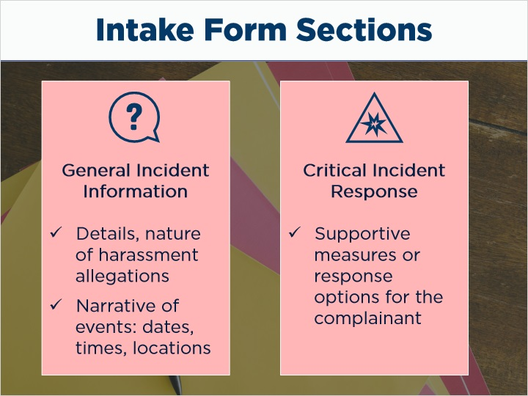
Notes:
- Some key sections in the intake form include:
General incident information
This section will include the details about incident, the nature of the allegations of harassment, and a succinct narrative of events
Dates, times, locations, etc., would all be included in this section.
Critical Incident Response
The intake officer would go over any possible supportive measures or response options for the complainant. This could be facilitating medical assistance or connecting the complainant with counseling.
Review of student’s rights
Here would be any information related to a student’s reporting options like local law enforcement, institutional disciplinary process, the level of involvement the complainant wishes to have, summaries of meetings with the TIX Coordinator, resource allocation, etc.

1.21 Student Rights per NY-129B
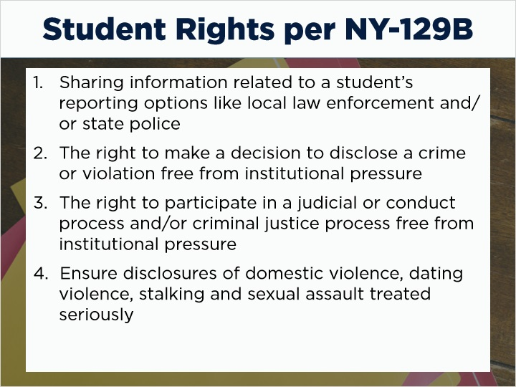
Notes:
- Review of student’s rights (including those required by New York institutions per NY 129B):
Sharing information related to a student’s reporting options like local law enforcement and/or state police,
The right to make a decision to disclose a crime or violation free from institutional pressure
The right to participate in a judicial or conduct process and/or criminal justice process free from institutional pressure
Ensure disclosures of domestic violence, dating violence, stalking and sexual assault treated seriously

1.22 Student Rights per NY-129B
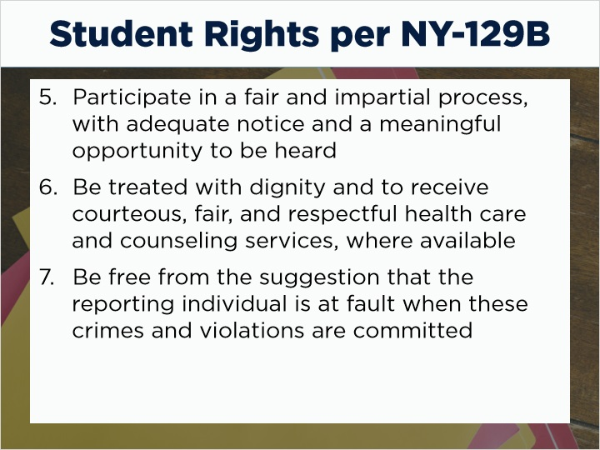
Notes:
- Participate in a fair and impartial process, with adequate notice and a meaningful opportunity to be heard
Be treated with dignity and to receive courteous, fair, and respectful health care and counseling services, where available
Be free from the suggestion that the reporting individual is at fault when these crimes and violations are committed

1.23 Student Rights per NY-129B
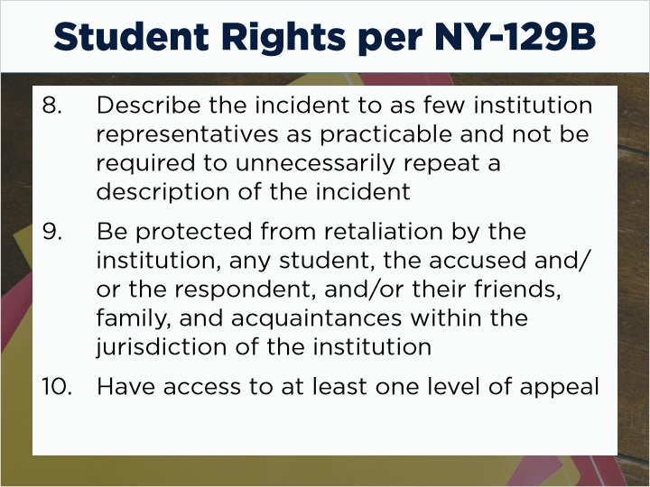
Notes:
- Describe the incident to as few institution representatives as practicable and not be required to unnecessarily repeat a description of the incident
Be protected from retaliation by the institution, any student, the accused and/or the respondent, and/or their friends, family, and acquaintances within the jurisdiction of the institution
Have access to at least one level of appeal

1.24 Student Rights per NY-129B
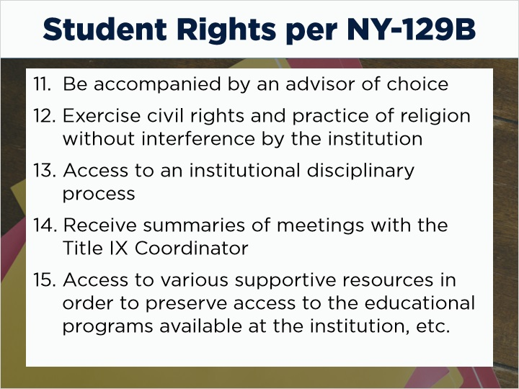
Notes:
- Be accompanied by an advisor of choice
Exercise civil rights and practice of religion without interference by the institution
Access to an institutional disciplinary process
Receive summaries of meetings with the TIX Coordinator,
Access to various supportive resources in order to preserve access to the educational programs available at the institution, etc.

1.25 End of Intake
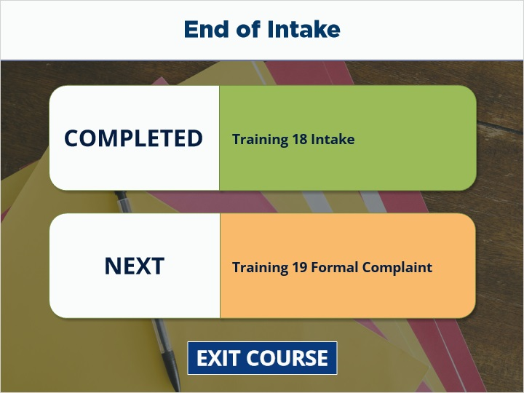
Notes:
You have completed Training: Intake. Next is Training : Formal Complaint. Select Exit Course to receive credit and go to the next training.

