Intake and Formal Complaints

1. Intro Scene

1.1 Formal Complaints
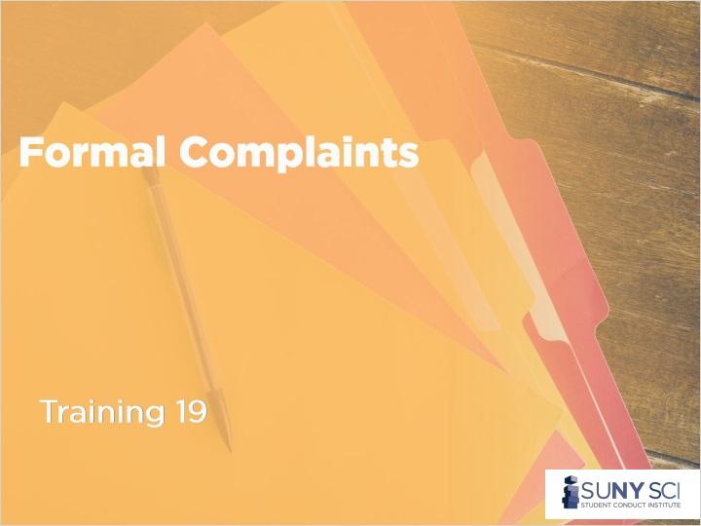
Notes:

1.2 Disclaimer
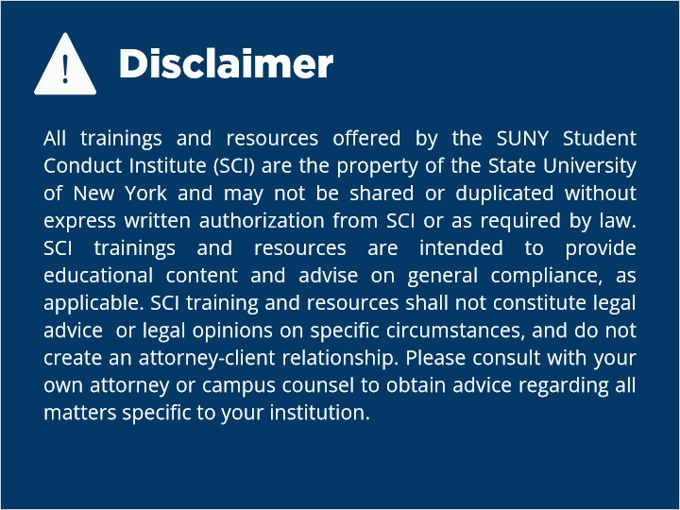
Notes:
All trainings and resources offered by the SUNY Student Conduct Institute (SCI) are the property of the State University of New York and may not be shared or duplicated without express written authorization from SCI or as required by law. SCI trainings and resources are intended to provide educational content and advise on general compliance, as applicable. SCI training and resources shall not constitute legal advice or legal opinions on specific circumstances, and do not create an attorney-client relationship. Please consult with your own attorney or campus counsel to obtain advice regarding all matters specific to your institution.

1.3 Overview
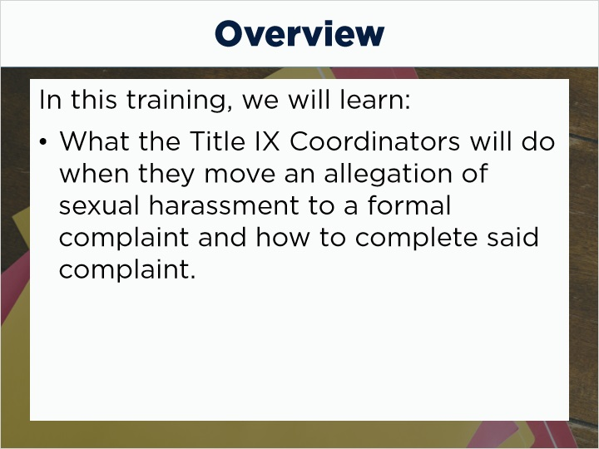
Notes:
Welcome to the Formal Complaint portion of the Title IX grievance process. We will discuss what the Title IX Coordinators do when they move an allegation of sexual harassment to a formal complaint and how to complete said complaint.

1.4 Actual Knowledge
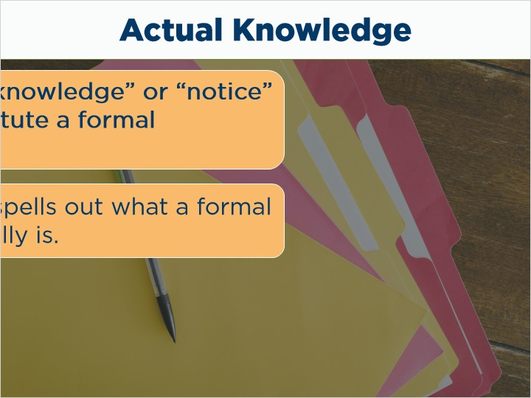
Notes:
As you may remember, simple “actual knowledge” or “notice” does not constitute a formal complaint. The Final Rule spells out what a formal complaint actually is.

1.5 The Final Rule
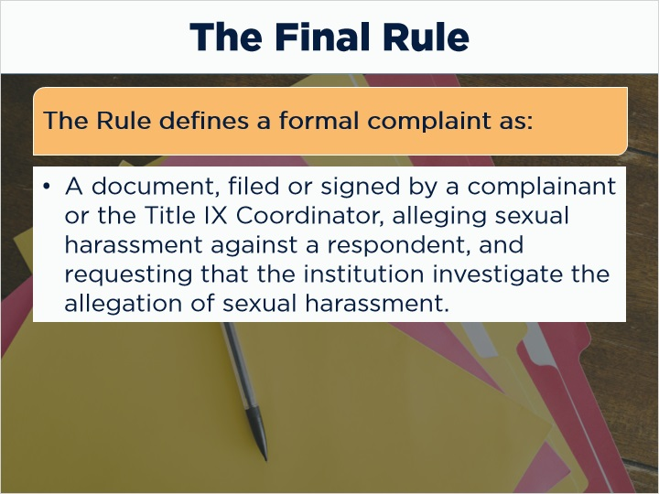
Notes:
- To properly process a case under the Grievance Procedures, we must first determine if we have a formal complaint.
The Rule defines a formal complaint as
a document,
filed and signed by a complainant or signed by the Title IX Coordinator,
alleging sexual harassment against a respondent, and
requesting that the institution investigate the allegation of sexual harassment.

1.6 Who can file a complaint?
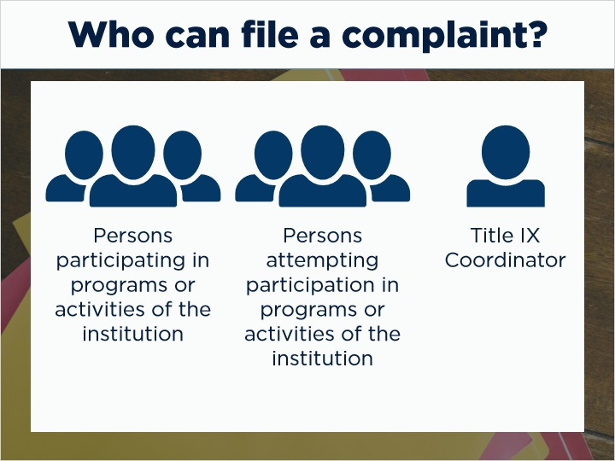
Notes:
- Who can file a complaint?
Persons currently participating in the educational programs or activities of the institution
Persons attempting to participate in those programs or activities
The Title IX Coordinator

1.7 Multiple Complaints
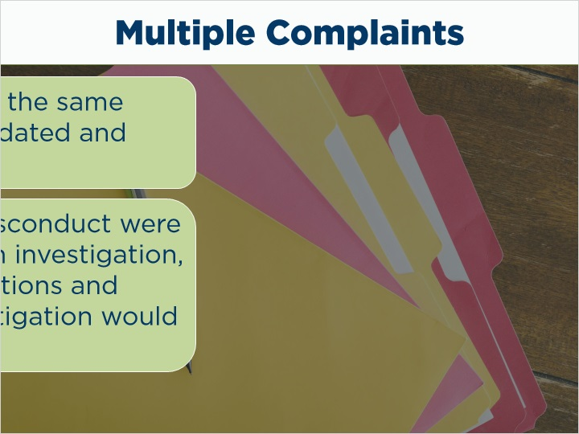
Notes:
Multiple complaints from the same incidents may be consolidated and heard at one time. However, if allegations of other misconduct were to be identified during an investigation, a revised notice of allegations (and possible additional investigation) would be required.

1.8 Complainant Considerations
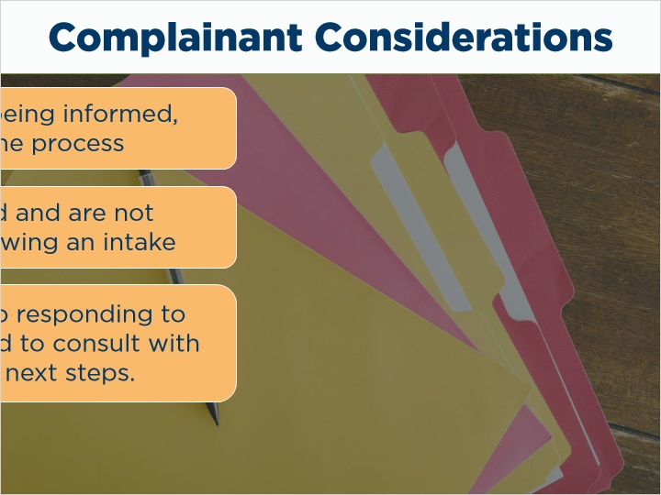
Notes:
- Some things to consider:
Individuals will still, despite being informed of them, have varied familiarity with the process
Some complaints are delayed, and are not necessarily immediately following an intake
Some complainants may stop responding to your requests and attempts to communicate. If that’s the case, you will need to consult with your counsel and staff about next steps. You’ve received a formal complaint; therefore you have an obligation to progress through your options.

1.9 Document Filed By Complainant
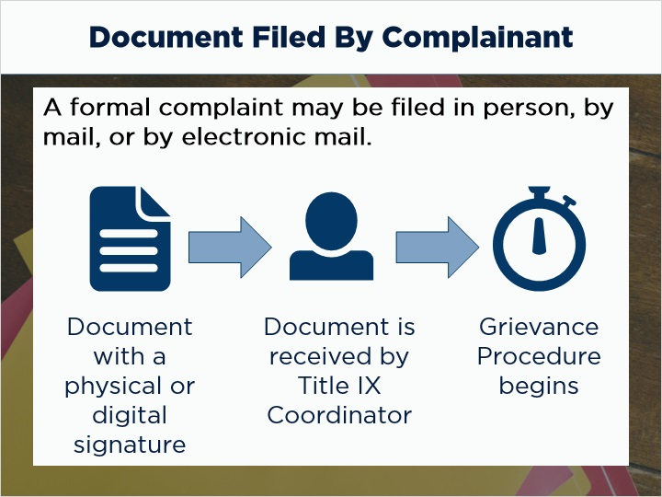
Notes:
The Rule states that a formal complaint may be filed with the Title IX Coordinator in person, by mail, or by electronic mail.

“Document filed by a complainant” means a document or electronic submission (such as by electronic mail or through an online portal provided for this purpose by the recipient) that contains the complainant’s physical or digital signature or otherwise indicates that the complainant is the person filing the formal complaint.
If you have received an email from the institutional email account of a student or employee, and that email alleges Title IX covered sexual harassment and requests that the institution take formal action to address it, it's likely that you have a formal complaint. That means you are officially in your grievance procedure and the clock is ticking for you to take the required next steps.

1.10 Complainant Autonomy
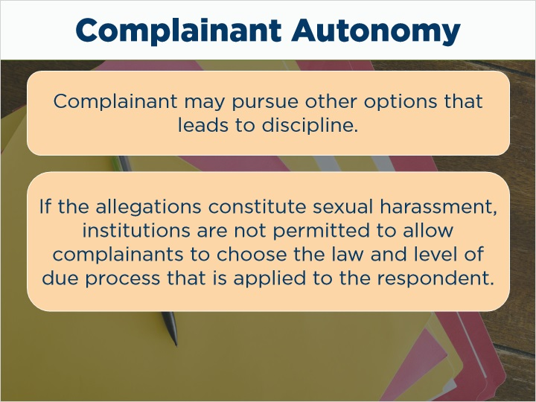
Notes:
What does complainant autonomy mean? If the complainant is uncomfortable with the grievance process after it has been explained to them, they may wish to pursue another option that leads to discipline. If the allegations constitute sexual harassment, however, that is not possible. Institutions are not permitted to allow complainants to choose the law and level of due process that is applied to the respondent. The good news here is that the complainant can participate in the process as much or as little as they would like.

1.11 Declining Formal Complaint
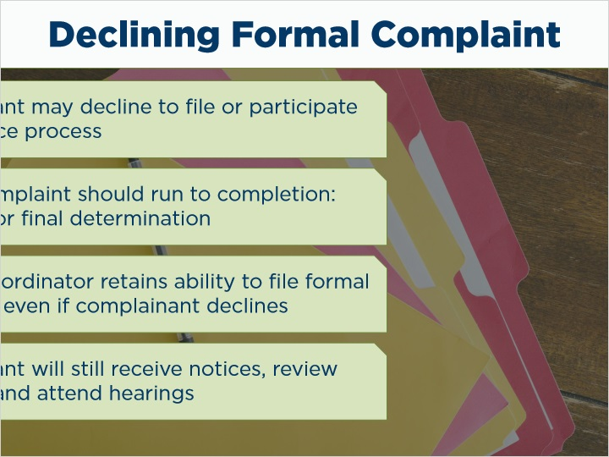
Notes:
The complainant may decline to file a formal complaint. Or they may choose to file the complaint, and then decline to participate in the grievance process any further. When a complaint is filed, it should run to completion - meaning, a dismissal or a final determination. Although the institution may dismiss if the complainant withdraws their complaint or if the institution is otherwise unable to gather sufficient evidence, the process can often continue even without a complainant’s continuing involvement. While not ideal, it may mean that a hearing is held without one or more parties’ participation or involvement. In situations where one or both parties do not appear at the hearing, the party should still have an advisor present to conduct cross-examination on their behalf.

Ultimately, the Title IX Coordinator also retains the ability to file a formal complaint themselves if the reporting individual declines to do so. However, remember that the reporting individual would still be identified as the complainant in that case. The complainant will still receive all written notices, have the right to review evidence, attend the hearing, etc.

1.12 Institution Requirements
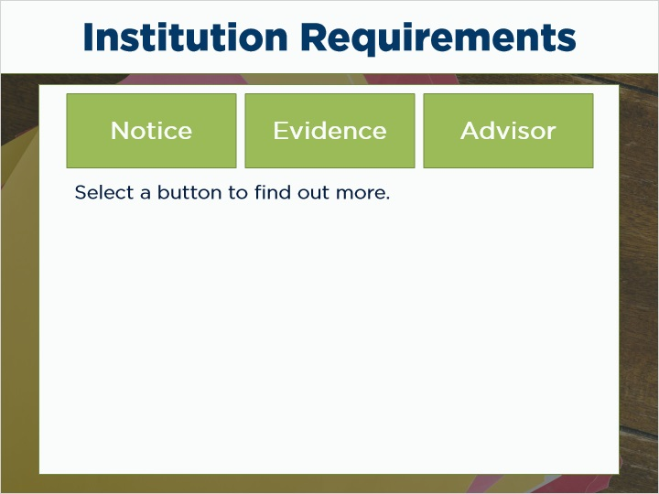
Notes:
- Institutional requirements after a formal complaint is filed:
When a formal complaint has been filed with an institution, the grievance process begins. Institutions are required to:
Notify all parties of a formal complaint simultaneously
Ensure burden of proof and evidence gathering is institution’s responsibility
Prohibit access, consideration, disclosure, or use of a party’s confidential records without party’s consent
Ensure access to advisor of choice during all components of grievance proceedings
Provide written notice of date, time, location, participants, and purpose of all meetings with sufficient time for preparation
Ensure equal opportunities for inspection and review of evidence to both parties
Ensure access to evidence prior to an investigation’s conclusion, with ten days to submit a written response
Create an investigative report summarizing relevant information at least ten days prior to a hearing, and send to all parties simultaneously with an opportunity to respond

1.13 Dismissed Complaints under the Final Rule
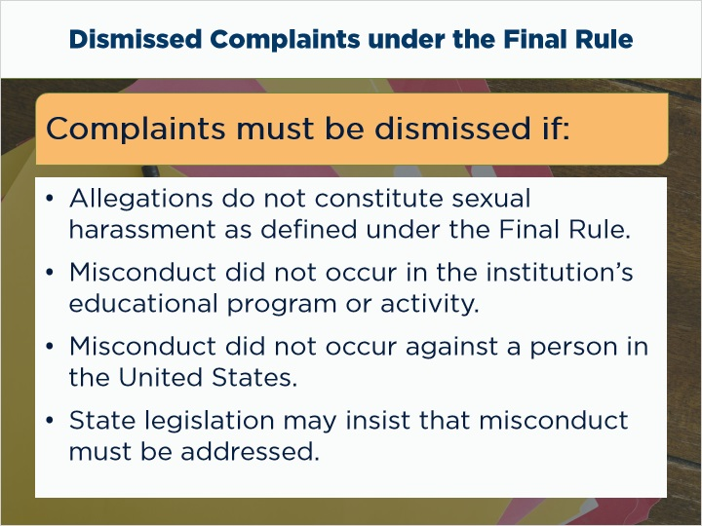
Notes:
Not all complaints progress to the conclusion of a live hearing. Sometimes complaints are dismissed, and institutions want to ensure that the “correct” decision is made. Fortunately, the final rule is relatively clear in this area.
Complaints must be dismissed if:
The allegations do not constitute sexual harassment as defined under the Final Rule, even if they can be proven.
The misconduct didn’t occur in the institution’s educational program or activity.
The misconduct did not occur against a person in the United States.
Important caveat: your state may have legislation that insists that misconduct in the complaint must be addressed. In that case, you can move the complaint to the appropriate process.

1.14 Other Dismissed Complaints
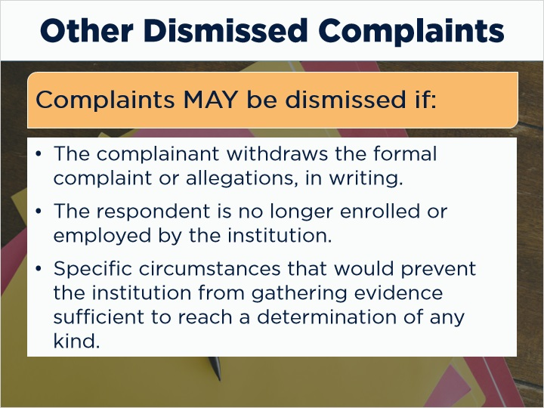
Notes:
Complaints MAY be dismissed if:
The complainant withdraws the formal complaint or allegations, in writing.
The respondent is no longer enrolled or employed by the institution.
Specific circumstances that would prevent the institution from gathering evidence sufficient to reach a determination of any kind.
These options are available to institutions to utilize them; however, they must be levied consistently and equitably without conflicts of interest or bias.

1.15 Dismissal Notification
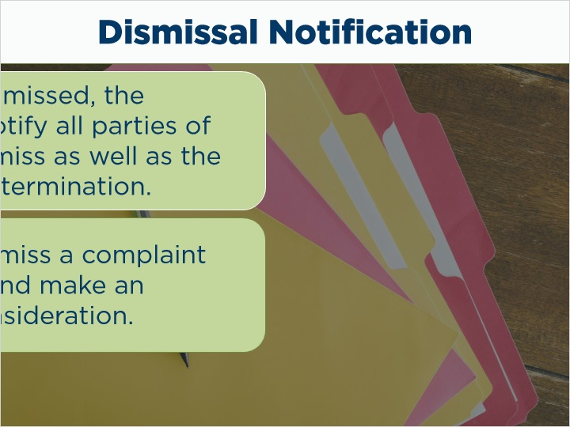
Notes:
If a complaint is dismissed, the institution MUST notify all parties of the decision to dismiss as well as the rationale for the determination. The decision to dismiss a complaint may be appealed and make an argument for reconsideration.

1.16 Conclusion
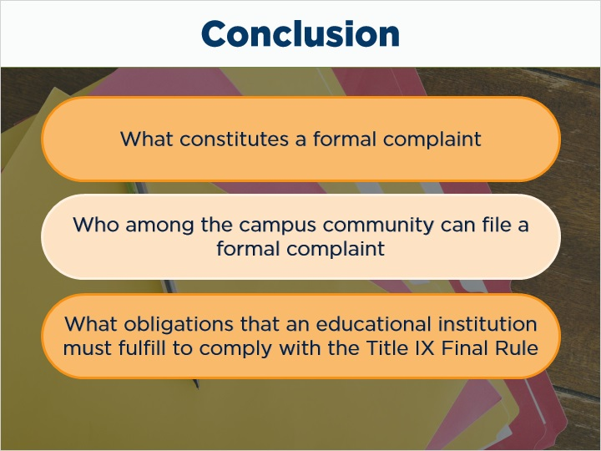
Notes:
In summary, we reviewed what constitutes a formal complaint, who among the campus community can file a formal complaint, and the obligations that an educational institution must fulfill to comply with the Title IX Final Rule.

1.17 End of Formal Complaints
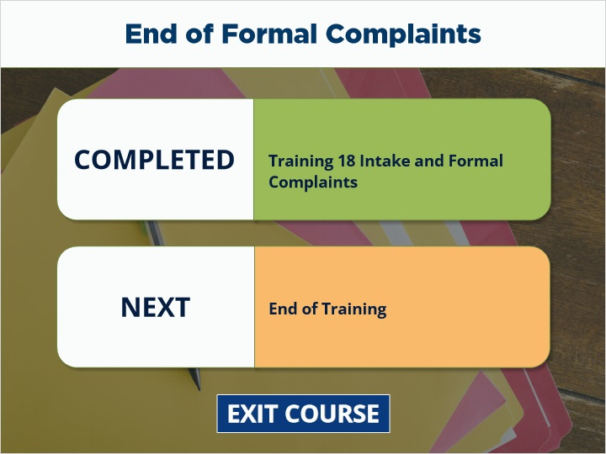
Notes:
You have reached the end of the Title IX Coordinator training by the SUNY Student Conduct Institute. Thank you very much for your participation. Select Exit Course to close the training and get credit.

