Legal Foundations for Live Hearings

1. Draft

1.1 Title
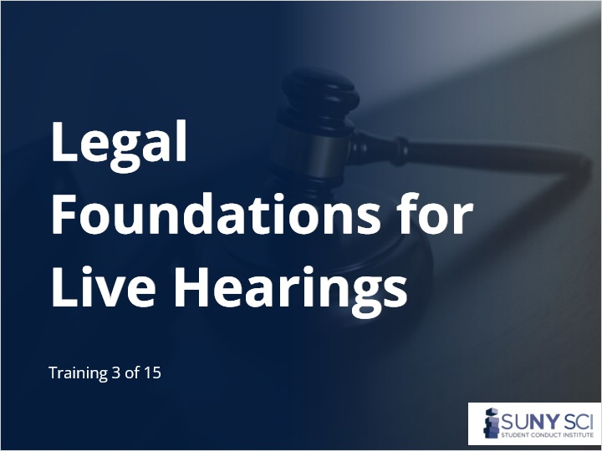
Notes:

1.2 Disclaimer
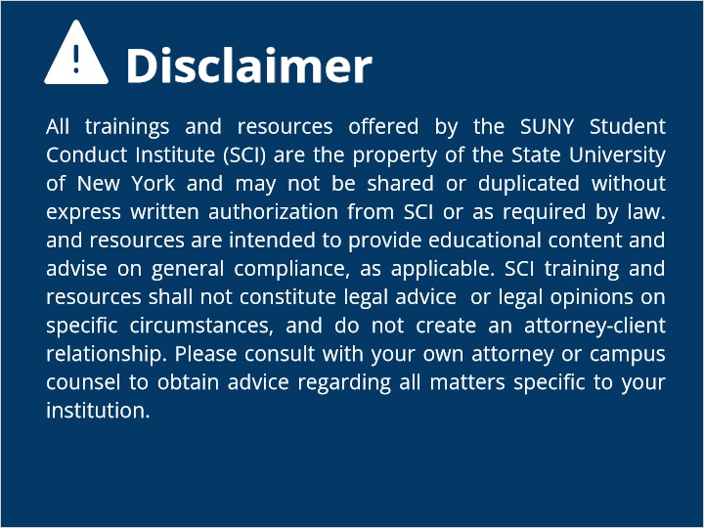
Notes:

1.3 Overview
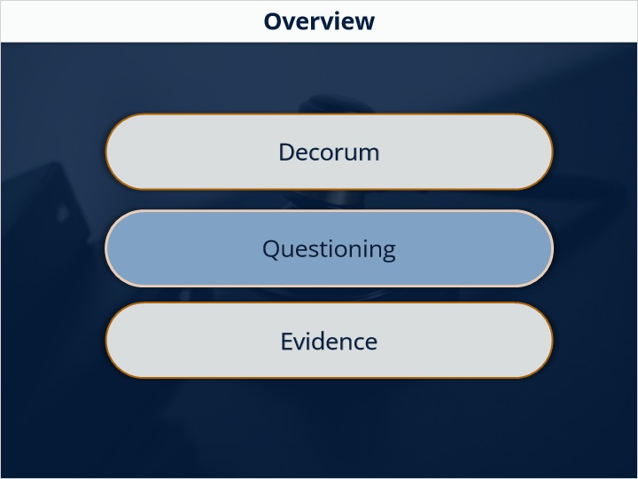

1.4 Initiating Title IX Investigations
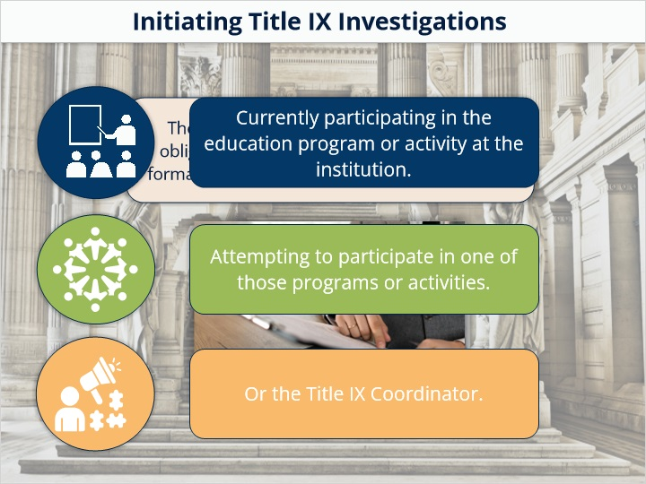

1.5 What is a Formal Complaint?
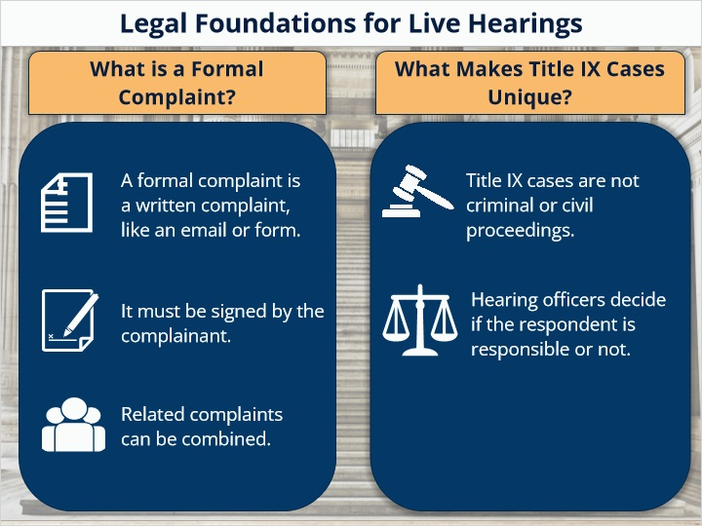

1.6 Impartial Title IX Grievance Procedure
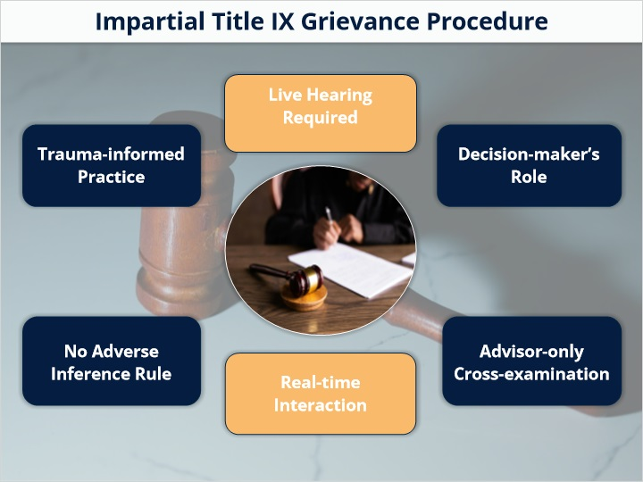
Notes:

1.7 Rules of Decorum
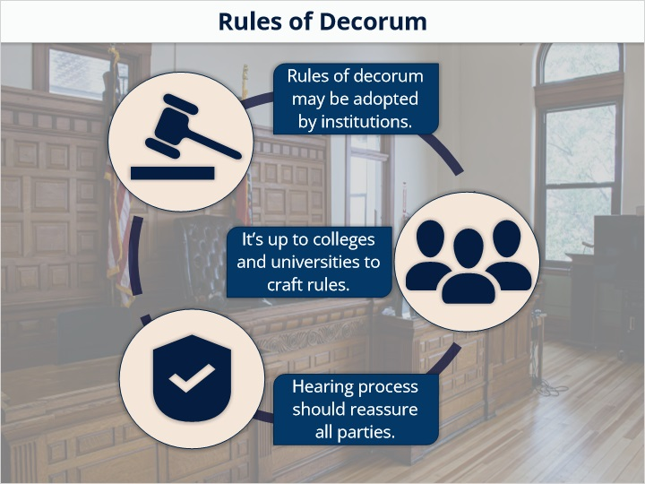

1.8 Rules of Decorum
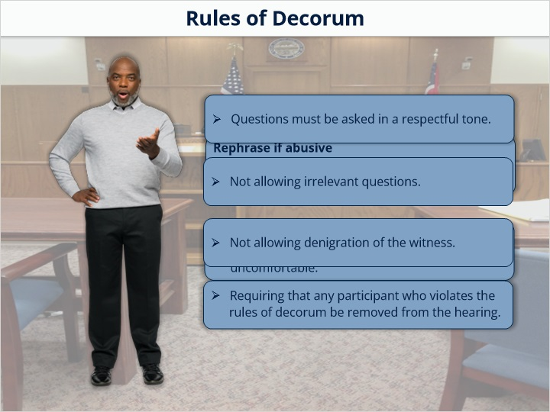

1.9 Relevant Questions
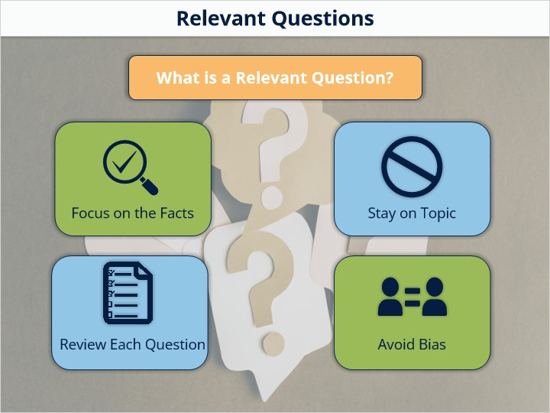

1.10 Standards of Proof in Title IX Cases
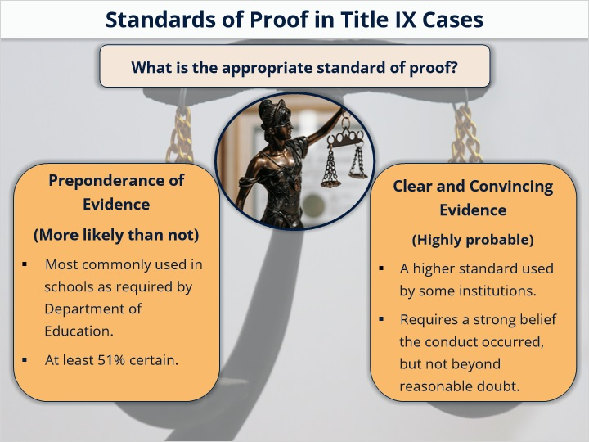

1.11 Exclusions from Evidence
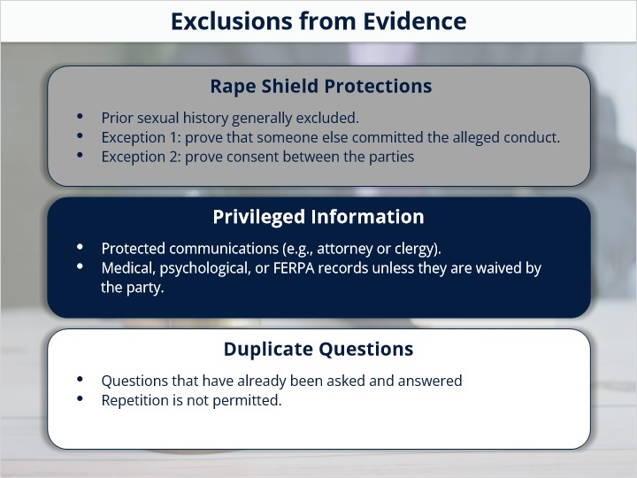

1.12 Knowledge Check
(Multiple Response, 10 points, 1 attempt permitted)
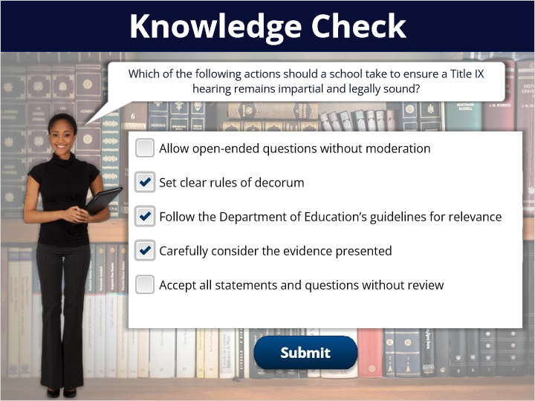
Correct | Choice
 | Allow open-ended questions without moderation
X | Set clear rules of decorum
X | Follow the Department of Education’s guidelines for relevance
X | Carefully consider the evidence presented
 | Accept all statements and questions without review

Feedback when correct:
Great work!
Feedback when incorrect:
Not quite. Review the guidelines and think about what supports fairness and legality.

1.13 Assessing Credibility of Evidence
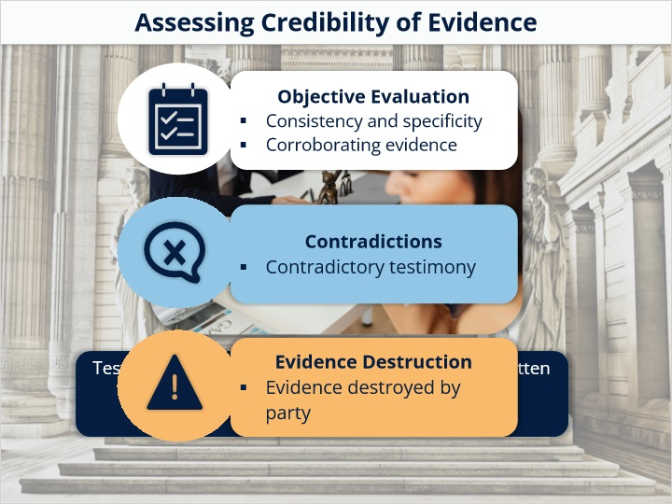

1.14 Objective vs. Subjective Testimony
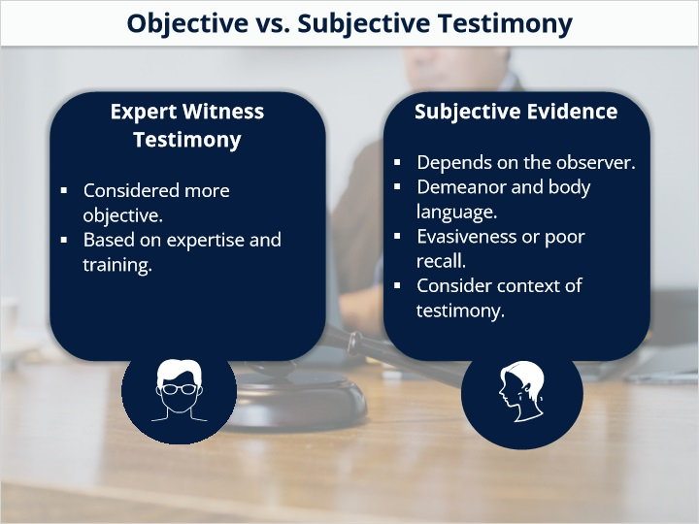

1.15 Conclusion
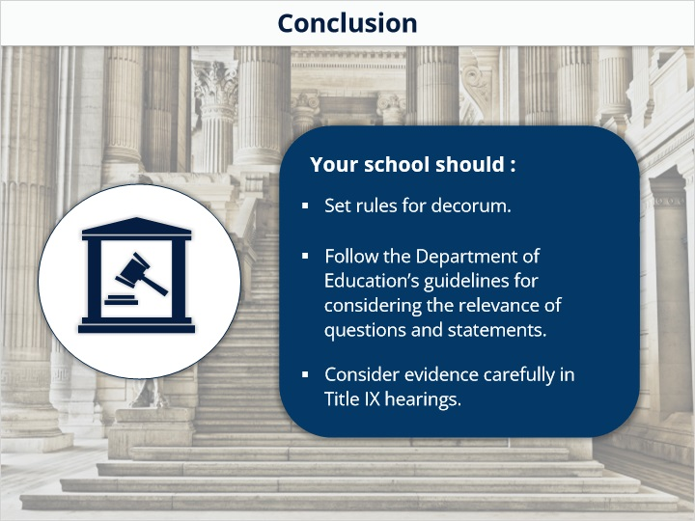

1.16 Next
