Pre-hearing Preparation

1. Pre-hearing Preparation

1.1 Title

Notes:

1.2 Disclaimer
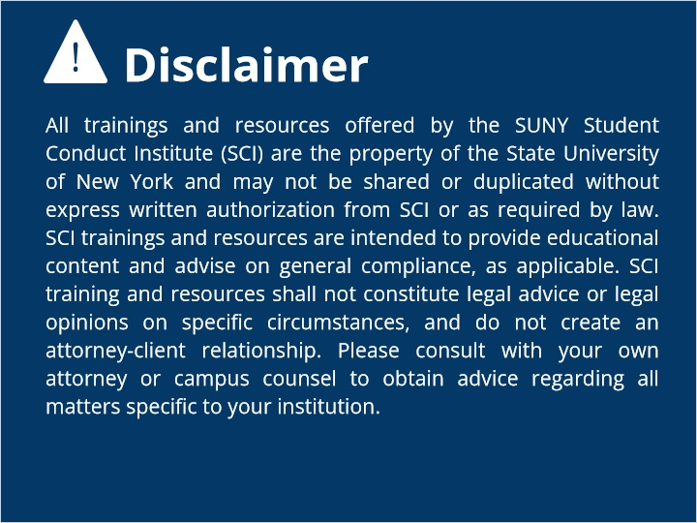

1.3 Overview
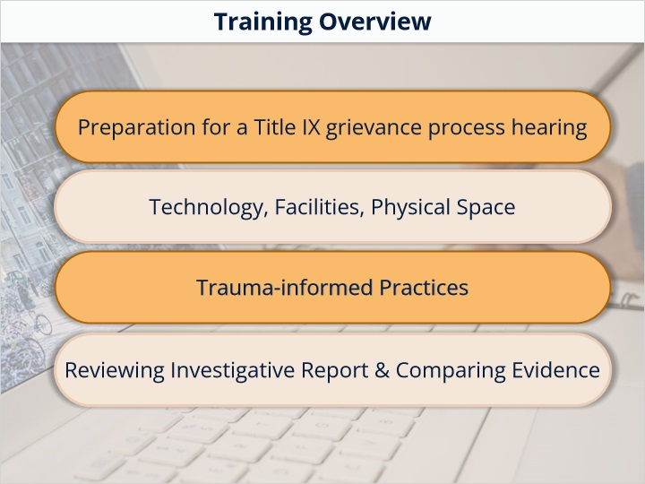

1.4 Technology Access
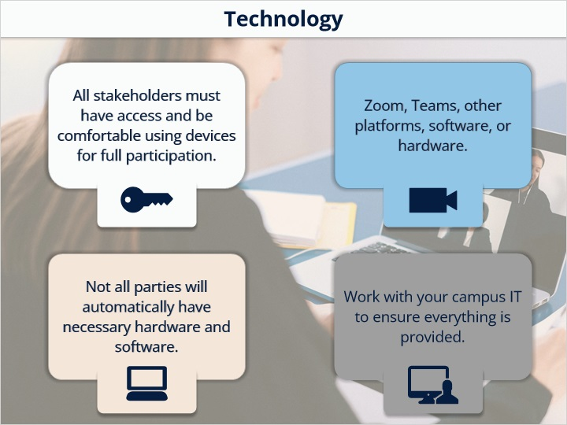

1.5 Technology Preparation
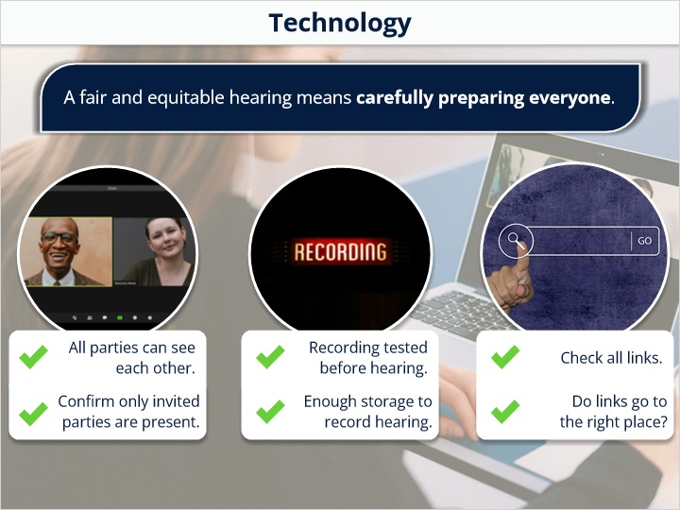

1.6 Physical Space
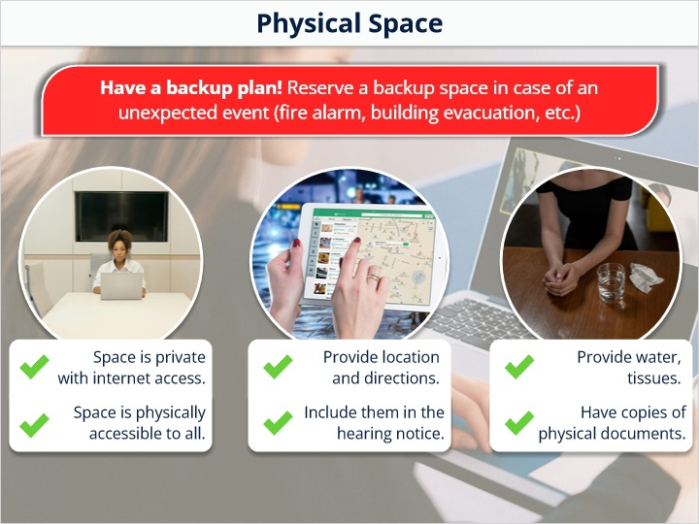

1.7 trauma informed interview
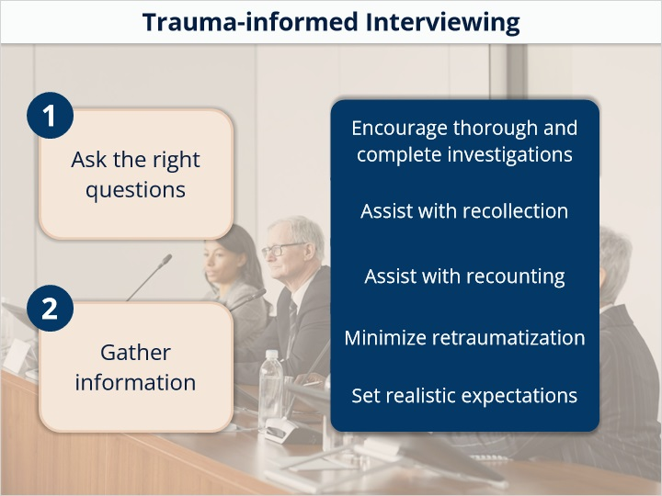

1.8 Trauma Informed Practices
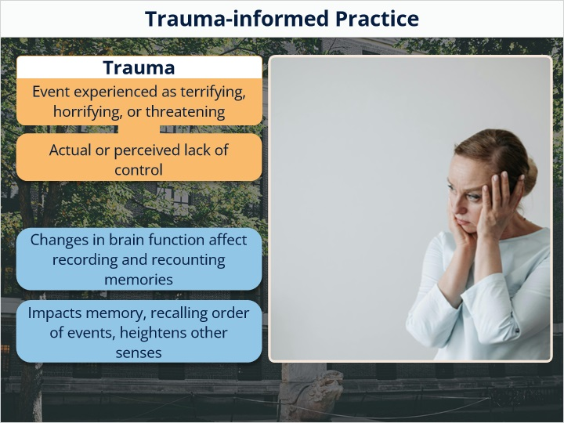

1.9 Trauma-Informed Practices 2
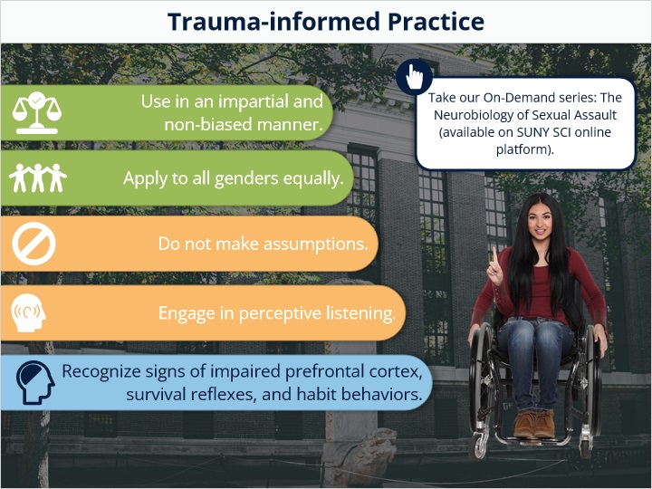

1.10 Misapplication
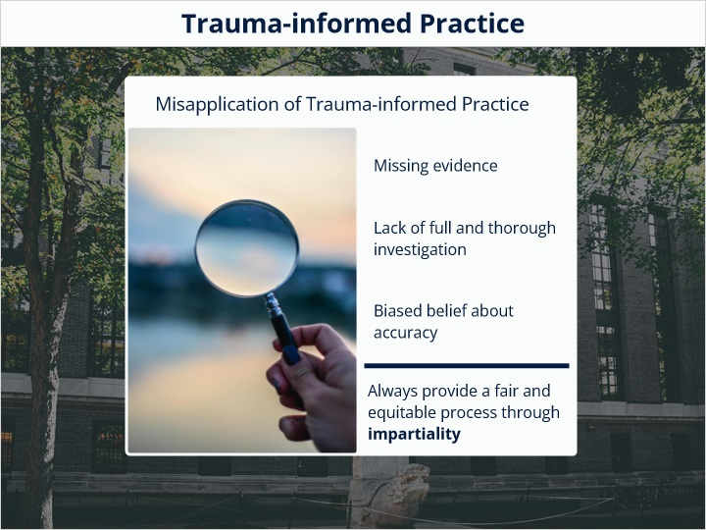

1.11 Knowledge Check
(Multiple Response, 10 points, 1 attempt permitted)
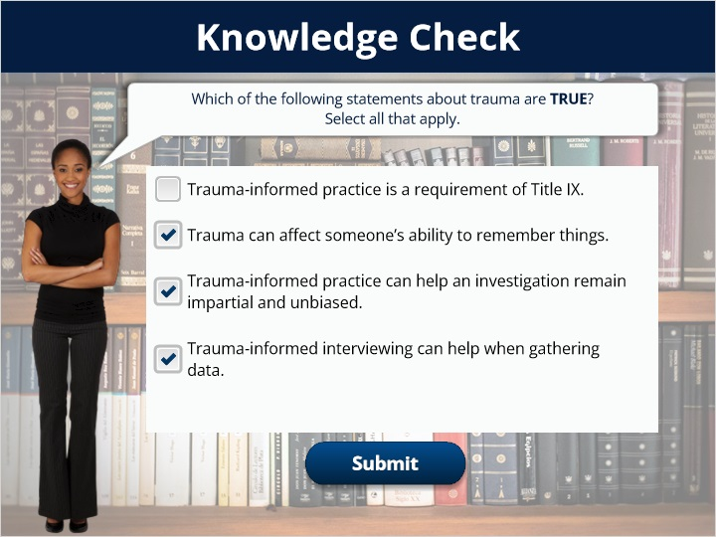
Correct | Choice
 | Trauma-informed practice is a requirement of Title IX.
X | Trauma can affect someone’s ability to remember things.
X | Trauma-informed practice can help an investigation remain impartial and unbiased.
X | Trauma-informed interviewing can help when gathering data.

Feedback when correct:
Great work!
Feedback when incorrect:
Trauma-informed practice is permitted by the Department of Education, but not a specific requirement of Title IX.

1.12 Additional Preparation


1.13 Report
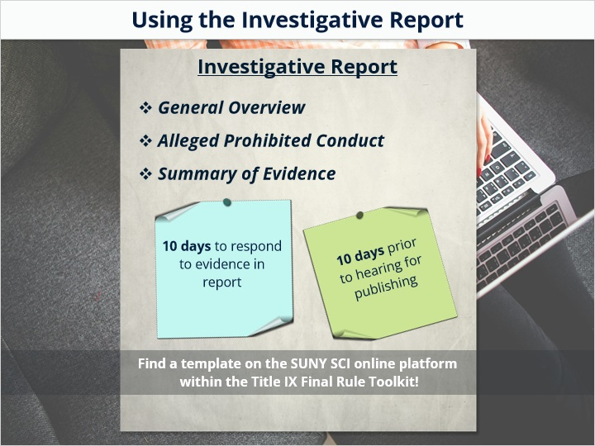

1.14 Evidence
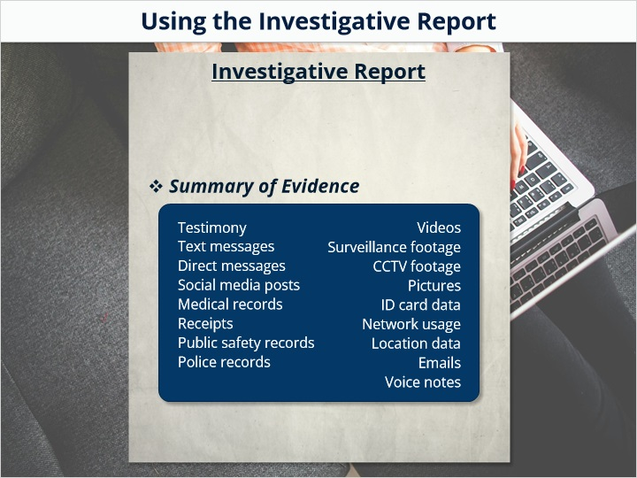

1.15 Investigative Report
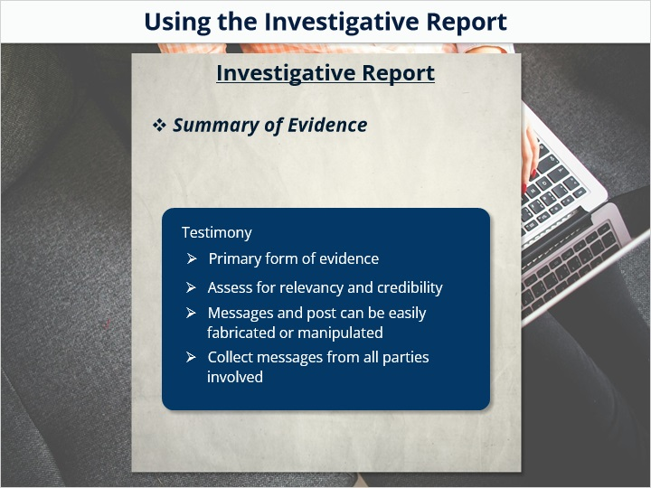
Notes:

1.16 Conclusion
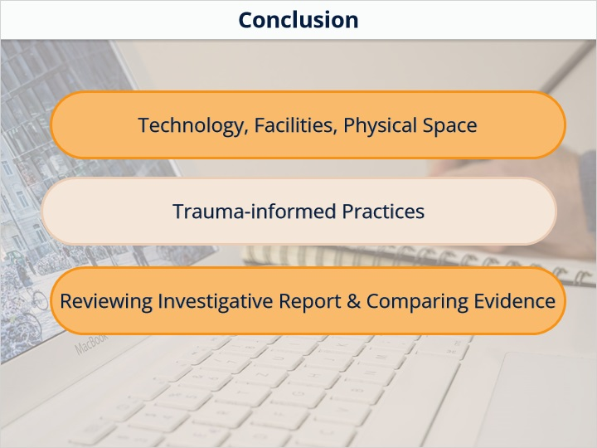

1.17 Title
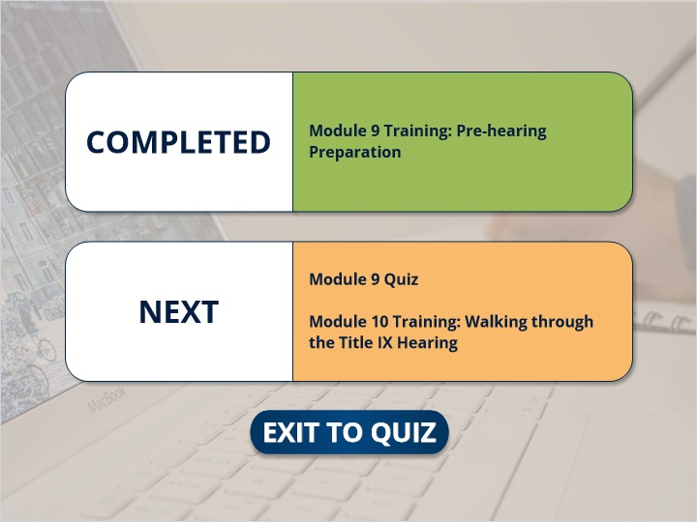
Notes:

