Recordkeeping

1. Intro Scene

1.1 Recordkeeping

Notes:
[Upbeat music]

1.2 Disclaimer
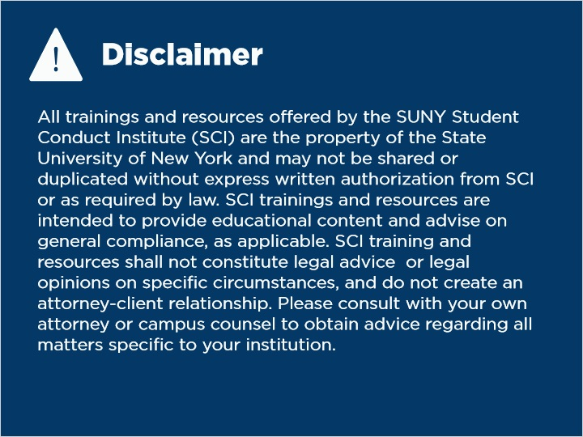
Notes:
All trainings and resources offered by the SUNY Student Conduct Institute (SCI) are the property of the State University of New York and may not be shared or duplicated without express written authorization from SCI or as required by law. SCI trainings and resources are intended to provide educational content and advise on general compliance, as applicable. SCI training and resources shall not constitute legal advice or legal opinions on specific circumstances, and do not create an attorney-client relationship. Please consult with your own attorney or campus counsel to obtain advice regarding all matters specific to your institution.

1.3 Overview
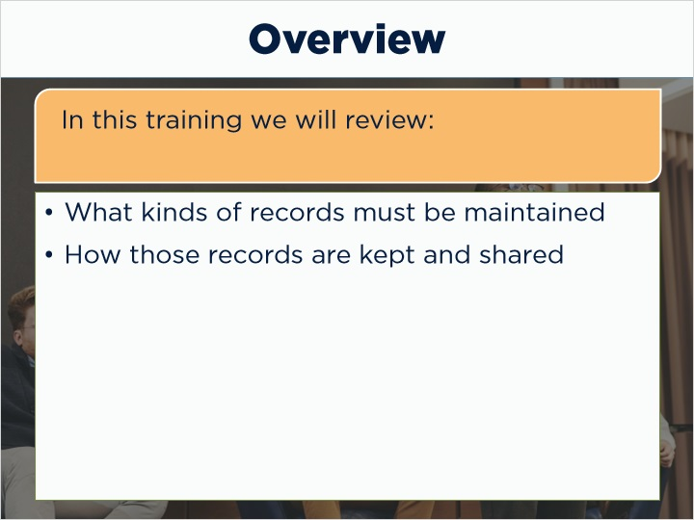
Notes:
Welcome to recordkeeping obligations for Title IX coordinators. We will review what kinds of records institutions must maintain, as well as the mechanisms for how those records are kept and shared.
Institutions are obligated to keep these records for many reasons, including assurance that an institution is consistent in their response to reports of sexual harassment, compliance with the Title IX final rule and other pieces of legislation, and to enforce transparency with important stakeholders in the institution and the Title IX grievance process.

1.4 The Final Rule
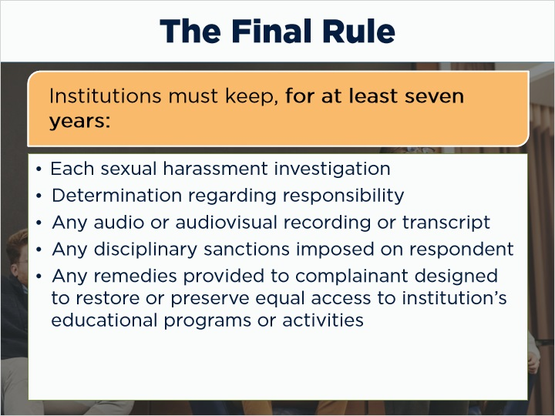
Notes:
Institutions must keep records for at least seven years, per the final rule. These records include:
Each sexual harassment investigation, including:
- Determination regarding responsibility
- Any audio or audiovisual recording or transcript
- Any disciplinary sanctions imposed on the respondent
- Any remedies provided to the complainant designed to restore or preserve equal access to the institution’s educational programs or activities

1.5 The Final Rule: Other Records
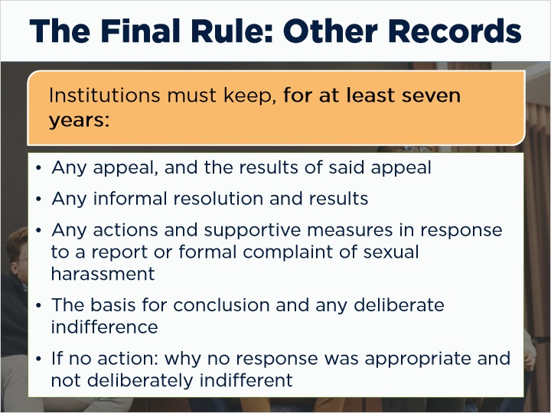
Notes:
They should also include:
- Any appeal, and the results of said appeal
- Any informal resolution and results
- Any actions and supportive measures in response to a report or formal complaint of sexual harassment
- The basis for conclusion and any deliberate indifference
- If no action: why no response was appropriate and not deliberately indifferent

1.6 Final Rule: Training Materials
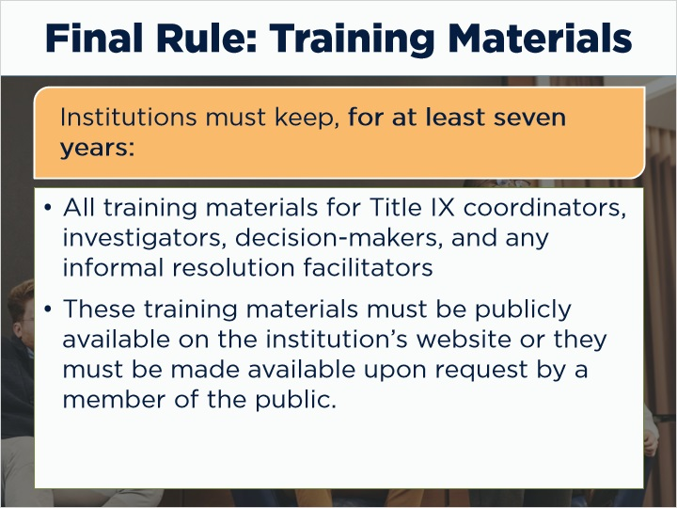
Notes:
All training materials for Title IX coordinators, investigators, decision-makers, and any informal resolution facilitators.
There is an additional stipulation that these training materials must be publicly available on the institution’s website, or they must be made available upon request for inspection by a member of the public.

1.7 Maintaining Records
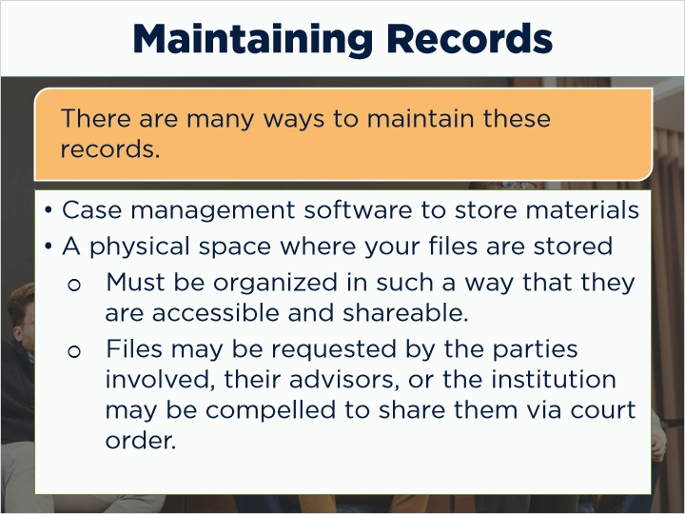
Notes:
There are many ways to maintain these records. The easiest method to maintain records would likely be the case management software that you institution uses to store materials while a case is underway, although that is dependent on your institution’s resources.
If your institution wishes to maintain a physical space where your files are stored, they must be organized in such a way that they are accessible and shareable. Some of these files may be requested by the parties involved, their advisors, or the institution may be compelled to share them through a court order.

1.8 Knowledge Check
(Multiple Response, 10 points, unlimited attempts permitted)
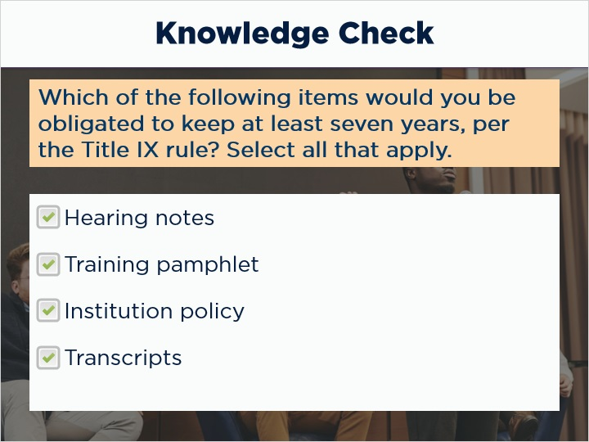
Correct | Choice
X | Hearing notes
X | Training pamphlet
X | Institution policy
X | Transcripts

Feedback when correct:
That's right! You should keep all of these in a place where they can be easily found and shareable.

Notes:
- Knowledge check: Which of the following items would you be obligated to keep at least seven years, per the Title IX rule?
Notes taken during a hearing
Pamphlet recruiting panelists for Title IX processes
A copy of your institutional code of conduct
Transcripts of audio recording from a Title IX hearing

1.9 Conclusion
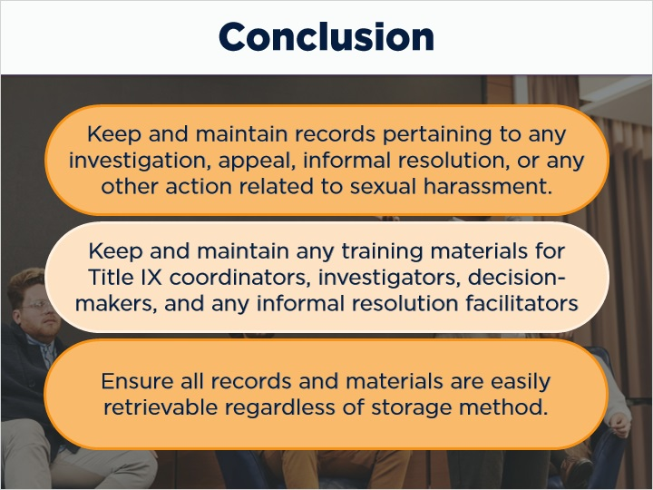
Notes:
In this course we learned about how to:

Keep and maintain records pertaining to any investigation, appeal, informal resolution, or any other action related to sexual harassment. Also, maintain any training materials for Title IX coordinators, investigators, decision-makers, and any informal resolution facilitators (if that option is in use).

While there are many ways to maintain these records, ensure that these records are easily retrievable regardless of what an institution utilizes for storage.

1.10 Exit Slide
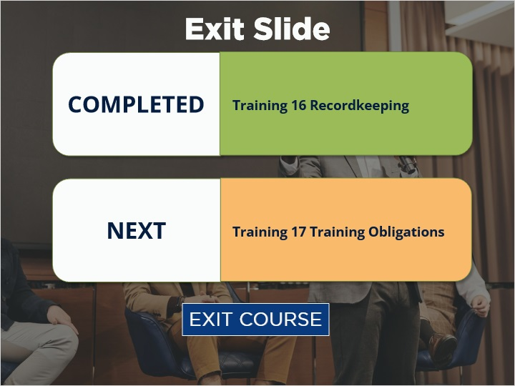
Notes:
You have reached the end of Training 17: Training Obligations. Next is Training 18: Intake and Formal Complaints. Select Exit Course to receive credit and go to the next training.

