Retaliation

1. Draft

1.1 Title

Notes:

1.2 Disclaimer
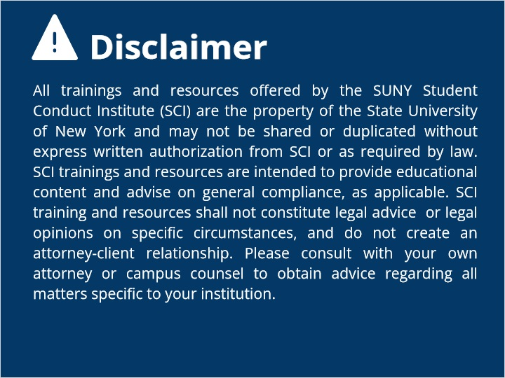
Notes:

1.3 Overview
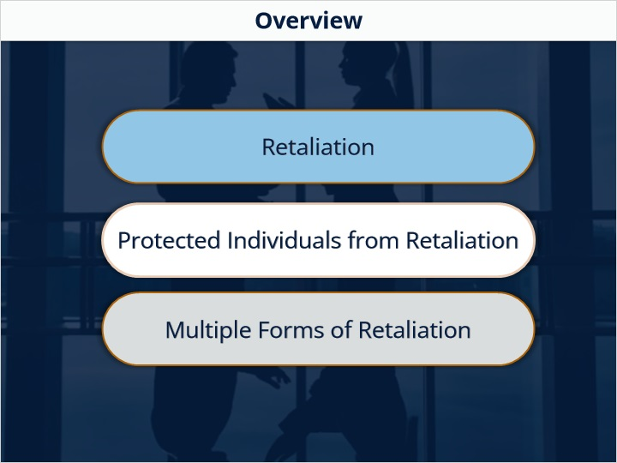

1.4 What is Retaliation?
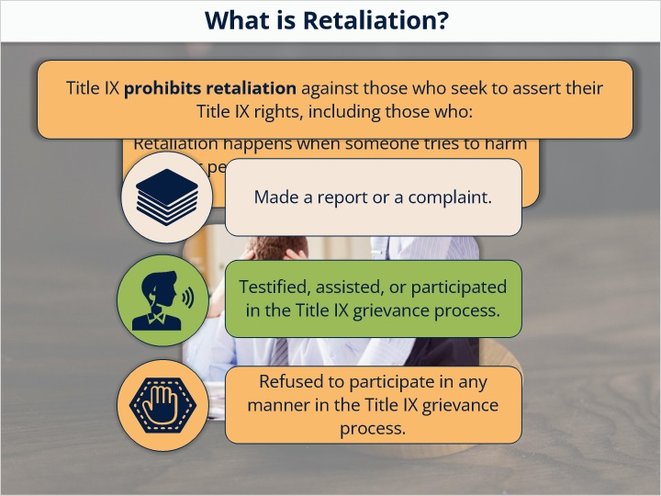

1.5 Forms of Retaliation
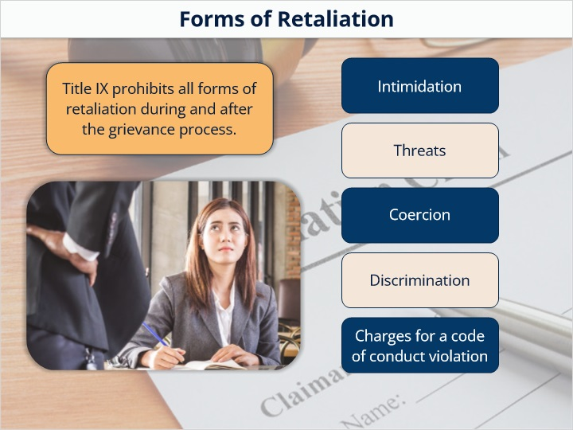

1.6 Intimidation and Threats
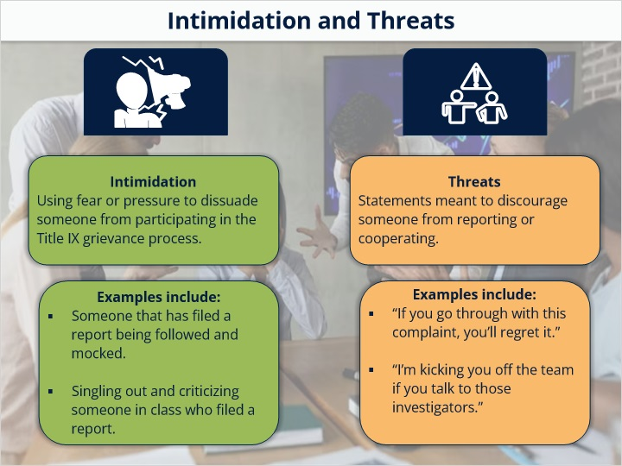

1.7 Coercion and Discrimination
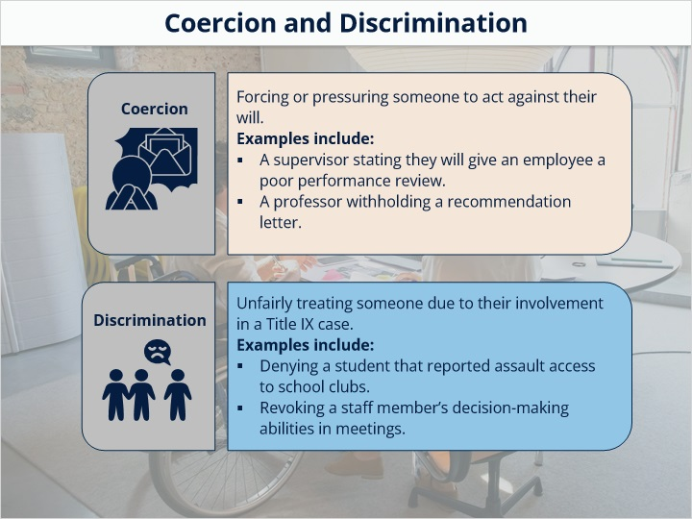

1.8 Knowledge Check
(Multiple Response, 10 points, 1 attempt permitted)
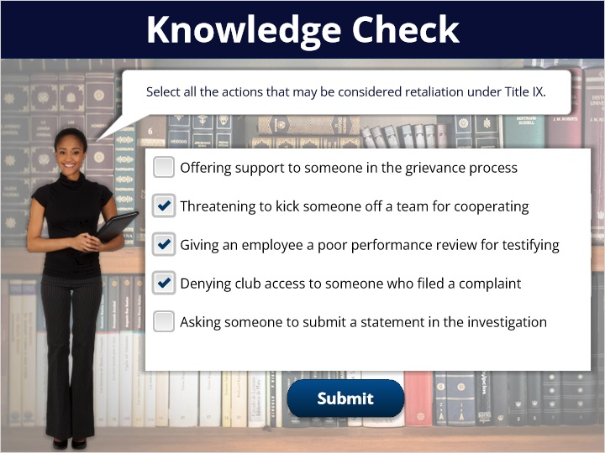
Correct | Choice
 | Offering support to someone in the grievance process
X | Threatening to kick someone off a team for cooperating
X | Giving an employee a poor performance review for testifying
X | Denying club access to someone who filed a complaint
 | Asking someone to submit a statement in the investigation

Feedback when correct:
Great work!
Feedback when incorrect:
Not quite. Review the guidelines and think about what supports fairness and legality.

1.9 Code of Conduct Violations
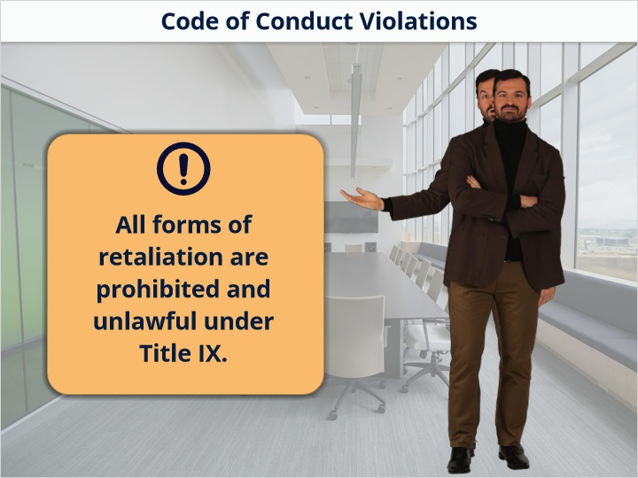

1.10 Summary
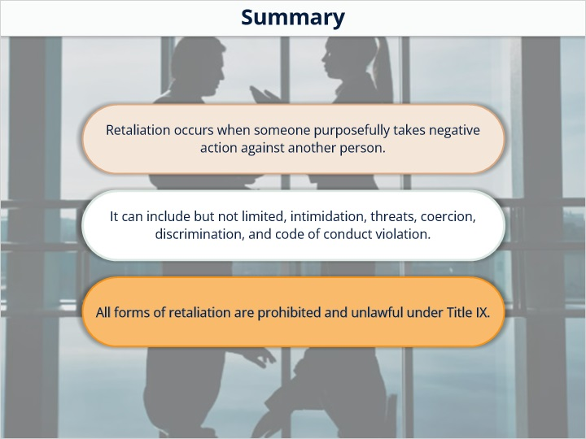

1.11 End Slide
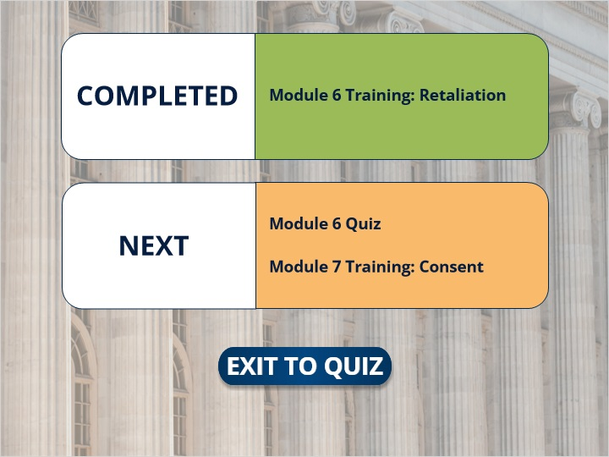
Notes:

