The Ideal Hearing Panelist and Conflicts of Interest & Bias

1. Draft

1.1 Title
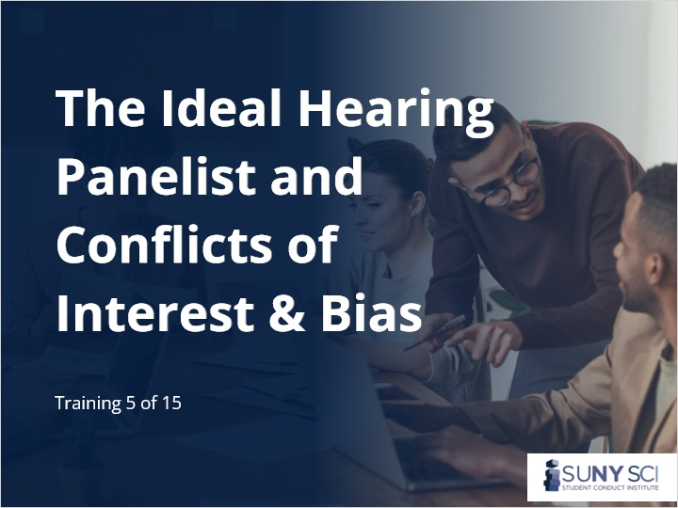
Notes:

1.2 Disclaimer
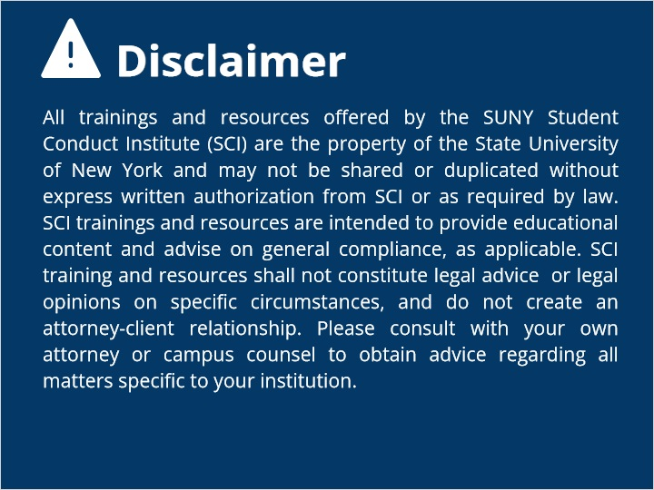
Notes:

1.3 Overview
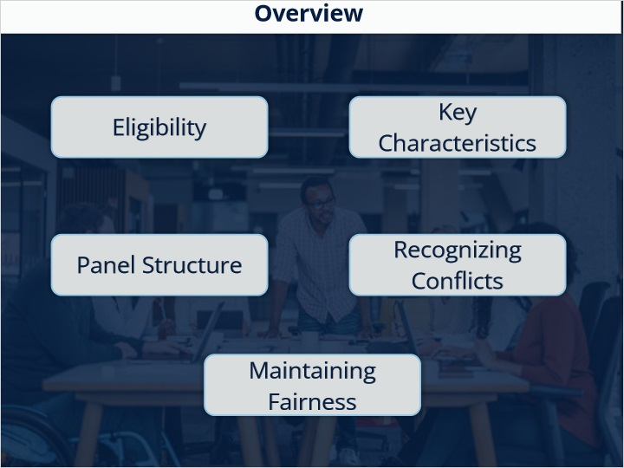

1.4 Who can Serve on a Title IX Hearing Board?
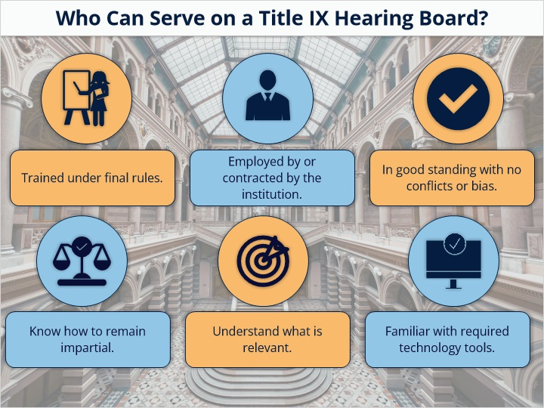

1.5 Hearing Board Panelist
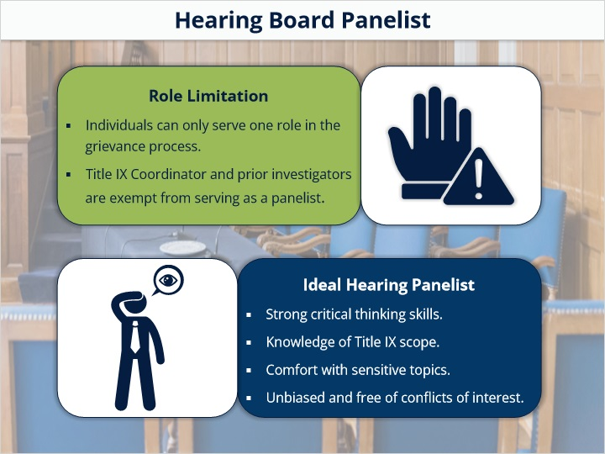

1.6 Key Panel Roles
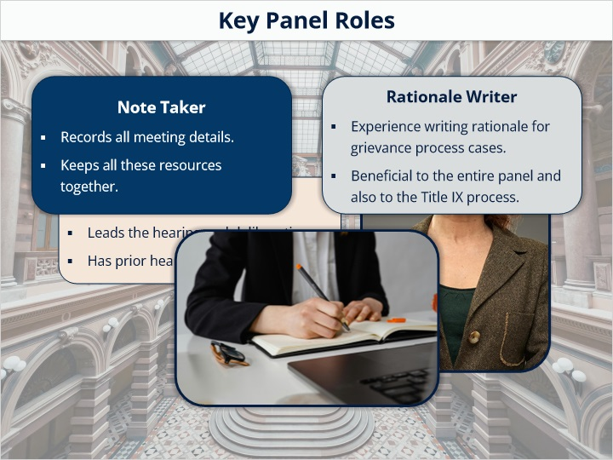

1.7 Key Roles in the Hearing Process
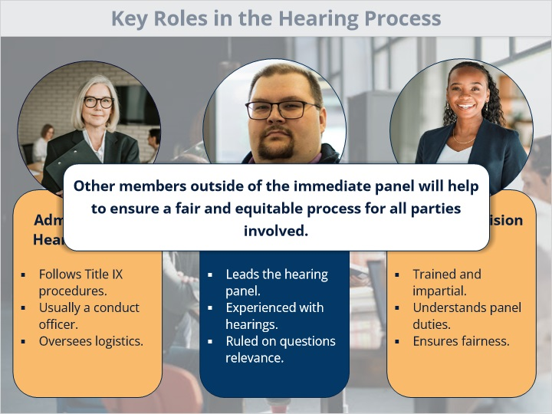

1.8 Recognizing Bias and Conflicts of Interest
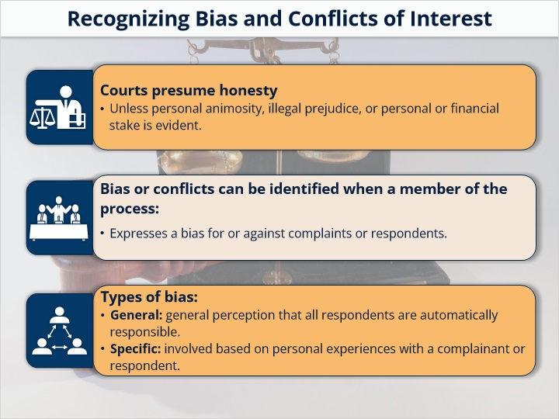

1.9 Role Conflicts and Perceptions
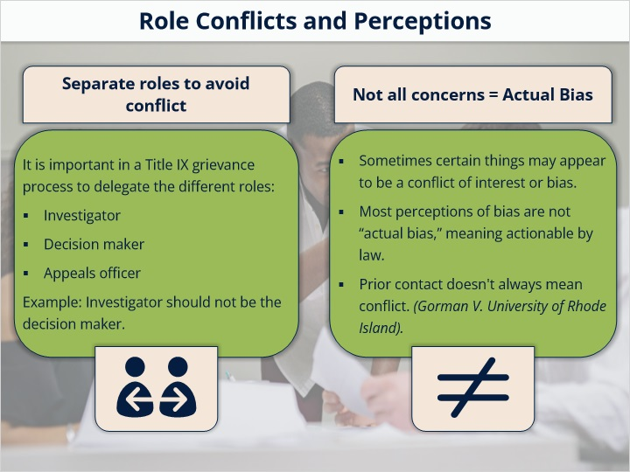

1.10 Multiple Response
(Multiple Response, 10 points, 1 attempt permitted)
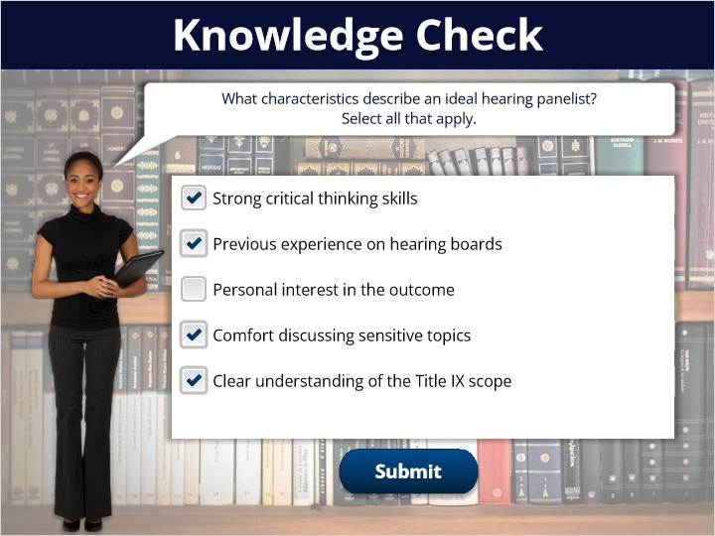
Correct | Choice
X | Strong critical thinking skills
X | Previous experience on hearing boards
 | Personal interest in the outcome
X | Comfort discussing sensitive topics
X | Clear understanding of the Title IX scope

Feedback when correct:
Great work!
Feedback when incorrect:
Not quite. Review the guidelines and think about what supports fairness and legality.

Notes:

1.11 What is Not a Conflict of Interest
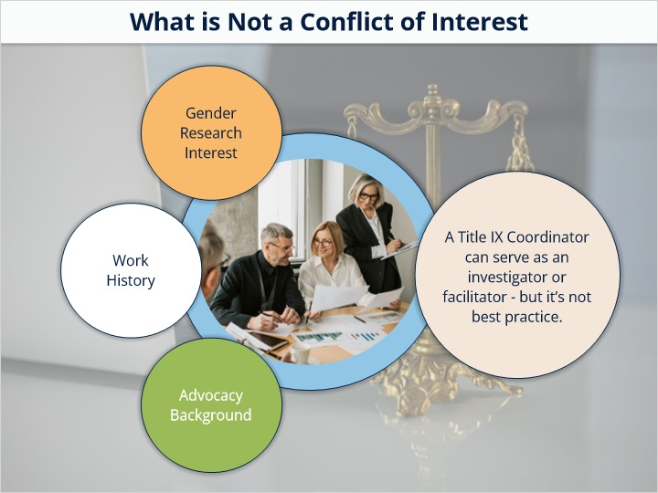

1.12 Avoiding Bias
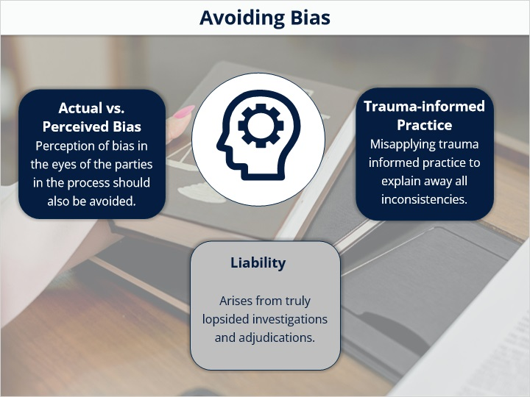

1.13 Role Conflicts and Perceptions
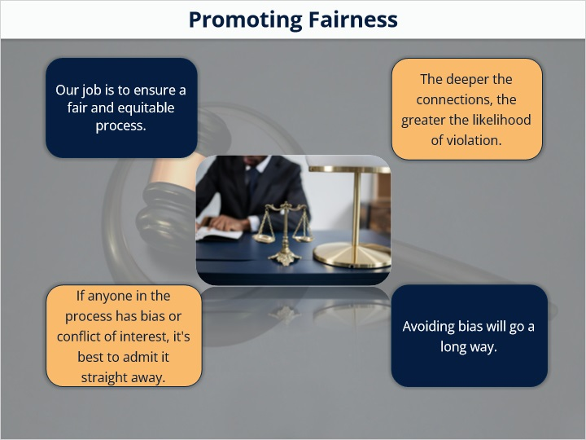

1.14 ToolKit Resource
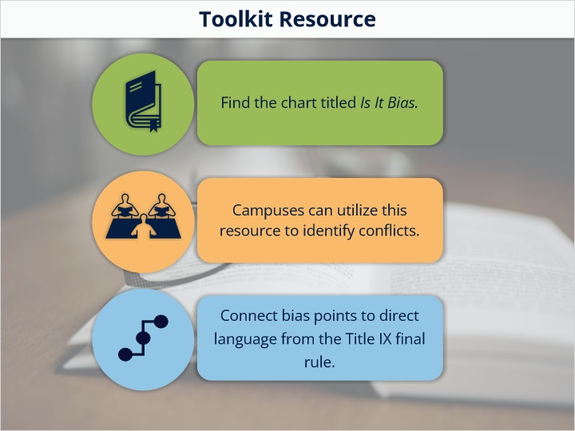

1.15 Summary
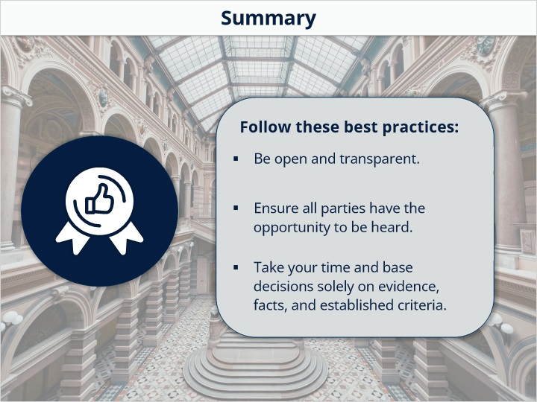

1.16 End Slide
