Title IX Final Rule Basics

1. Introduction

1.1 SCI Welcome & Legal disclaimer


1.2 Title IX Final Rule Basics
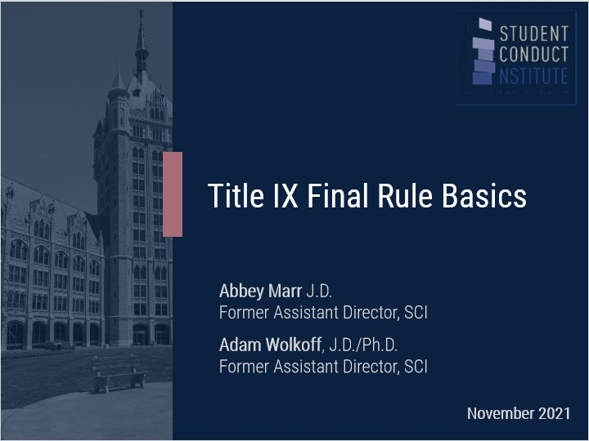

1.3 Learning Objectives
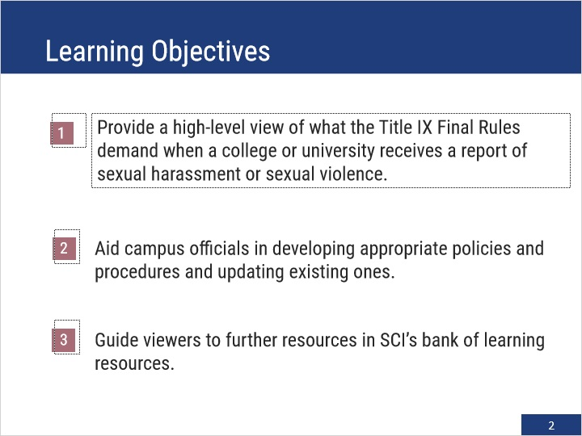

1.4 Road Map
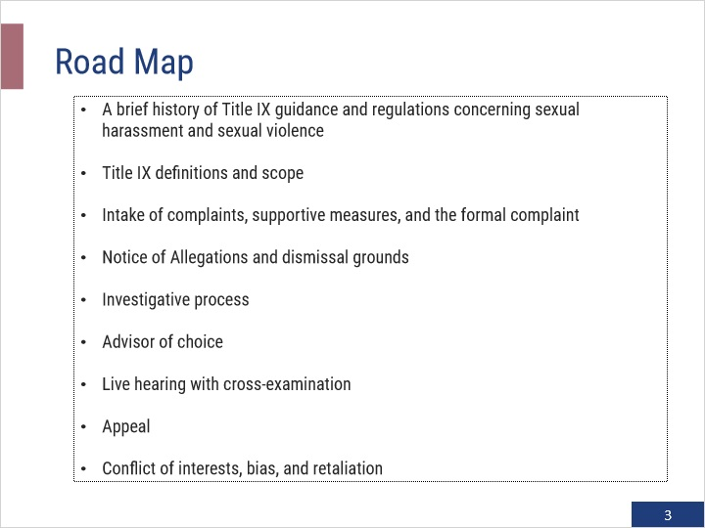

1.5 Title IX and Sexual Harassment
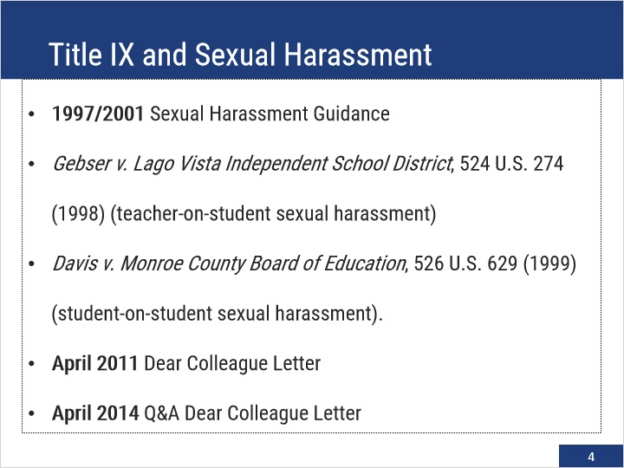

1.6 Title IX and Sexual Harassment
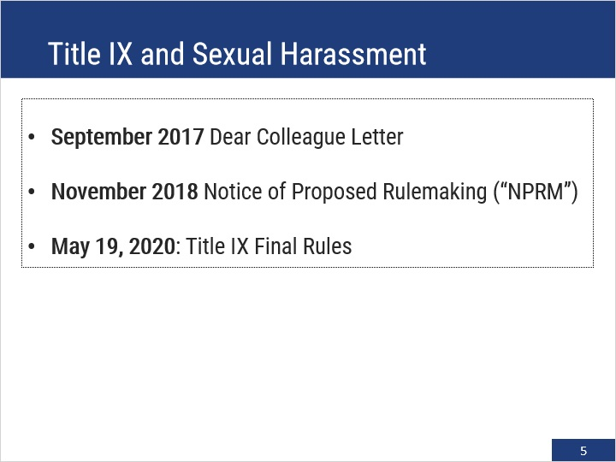

1.7 Scope of the Title IX Final Rule
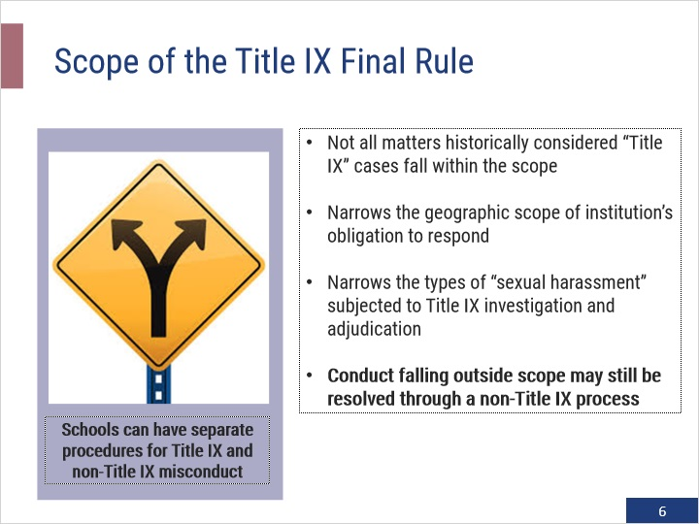

2. Brief History & Jurisdiction

2.1 “Sexual Harassment”: Then and Now
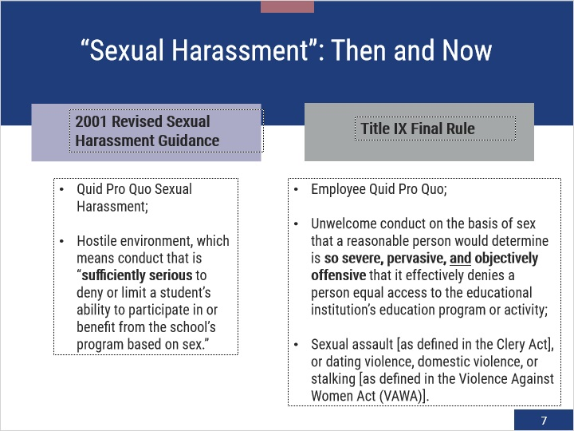

2.2 “Actual Knowledge” and Duty to Respond
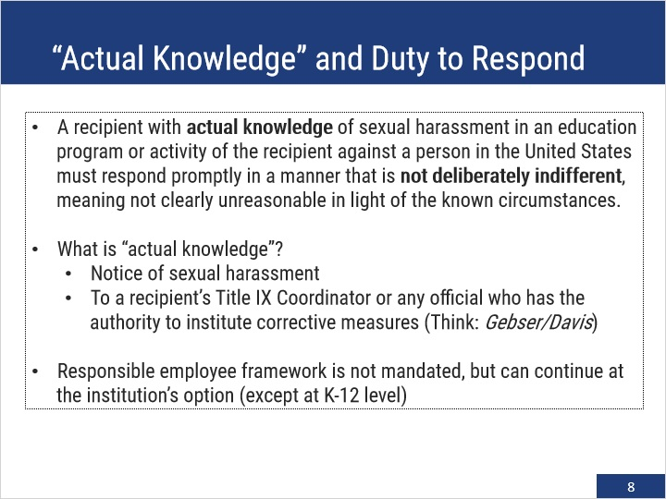

2.3 Jurisdiction under Title IX Final Rule
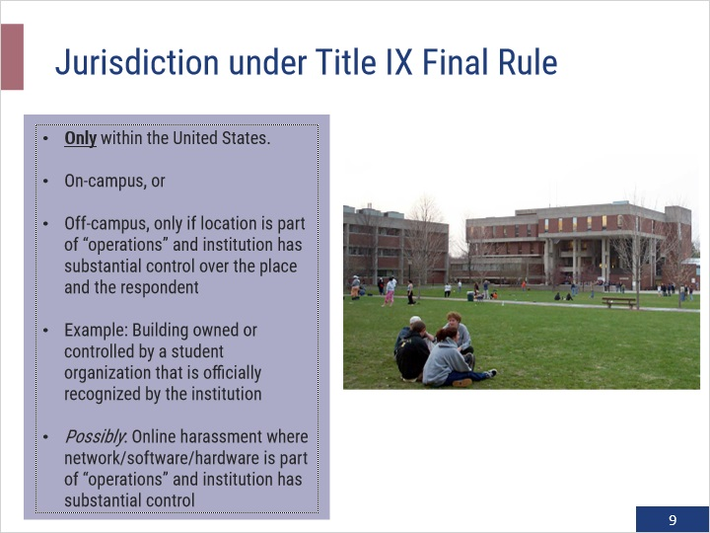

2.4 Conflicts of Interest and Bias
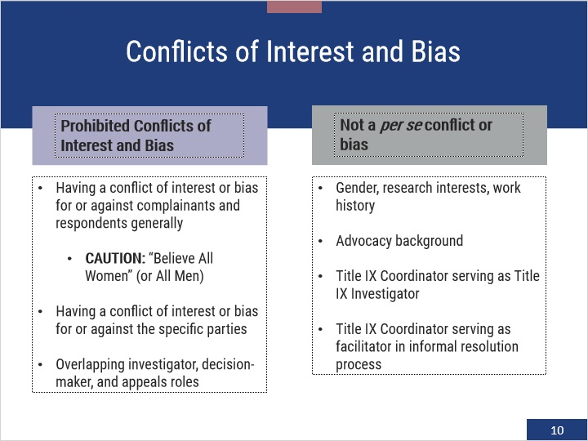

2.5 Intake Process and Supportive Measures
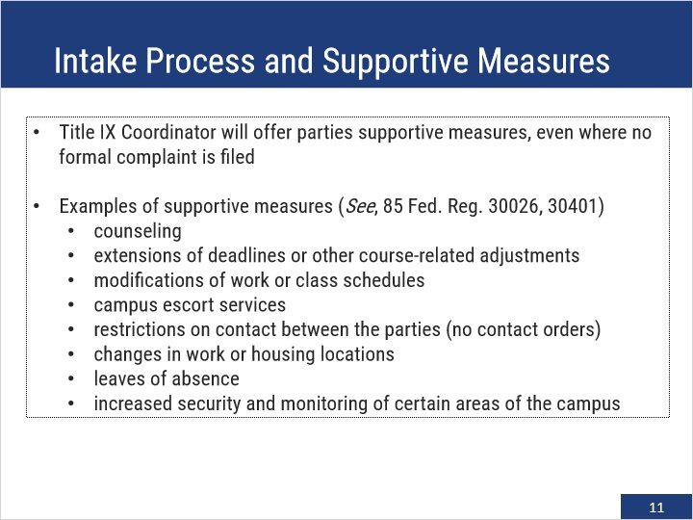

3. Allegations, Dismissals, and Investigation

3.1 Emergency Removals
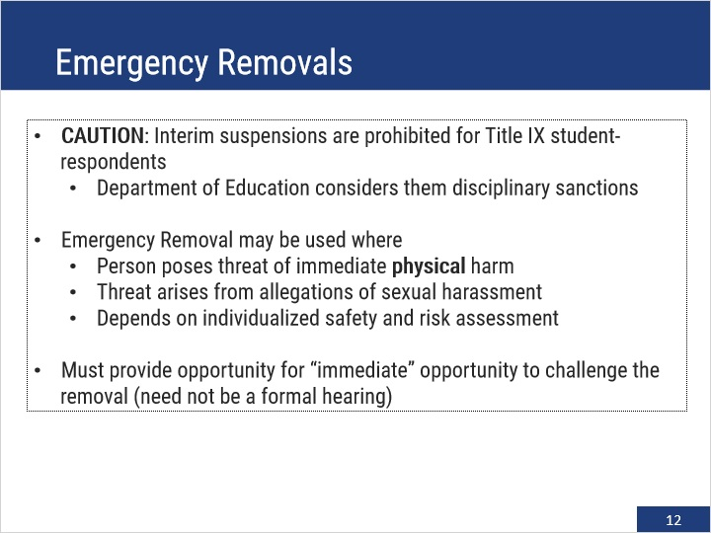

3.2 Formal Complaint
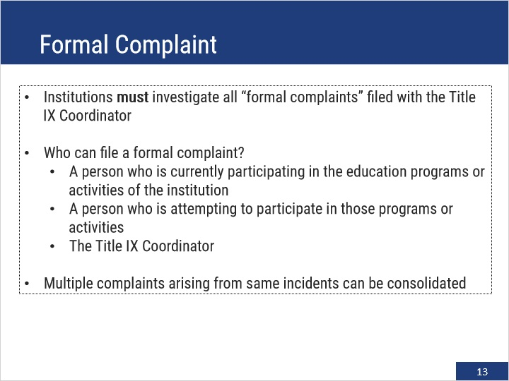

3.3 Time Frames
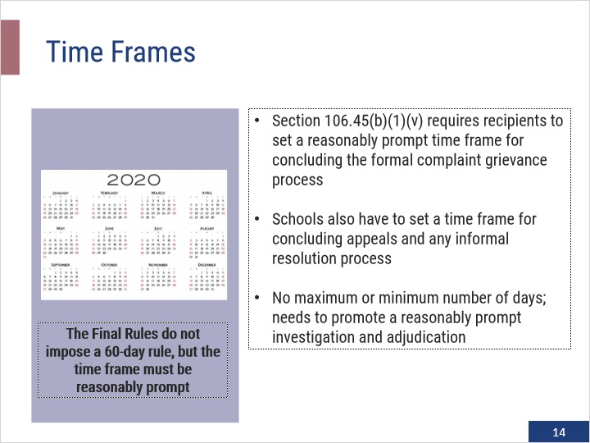

3.4 Allegations and Advisor
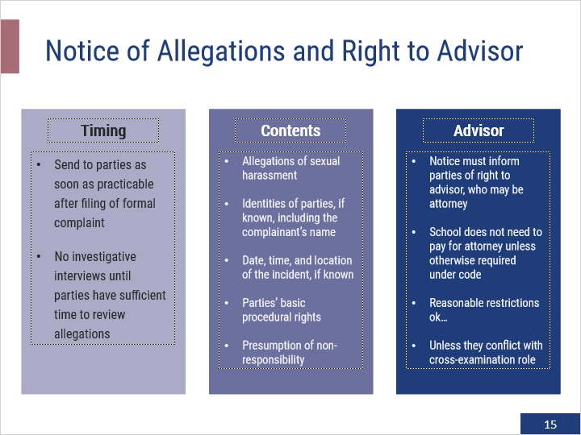

3.5 Mandatory and Discretionary Dismissal
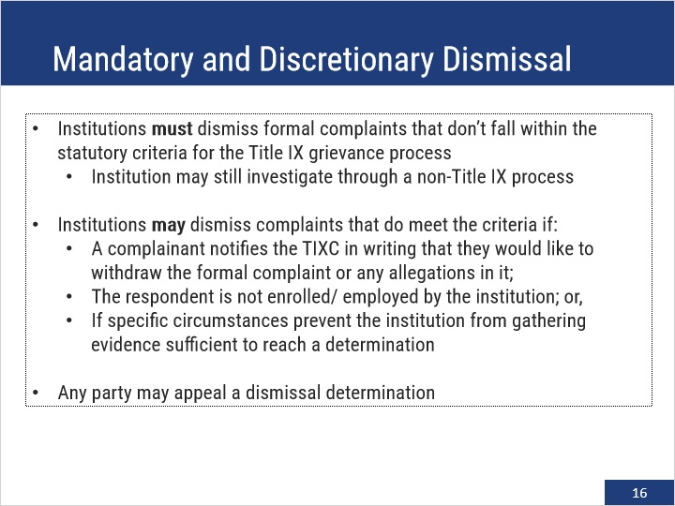

3.6 Investigative Process
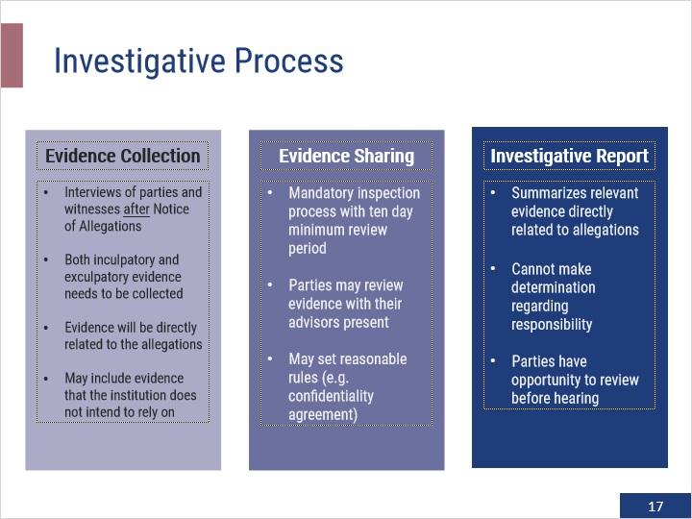

3.7 Live Hearing
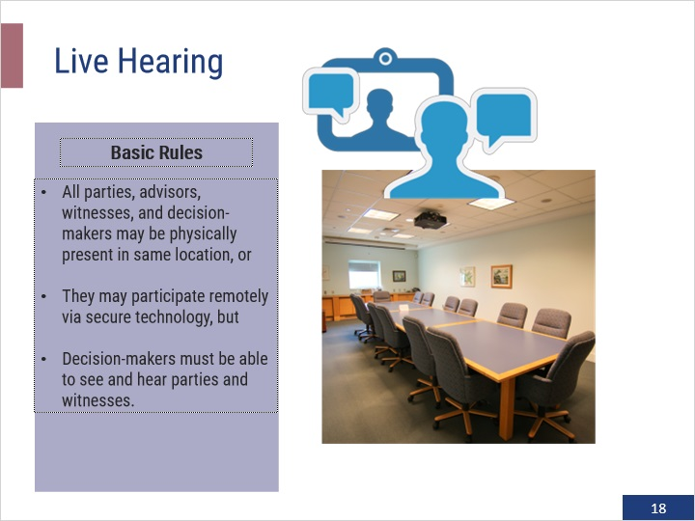

4. Cross-examination and Appeals

4.1 Relevant Questions
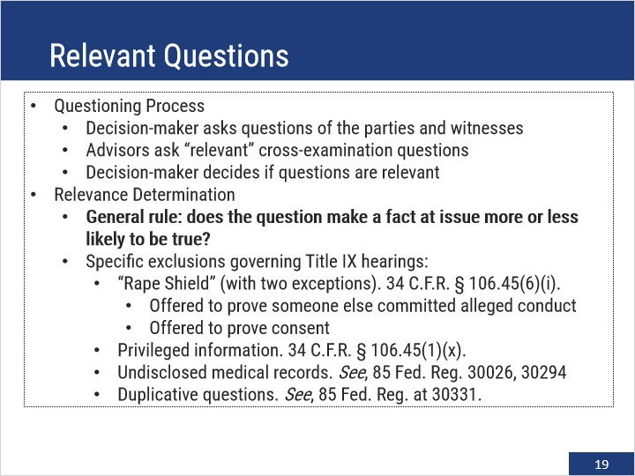

4.2 Cross-Examination
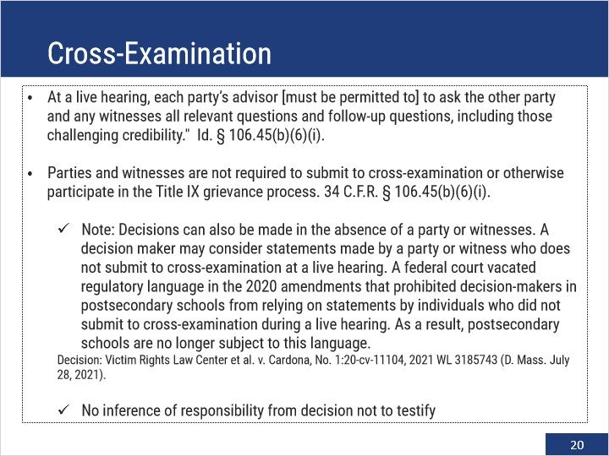

4.3 Determination Regarding Responsibility
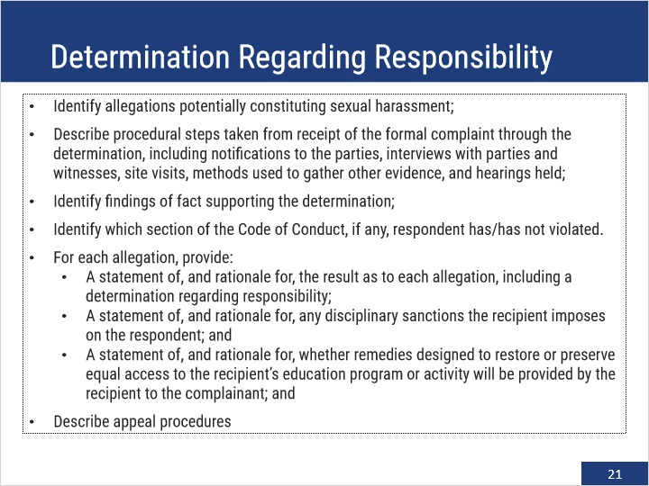

4.4 Appeal
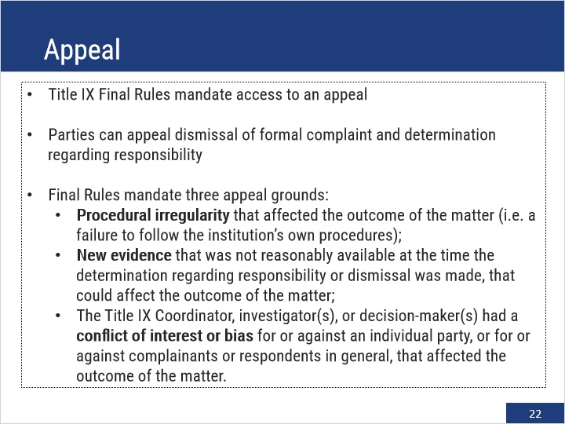

4.5 Retaliation (Section 106.71)
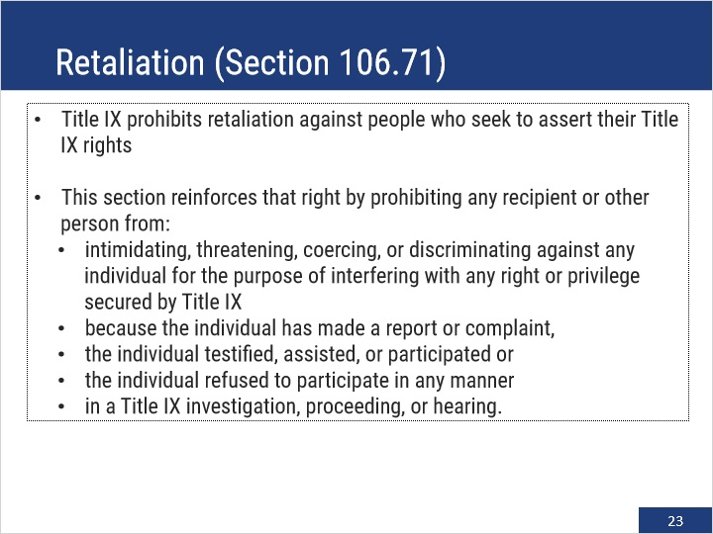

4.6 Under the 2020 Title IX Rules, who is not able to file a formal complaint?
(Multiple Choice, 10 points, unlimited attempts permitted)
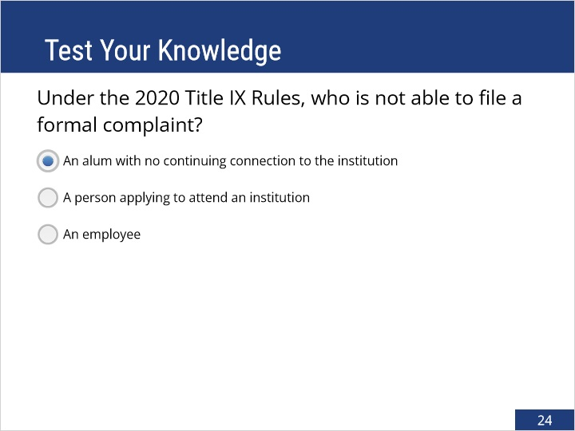
Correct | Choice
X | An alum with no continuing connection to the institution
 | A person applying to attend an institution
 | An employee

Feedback when correct:
That's right! You selected the correct response.
Feedback when incorrect:
You did not select the correct response.

Correct (Slide Layer)
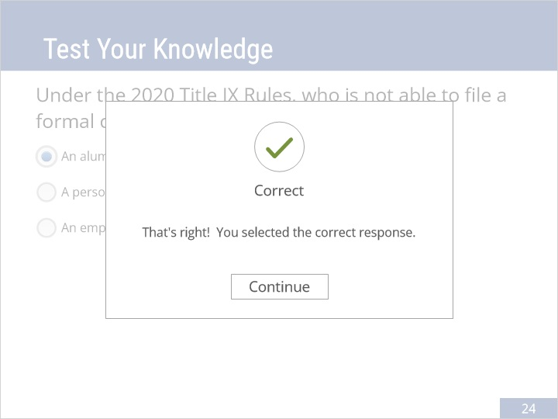

Incorrect (Slide Layer)
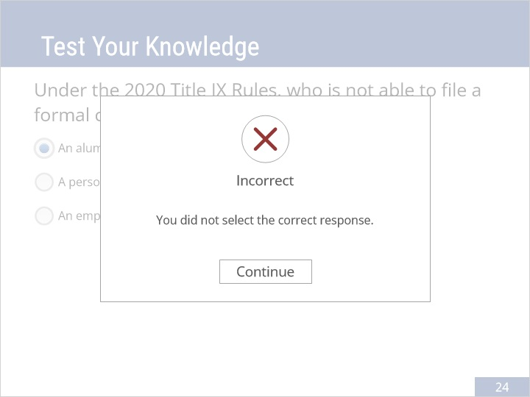

Try Again (Slide Layer)
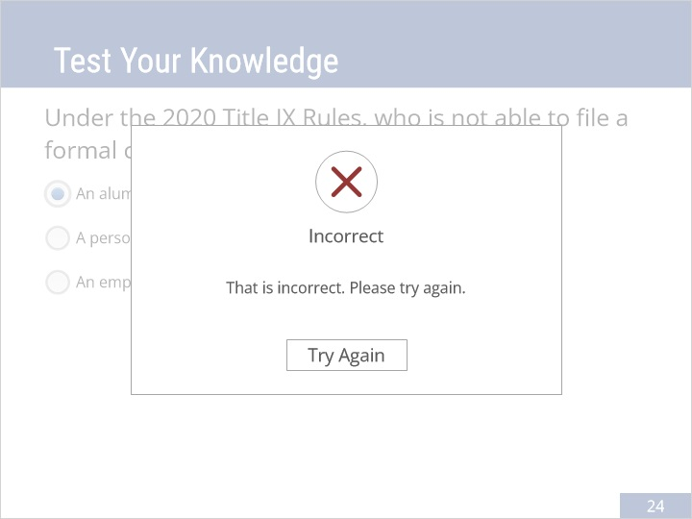

4.7 Which cross-examination question will always be irrelevant under the 2020 Title IX Rules?
(Multiple Choice, 10 points, unlimited attempts permitted)
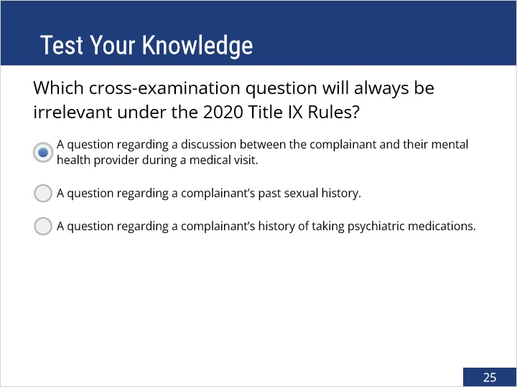
Correct | Choice
X | A question regarding a discussion between the complainant and their mental health provider during a medical visit.
 | A question regarding a complainant’s past sexual history.
 | A question regarding a complainant’s history of taking psychiatric medications.

Feedback when correct:
That's right! You selected the correct response.
Feedback when incorrect:
You did not select the correct response.

Correct (Slide Layer)
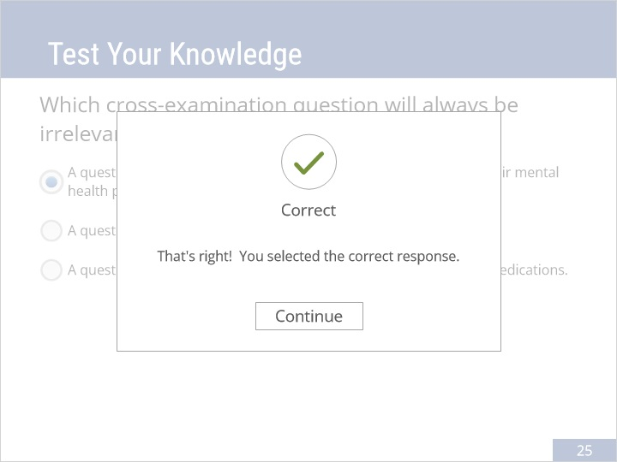

Incorrect (Slide Layer)
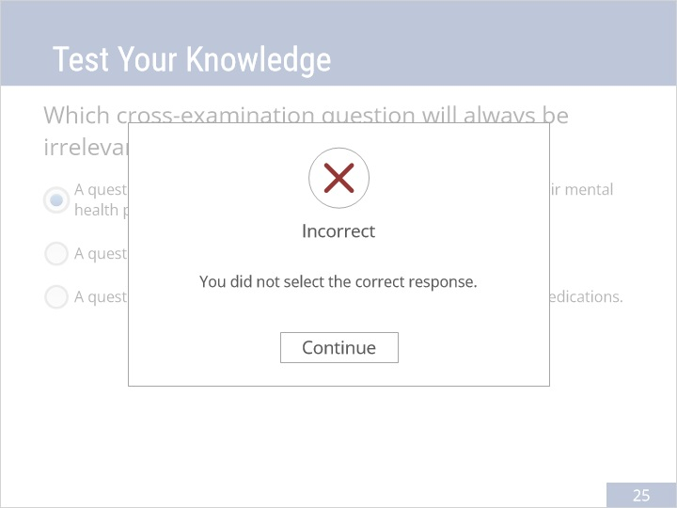

Try Again (Slide Layer)
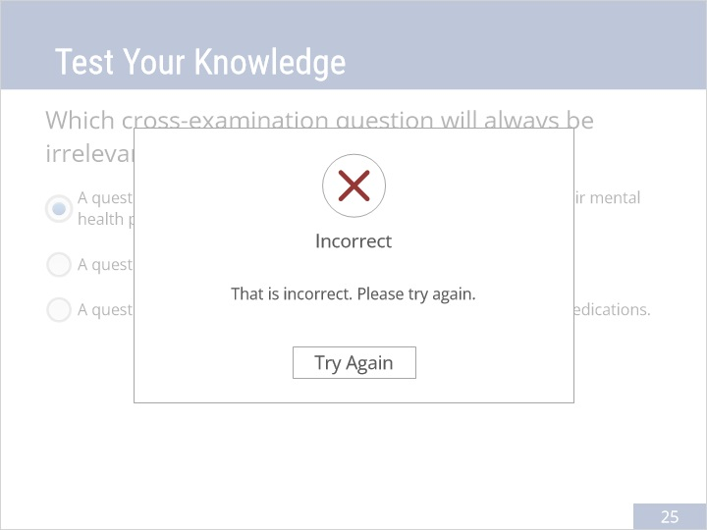

4.8 The 2020 Title IX Rules prohibit this conduct as retaliation:
(Multiple Choice, 10 points, unlimited attempts permitted)
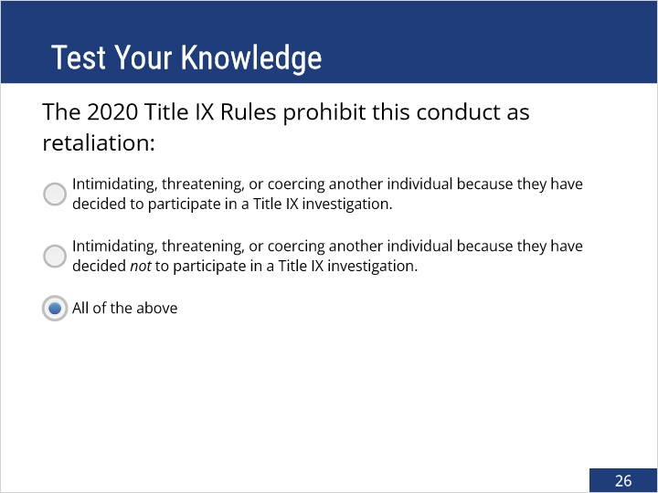
Correct | Choice
 | Intimidating, threatening, or coercing another individual because they have decided to participate in a Title IX investigation.
 | Intimidating, threatening, or coercing another individual because they have decided not to participate in a Title IX investigation.
X | All of the above

Feedback when correct:
That's right! You selected the correct response.
Feedback when incorrect:
You did not select the correct response.

Correct (Slide Layer)
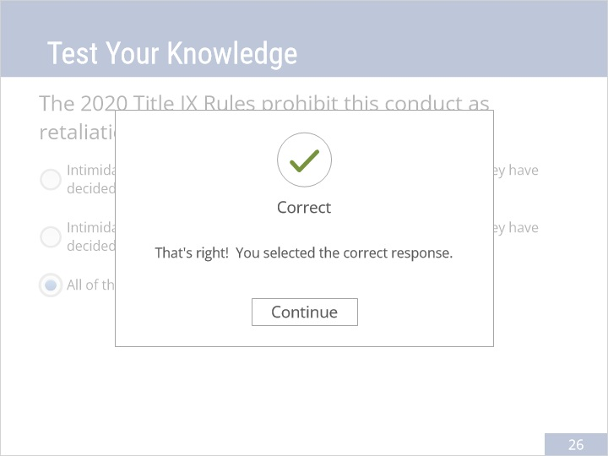

Incorrect (Slide Layer)
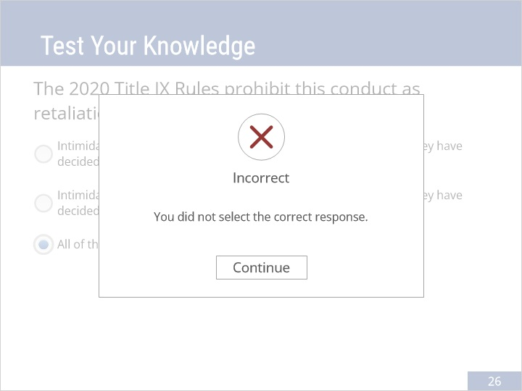

Try Again (Slide Layer)
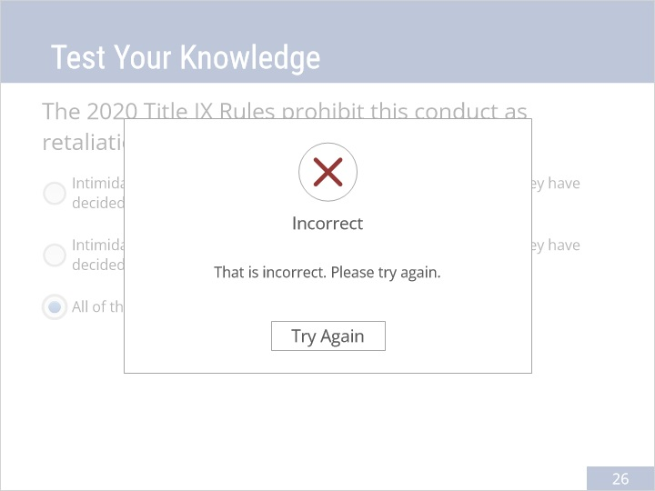

4.9 Further Reading
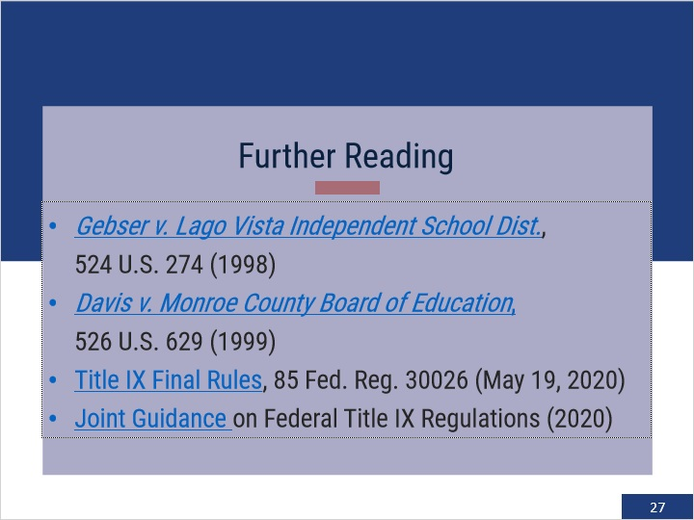

5. Exit Questions

5.1 Attest
(True/False, 100 points, 1 attempt permitted)
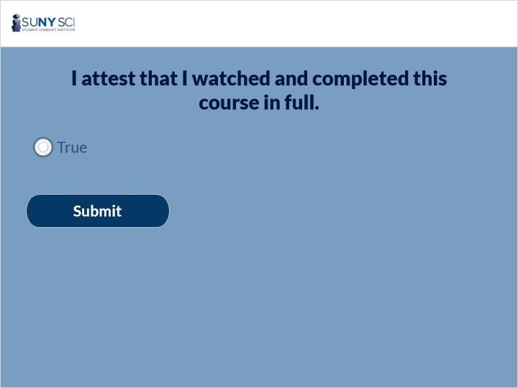
Correct | Choice
X | True

5.2 Results Slide
(Results Slide, 0 points, 1 attempt permitted)
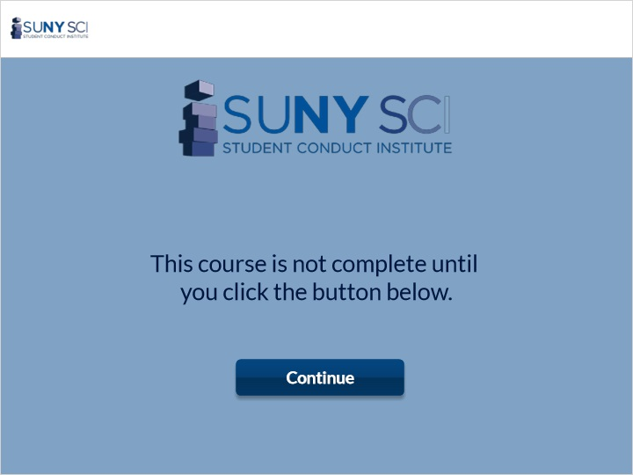

Results for
5.1 Attest

Result slide properties | Passing Score
80%

Success (Slide Layer)

Failure (Slide Layer)

5.3 End Course
