Training Obligations

1. Intro Scene

1.1 Training Obligations
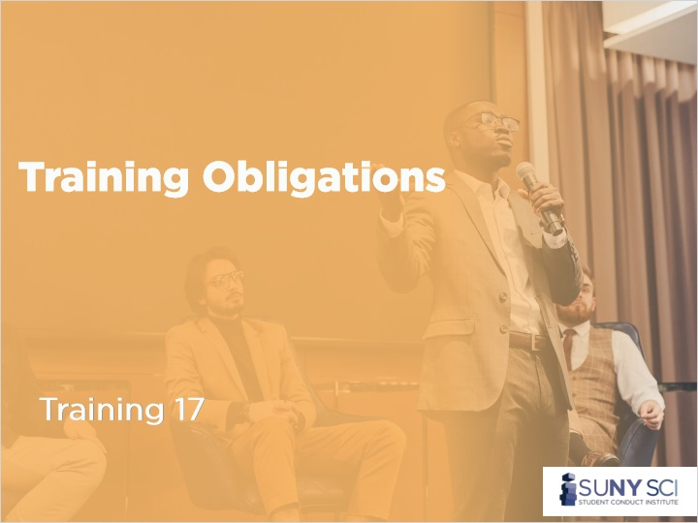
Notes:
[Upbeat music]

1.2 Disclaimer
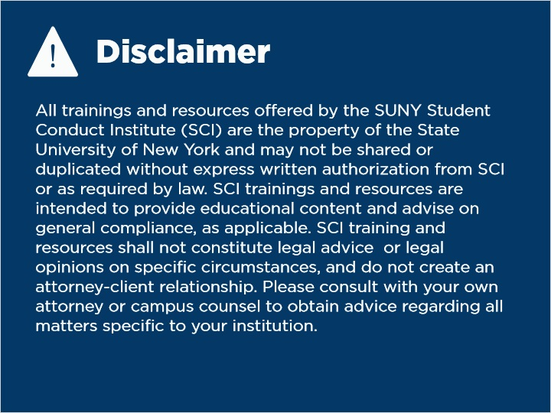
Notes:
All trainings and resources offered by the SUNY Student Conduct Institute (SCI) are the property of the State University of New York and may not be shared or duplicated without express written authorization from SCI or as required by law. SCI trainings and resources are intended to provide educational content and advise on general compliance, as applicable. SCI training and resources shall not constitute legal advice or legal opinions on specific circumstances, and do not create an attorney-client relationship. Please consult with your own attorney or campus counsel to obtain advice regarding all matters specific to your institution.

1.3 Which Roles Need Training?
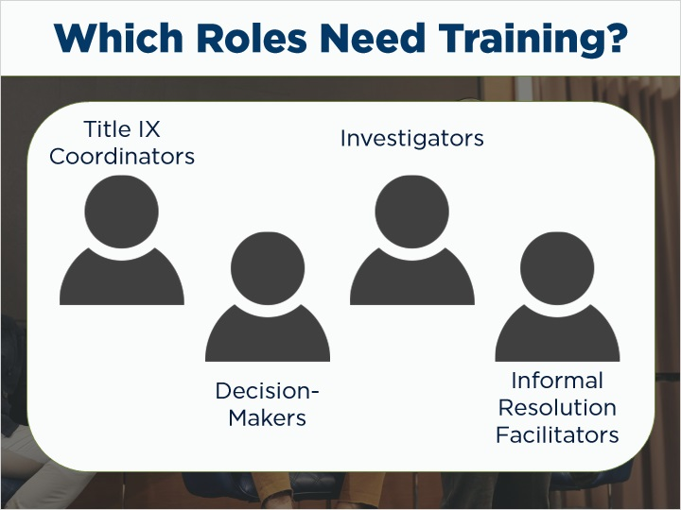
Notes:
There are other obligations for the Title IX Coordinator beyond the oversight of a grievance process. The Coordinator is also responsible for the training of employees responsible for various stages of the process. This includes the Title IX Coordinator themselves and their deputies, any decision-makers, investigators, and facilitators of the informal resolution process should your institution choose to utilize an informal option for resolution.
In this course, we will review these obligations and how Title IX coordinators can fulfill them. These trainings can be delegated to other individuals or deputies, but the Title IX Coordinator will be ultimately responsible for compliance in the areas.

1.4 Training
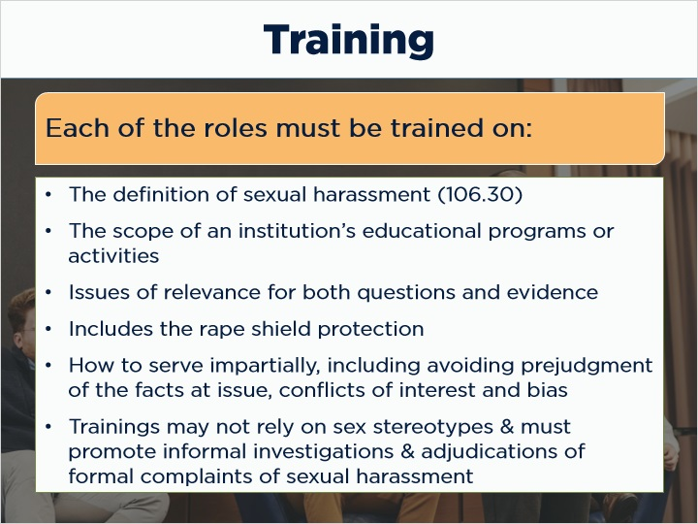
Notes:
Let’s start with reviewing the subjects that every role in the Title IX process are required to receive training for. Each of the roles identified must be trained on:
The definition of sexual harassment (106.30)
The scope of an institution’s educational programs or activities
Issues of relevance for both questions and evidence
Includes the rape shield protection
How to serve impartially, including avoiding prejudgment of the facts at issue, conflicts of interest and bias
Furthermore, none of the trainings may rely on sex stereotypes, and must promote informal investigations and adjudications of formal complaints of sexual harassment.

1.5 Title IX Coordinator Training
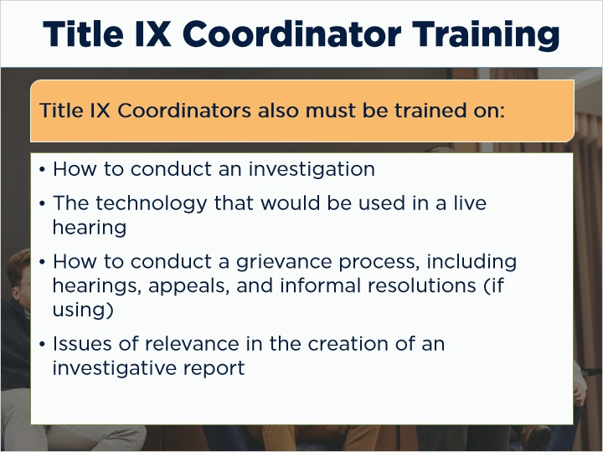
Notes:
- Title IX Coordinators are additionally required to be trained on:
How to conduct an investigation,
The technology that would be used in a live hearing,
How to conduct a grievance process, including hearings, appeals, and informal resolutions (if using), and
Issues of relevance in the creation of an investigative report.

1.6 Decision-makers Training
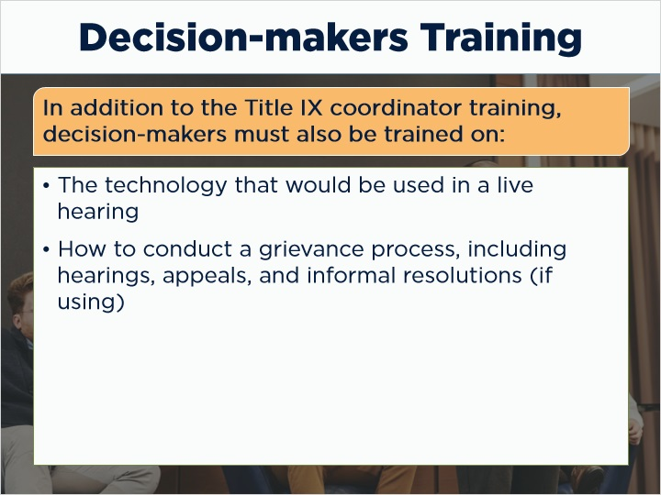
Notes:
- Decisionmakers are additionally required to be trained on:
The technology that would be used in a live hearing, and
How to conduct a grievance process, including hearings, appeals, and informal resolutions (if using).

1.7 Investigators Training
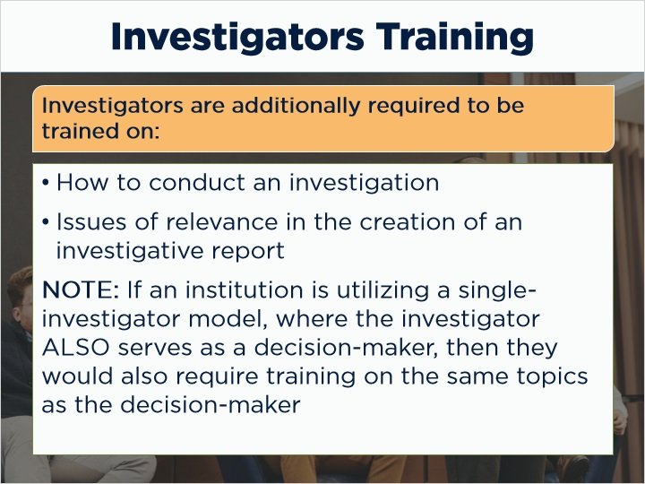
Notes:
Investigators are additionally required to be trained on:
How to conduct an investigation, and
Issues of relevance in the creation of an investigative report.
Furthermore, if an institution is utilizing a single-investigator model, where the investigator ALSO serves as a decision-maker, then they would also be required to be trained on the same topics as the decision-maker.

1.8 Informal Resolution Facilitators
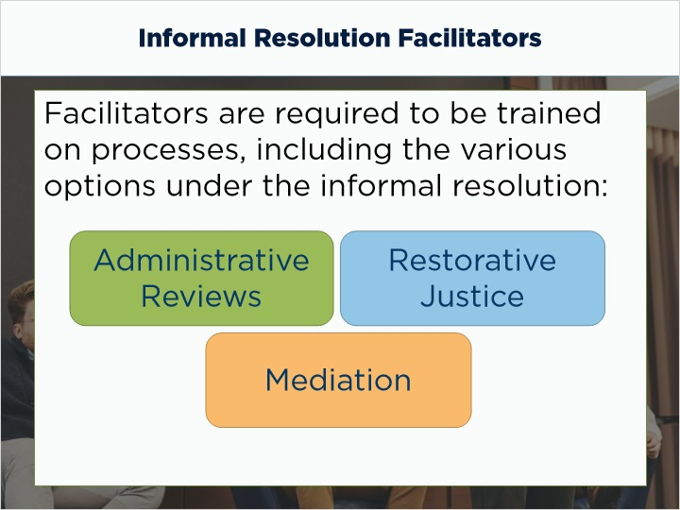
Notes:
Finally, if your institution chooses to utilize an informal resolution option for Title IX complaints, facilitators of the process are required to be trained on those processes, including the various options available for informal resolution. These include, but are not limited to: administrative reviews, mediation, and restorative justice.

1.9 NY-129 B Requirement
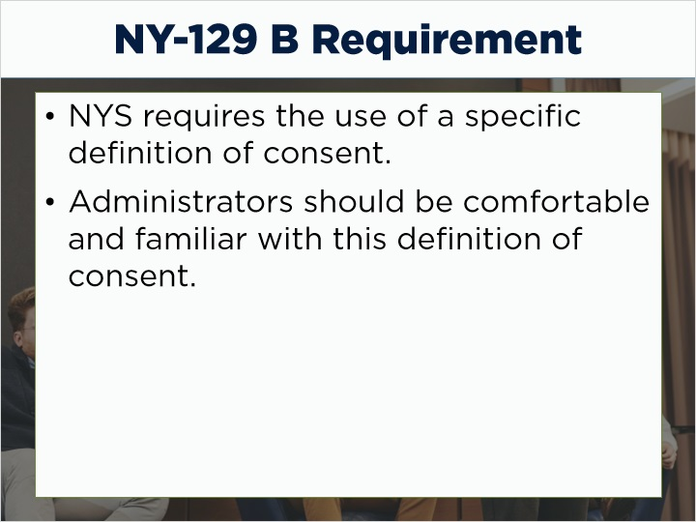
Notes:
There are some additional requirements for training per the NY 129 B legislation. This does not apply to institutions located outside of New York state. New York institutions are also required to utilize the specific definition of consent identified in the consent course. Administrators responsible for a part of the Title IX grievance process should be comfortable and familiar with this definition of consent.

1.10 End of Training Obligations
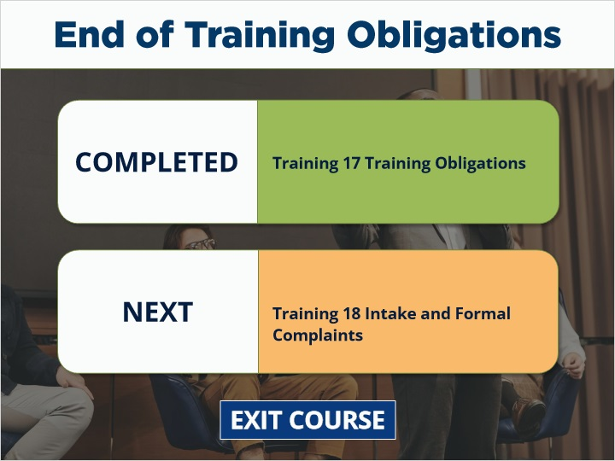
Notes:
You have reached the end of Training Obligations. Next is Intake and Formal Complaints. Select Exit Course to receive credit and go to the next training.

