Walkthrough of a Title IX Hearing

1. Walkthrough of a Title IX Hearing

1.1 Title

Notes:

1.2 Disclaimer
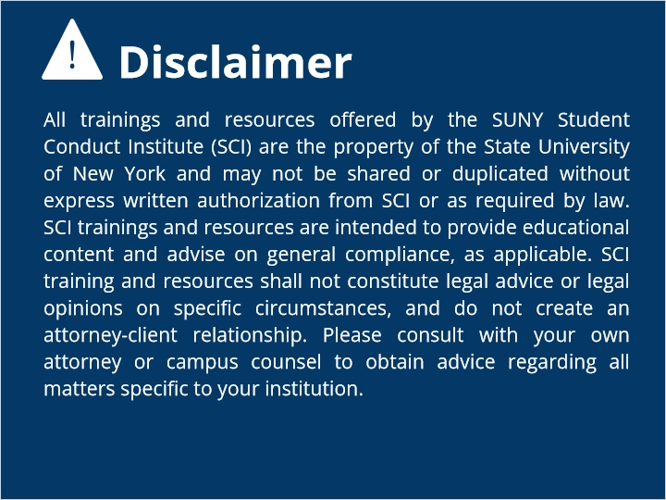

1.3 Informal About
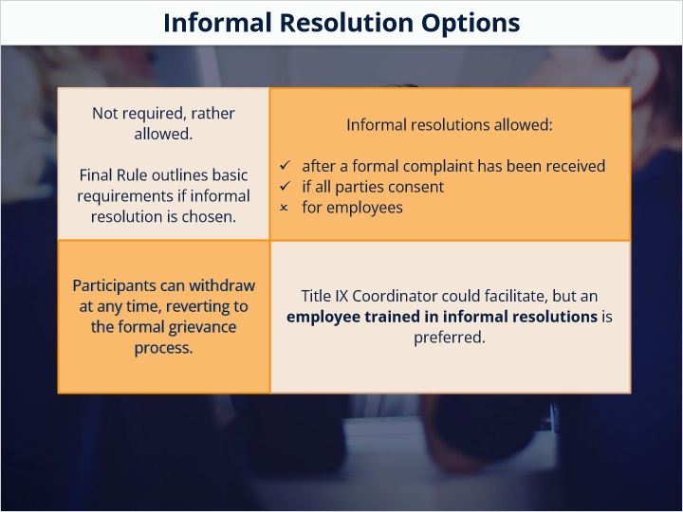

1.4 Informal 3 options
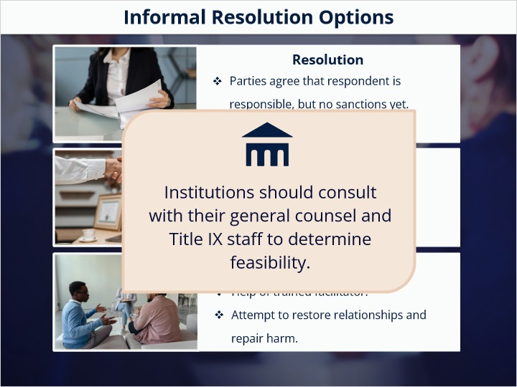

1.5 process overview
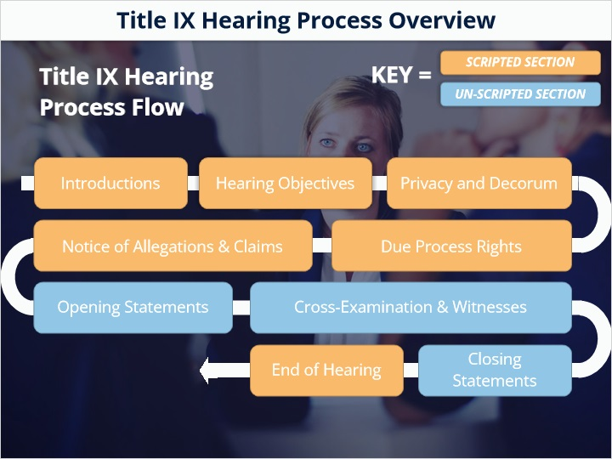

1.6 Introduction
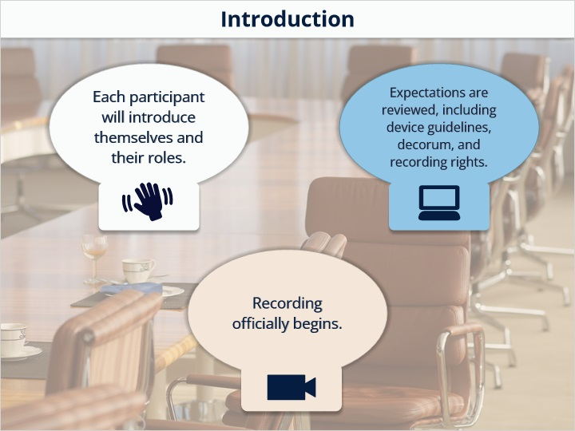

1.7 Hearing Objective
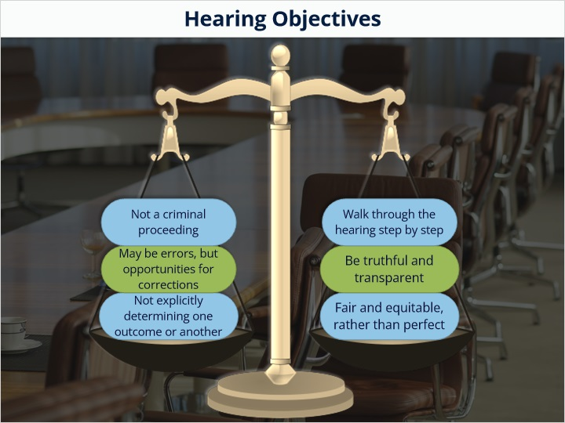

1.8 Privacy and Decorum
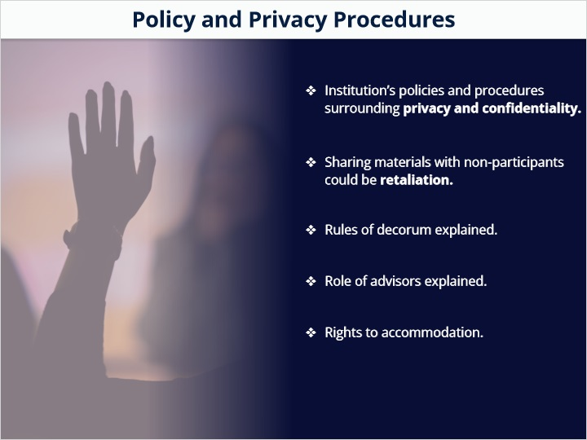

1.9 Decorum
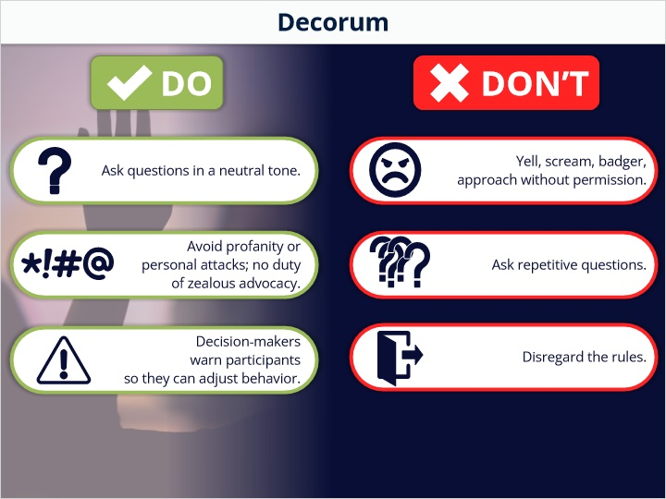

1.10 Due Process
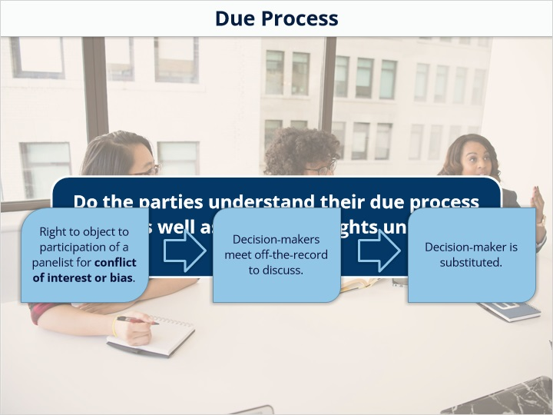

1.11 Due Process
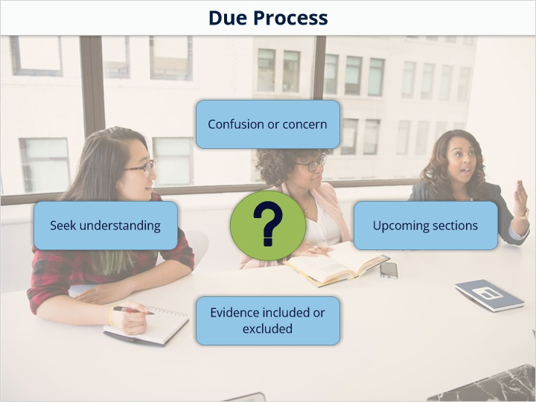

1.12 Notice
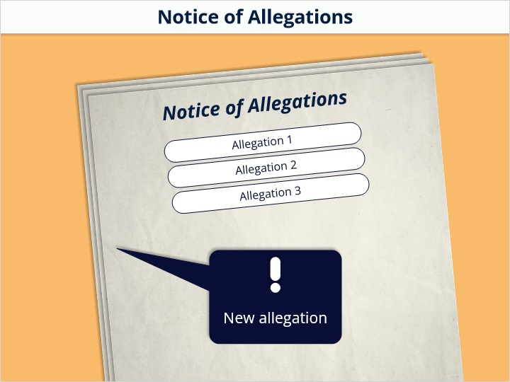

1.13 Opening Statements
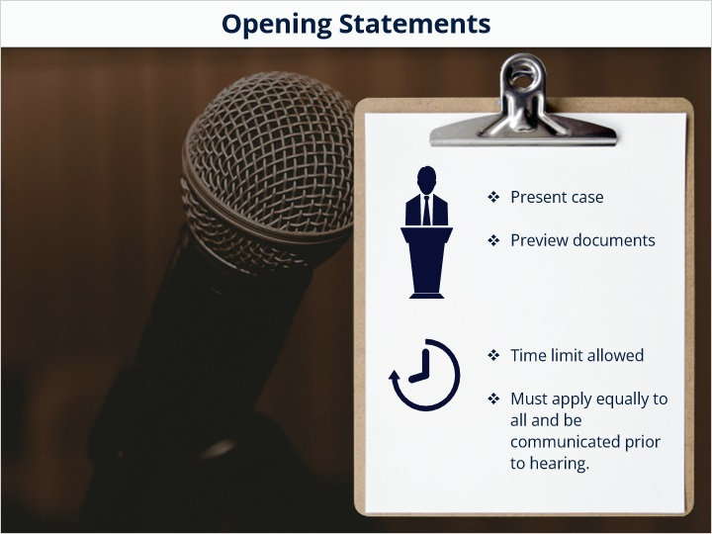

1.14 Multiple Response
(Multiple Response, 10 points, 1 attempt permitted)
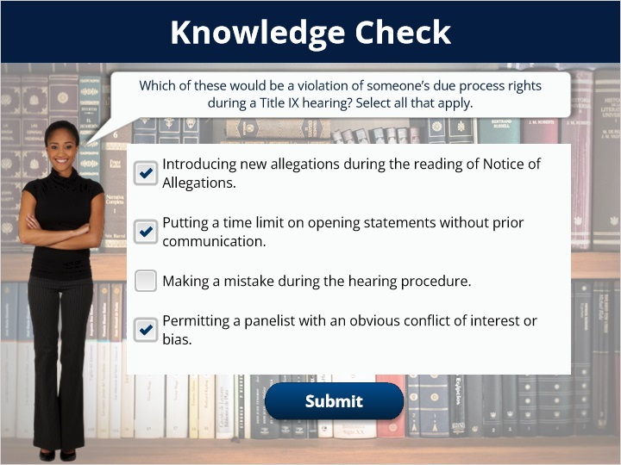
Correct | Choice
X | Introducing new allegations during the reading of Notice of Allegations.
X | Putting a time limit on opening statements without prior communication.
 | Making a mistake during the hearing procedure.
X | Permitting a panelist with an obvious conflict of interest or bias.

Feedback when correct:
Great work!
Feedback when incorrect:
Mistakes might be made, but there are opportunities for correction in the hearing procedure. Participants should strive for a fair and equitable hearing, not a perfect one.

Notes:

1.15 Cross Examine
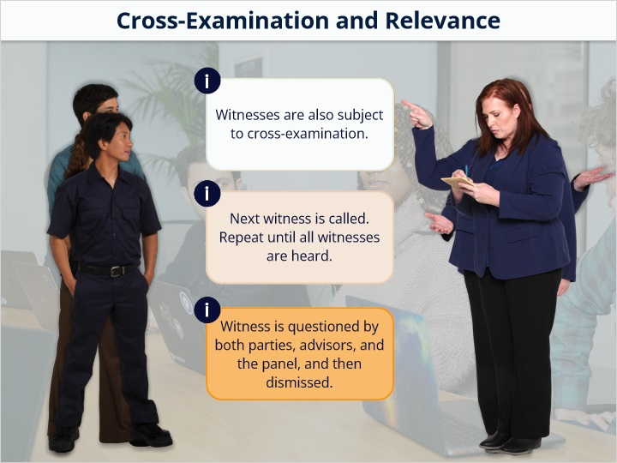

1.16 Statements
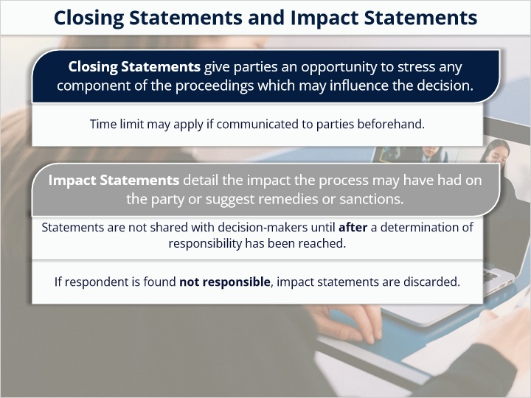

1.17 End of Hearing
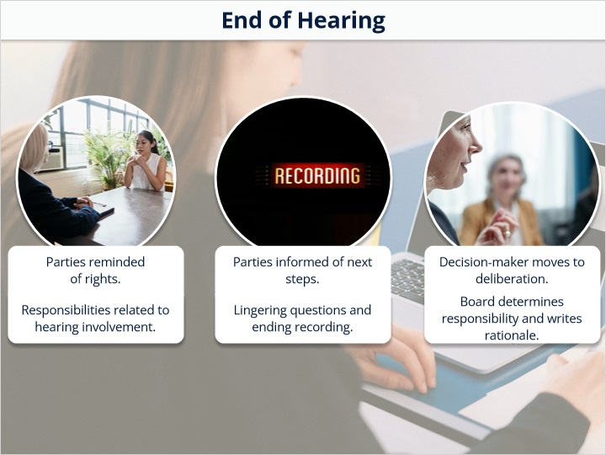

1.18 Title
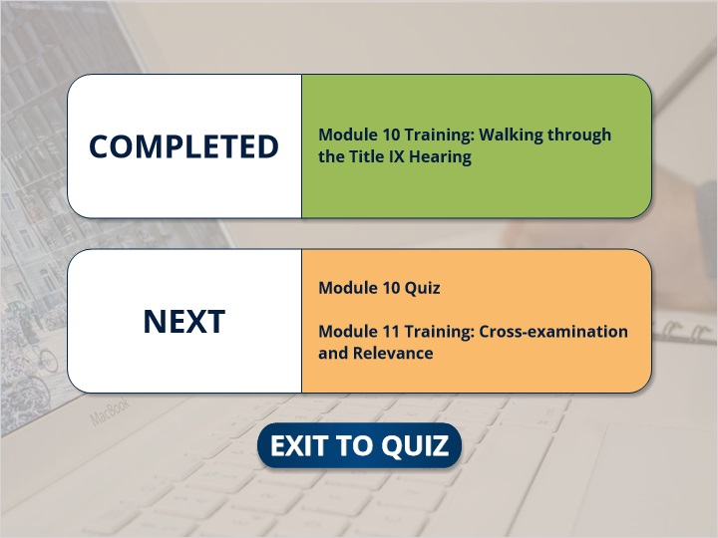
Notes:

